ATHENA-CDS Knowledge Base

Revision History

|  |  |  |
| --- | --- | --- |
| **Version** | **Date** | **Changes** |
| 0.1 | 2019/02/14 | Added Revision History table; edited up to Section 2.3.2 |
|  | 2019/03/30 | Deleted some obsolete sections |
|  |  |  |
|  |  |  |
|  |  |  |
|  |  |  |
|  |  |  |

ATHENA-CDS Knowledge Base 1

1 Protégé 3

1.1 Protégé Knowledge Model 6

1.1.1 Instances, Slots, and Classes 6

1.1.2 Metaclass in Protégé 7

1.1.3 Constraints in Protégé: Facets and PAL Constraints 10

1.2 Protégé’s File Format 12

1.3 Protégé User Interface 12

1.4 Components of the Protégé UI 12

1.4.1 Forms Tab 12

1.4.2 Classes Tab 14

1.4.3 Instances Tab 15

1.4.4 Classes & Instances Tab 16

1.4.5 Knowledge Tree Tab 18

1.4.6 Graph Widget 19

1.5 Two Common Tasks 20

1.5.1 Using the Search Function to Find Classes or Instances 21

1.5.2 Finding References to Classes, Slots, or Instances throughout the Knowledge Base 22

2 EON Models and the ATHENA-CDS Knowledge Base 24

2.1 Patient Data Model 26

2.2 Medical Concept Model 28

2.2.1 Metaclasses 29

2.2.2 Terminology Hierarchies 31

2.2.3 Value_Type Hierarchy 33

2.3 EON Guideline Model 35

2.3.1 Management Guideline 36

2.3.2 Clinical Algorithm 39

2.3.3 Action Specification 47

2.3.4 Drug Usage and Guideline Drug Activities 57

2.4 Expressions 63

2.4.1 Template-based Expression Language 64

2.4.2 Structured Query in the EON Guideline Model 71

2.4.2.1 Introduction 71

2.4.2.2 Basic Operations 72

2.4.2.3 Filter 73

2.4.2.4 Grammar 76

2.4.2.5 Patterns 78

2.4.3 PAL-based Expression Language 79

2.4.4 Summary 80

3 Updating Knowledge Sources in ATHENA-CDS SYSTEM 81

3.1 Update the Rules Document 81

3.2 Update the Knowledge Base in Protégé 81

3.2.1 Add a New Drug 81

3.2.2 Displaying a Drug as Preferred in the Advisory 85

3.2.3 Enabling Dose Increase Recommendations for a New Drug 90

3.2.4 Adding a Compelling Indication to a Drug Class 92

3.2.5 Removing Instances by Clicking the - Button 100

3.2.6 Adding a New Medical Condition 101

3.2.6.1 Creating a New Disease or Condition Defined by ICD9 Code 101

3.2.6.2 Adding a Condition Defined by Criteria 105

3.2.7 Adding Messages to Display in the ATHENA-CDS Hypertension Advisory 108

3.2.7.1 Scenario-related Message 111

3.2.7.2 Action_Choice-related Message 117

3.2.7.3 Drug Classes-related Message 122

3.2.7.4 Creating a New Primary Message Using the Classes & Instances Tab 127

3.2.7.5 Parameterized Message 129

4 Appendix 1: Questions and Answers 129

5 Appendix 2: Installing ATHENA Test Environment on a Local Machine 133

6 References 134

ATHENA-CDS knowledge bases is a collection of encoded clinical practice guidelines designed for the management of various chronic diseases in primary care. As of 02/10/2019, the collection includes knowledge bases for the glycemic control for type-2 diabetes and the management of hypertension, hyperlipidemia, heart failure, and chronic kidney disease. The knowledge bases were developed by clinicians and knowledge engineers in various instantiations of the ATHENA-CDS Project, using a number of sources such as VA guidelines and primary literature. Some are more up-to-date than others. These knowledge bases encode guideline knowledge in the format required by the EON Guideline Model, using Protégé 3.x as the tool for encoding, browsing, and editing this knowledge base.

In the following, “ATHENA-CDS Knowledge Base” will denote any of the ATHENA-CDS knowledge bases interchangeably. When necessary, we will reference the particular knowledge base (e.g., “ATHENA DM Glycemic Control: Dashboard”) to make clear the context.

In this section, we describe Protégé (Section )), the structure of the models in EON and of the ATHENA-CDS Knowledge Base (Section 2), and how to update the ATHENA-CDS Knowledge Bases (Section 3).

# Protégé

Protégé (Gennari et al., 2003; Musen, 1999) is an integrated software tool used by system developers and domain experts to develop knowledge-based systems. Created at Stanford Center for Biomedical Informatics Research (BMIR), Stanford University, Protégé (version 3.x and earlier) is the tool used to develop the ATHENA-CDS Knowledge Base. (The current version of Protégé has completely different knowledge representation and user interface. In the following, whenever we mention Protégé, we mean Protégé version 3.x.)

The following subsections give a basic introduction to Protégé 3.x. We will discuss Protégé 3.x’s knowledge model (Noy, Fergerson, & Musen, 2000), the integrity constraints that one can place in the knowledge base to make sure that it is well-formed, Protégé’s file format, and, finally, its graphical user interface.

The original version of ATHENA-CDS Knowledge Base was developed using Protégé-2000 and earlier versions. Between Protégé-2000 the 3.x version, its user interface (UI) has changed to a certain extent. In this manual, as much as possible, we will use screen shots taken from Protégé 3.5, but some older screen shots may still be present. Figure 1 shows the difference between the UIs of the two versions for the Management_Guideline class. Noticeably, the icons to view, create, destroy, add, remove entities (,, , ,  in Protégé-2000 UI and , , , ,  in Protégé 3.x UI respectively) are different. (The “add” operation adds an existing entity while the “remove” operation removes an entity from the UI but does not destroy the entity from the knowledge base.)

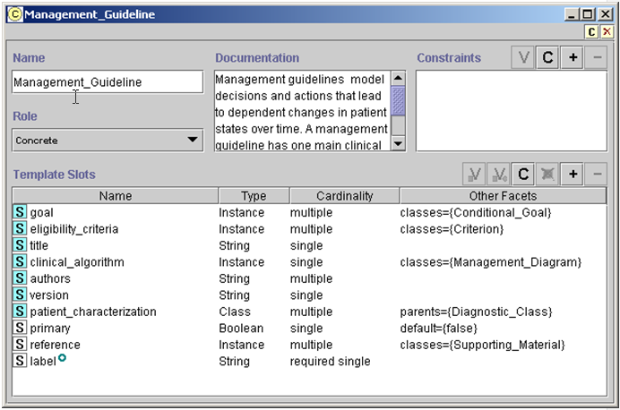

Figure . Comparing user interfaces of Protégé-2000 (top) and Protégé 3.x (bottom).

## Protégé Knowledge Model

### Instances, Slots, and Classes

In Protégé, the basic unit of knowledge representation is a *frame*, a structure that holds specific types of information. Frames can be used to hold information about concrete individuals in the domain (e.g., *George Washington* or *JNC 6 guideline*), in which case, the frames are *instance frames* (or, more simply, *instances*). Frames can also be used to represent a named collection of individuals (e.g., *American Presidents*) or an abstract concept (e.g., the concept of a beta adrenergic antagonist drug), in which case, the frames are *classes*. Properties of instances—e.g., eligibility_criteria (shown as Eligibility Criteria in Figure 2),[1] which define the target population of a guideline—are themselves frames called *slots*. Slots may have *values*. Slot values may be drawn from one of Protégé’s primitive types—float, integer, string, symbol, or Boolean—or they may be instances or classes.[2]

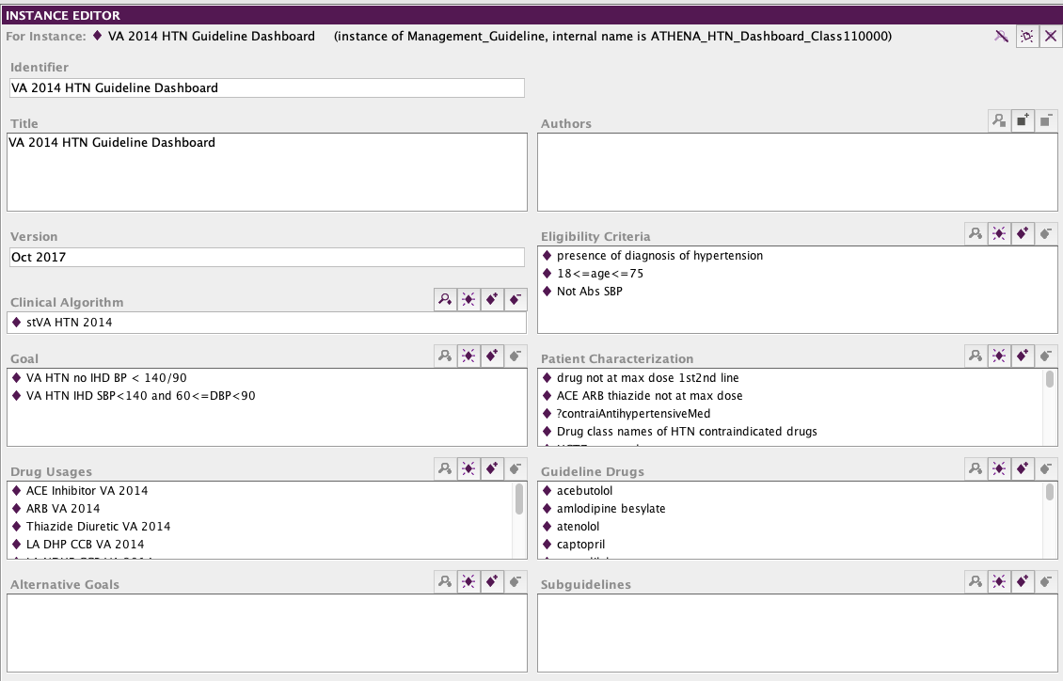

Figure 2 - Partial view of the VA 2014 Hypertension Guideline instance

In Protégé, classes are organized into classification hierarchies where children classes are specializations of parent classes. Furthermore, *template slots* associated with a class define the properties that instances of the class may have. Figure 3 shows the definition of the Management_Guideline class in Protégé. The left pane shows the class hierarchy of concepts in the ATHENA-CDS Knowledge Base. The middle pane shows instances (VA 2014 HTN Guideline) of the selected class (Management_Guideline), and the right pane shows the template slots associated with the selected class. Note that slots such as patient_characterization, eligibility_criteria, authors, version, and goal are precisely the slots that have values in Figure 2.

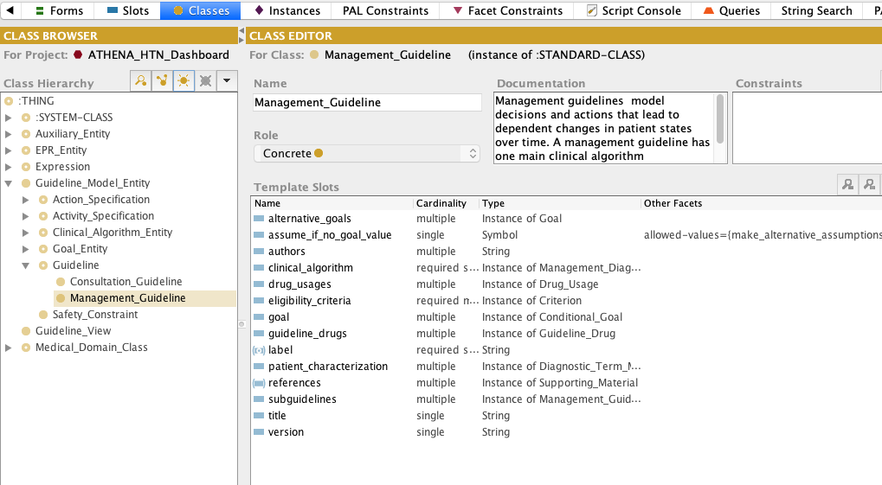

Figure 3 - Protégé graphical user interface showing the class hierarchy and the definition of a class

### Metaclass in Protégé

In Protégé, classes are themselves instances of other classes. Classes whose instances are classes are called *metaclasses*. Protégé defines a metaclass called :STANDARD-CLASS as the default metaclass for all classes. Users can define their own metaclasses by subclassing :STANDARD-CLASS. Figure 4 shows some of the metaclasses that have been defined for the EON/ATHENA-CDS system. This subsection will describe the reasons for users to define metaclasses. Details of the individual metaclasses will be discussed in Subsection 2.2.

There are two reasons for users of Protégé to define their own metaclasses:

1. Users can associate slots with a metaclass, as with regular classes. In Figure 5, the Diagnostic_Term_Metaclass has a DiagnosticCriteria slot. Thus, instances of Diagnostic_Term_Metaclass—e.g., the CRI (Renal Insufficiency) class (Figure 6)—may have values for the DiagnosticCriteria slot. The Guideline Interpreter would evaluate the DiagnosticCriteria slot value of CRI to determine whether a patient has renal insufficiency.
2. Another reason to have metaclasses is that, by making a collection of classes instances of a metaclass, special reasoning can be carried out for the collection. Thus, for example, by making drug concepts (such as lisinopril and atenolol) instances of the Medication_Metaclass, we can write decision criteria that range over these drug concepts (i.e., instances of Medication_Metaclass). This makes it possible to determine, say, whether a bad drug partner has already been prescribed for a possible drug recommendation.

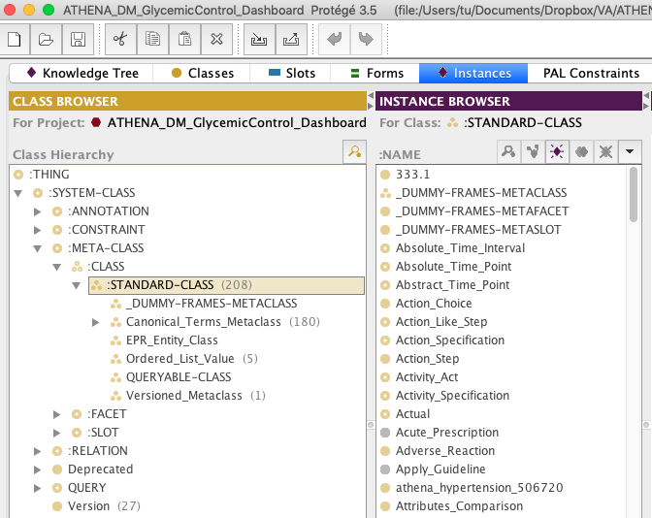

Figure 4 - The metaclass hierarchy in Protégé, showing classes (such as Absolute_Time_Interval) as instances of the :STANDARD-CLASS metaclass

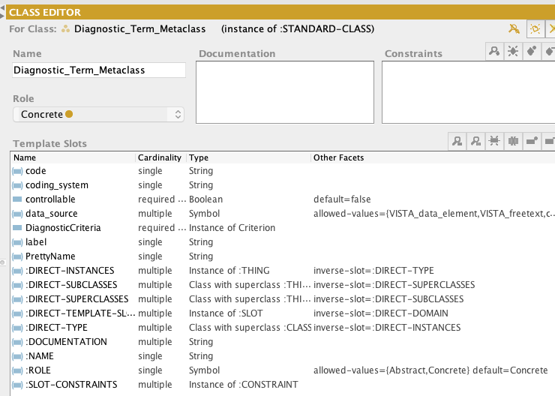

Figure 5 - The definition of Diagnostic_Term_Metaclass. DiagnosticCriteria is a slot whose value is specific to instances of this metaclass.

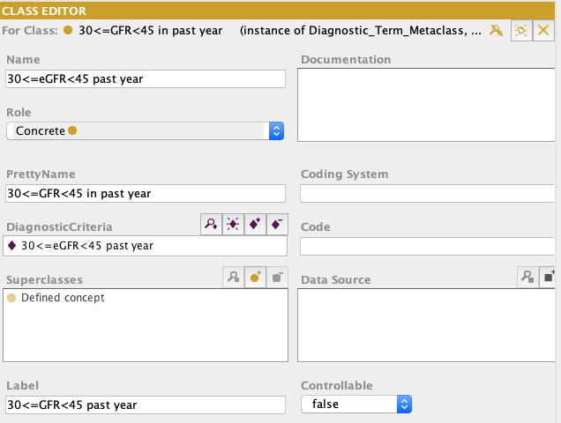

Figure 6 - The definition of the “30<=eGFR<45 past year” class (an instance of the Diagnostic_Term_Metaclass). It has a PrettyName and a criterion defining the situation where the most recent eGFR is between 30 and 45 (in the DiagnosticCriteria slot).

### Constraints in Protégé: Facets and PAL Constraints

In Protégé, slots are themselves frames that have properties. The properties of a slot, called *facets*, express constraints on possible values of slots. Figure 7 shows the facets of the eligibility_criteria slot as they appear in Protégé’s UI. We can see that:

* values of the slot are constrained to be of the value type, Instance;
* the values must be instances of the allowed class, Criterion; and
* the slot may have zero or more values, since the *Cardinality multiple* checkbox is checked and there is no entry in the *Cardinality at least* box.

The Minimum and Maximum facets apply only to slots whose value types are integers or floating-point numbers. The Template Values of a slot are values inherited by all instances of the classes to which the slot is attached. (For example, if we associate a criterion as a template value of the eligibility criteria slot in the Management_Guideline class, then all guidelines—be they hypertension or screening guidelines—will have that criterion as one of their eligibility criteria.) The Default value of a slot is the value that a slot is initially given when an instance is created. The creator of the instance is free to change the initially assigned value. The Inverse Slot of a slot is one that has a reciprocal relationship with the slot (e.g., parent-of and child-of are inverses of each other: if John is the parent of Jim, then Jim is a child of John).

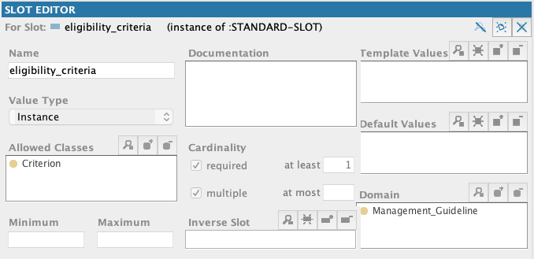

Figure 7 - The facets of the eligibility_criteria slot

Facets of a slot express constraints on a single slot. When a constraint is a complex relationship among multiple instances and slots, it can be written as a *Protégé Axiom Language (PAL) constraint* (Figure 8). A PAL constraint uses a logic-based language to express relationships among instances of a Protégé knowledge base that can span across multiple classes and slots.

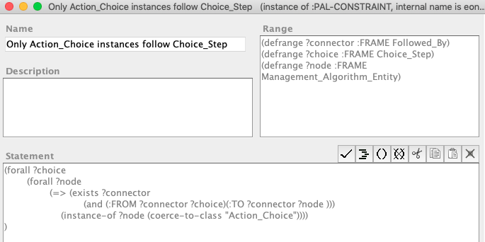

Figure 8 - A PAL constraint expressing the requirement that only instances of Action_Choice can follow an instance of Choice_Step

## Protégé’s File Format

Protégé saves a knowledge base—called a *project* in Protégé—as a collection of three files. They have the extensions .pont, .pins, and .pprj. The pont file contains the definition of Protégé classes. The pins file contains the definition of and data about instances. The pprj file contains display information for classes and instances as well as information about relationships among different Protégé projects. The same pont and pins files may be used in different pprj files if different displays are desired for the same knowledge base. Thus, in ATHENA-CDS, a clinician knowledge engineer may view and edit the ATHENA-CDS Hypertension Knowledge Base using, say, athena_hypertension.pprj, which references athena_all.pont and athena_all.pins and which has numerous UI customizations. The Guideline Interpreter, on the other hand—because it doesn’t need the display information kept in the athena_hypertension.pprj file—may load the athena_server.pprj project, which also references the same athena_all.pont and athena_all.pins files.

## Protégé User Interface

This subsection introduces the Protégé user interface, describing its components and highlighting some of the common operations. It also gives two examples of working with the Protégé GUI:

1. searching for classes or instances whose display name matches a string, and
2. finding all places where a class or instance is referenced.

## Components of the Protégé UI

The Protégé UI is divided into tabs, each of which provides a view into the content of the knowledge base. This subsection describes how to work with the tabs: Forms, Classes, Instances, Classes & Instances, and Knowledge Tree tabs.

### Forms Tab

The basic UI paradigm in Protégé is that information associated with a frame (see Subsection 1.1) are displayed on a *form*. For each class, Protégé generates a prototypical form used to display and edit instances of that class. The Forms tab allows a developer to customize this automatically generated instance form of a class. Figure 9 shows the Forms tab for the ATHENA-CDS Knowledge Base. The left-hand side of the tab shows the class hierarchy of the knowledge base. Selecting a class in this hierarchy (e.g., the Scenario class) causes the prototypical form associated with the class to be displayed on the right side of the tab. Each slot of the class is shown with a default *slot widget,* a UI component that displays the slot value and through which the slot value can be edited. For example, in Figure 9, the *label* slot is shown as a text box with the title “Label” above it, the Boolean new_encounter slot is displayed as a check box entitled “New Encounter”. By default, slots that have instances as values are displayed with slot widgets that allow a user to view (button), create (  button), add ( button), or remove ( button) instances as slot values.

The prototypical form associated with a class can be customized. By selecting a slot widget on the prototypical form and using the Selected Widget Type drop-down menu, a developer can change the slot widget associated with a slot. Figure 10 shows that the new_encounter Boolean slot can be displayed using either ComboBoxWidget or CheckBoxWidget. The Form Browser Key drop-down menu allows a user to select the slot whose value will be used as the display name of an instance. Figure 11 shows that the *label* slot has been selected as the slot whose value is the display name of Scenario instances.

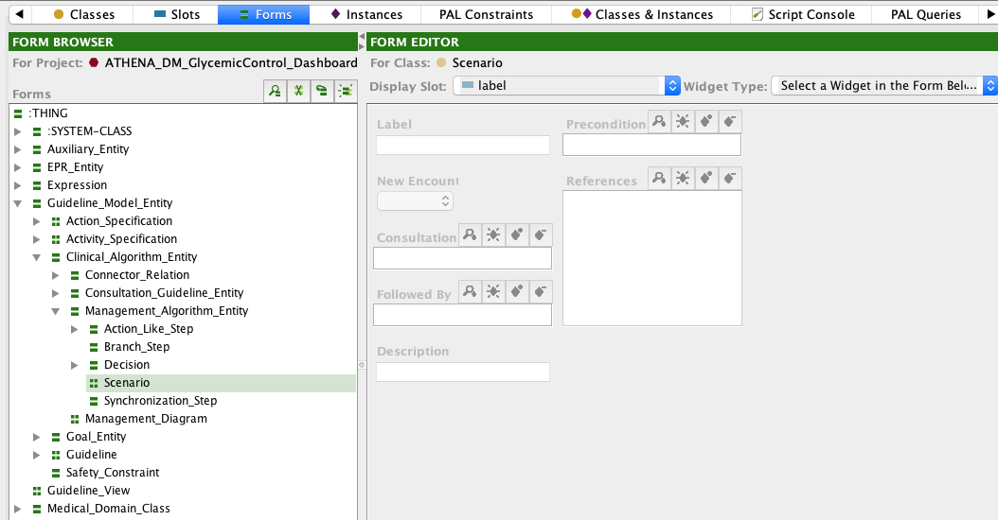

Figure 9 - The instance form associated with the Scenario class. It defines the UI for viewing and editing instances of the class.

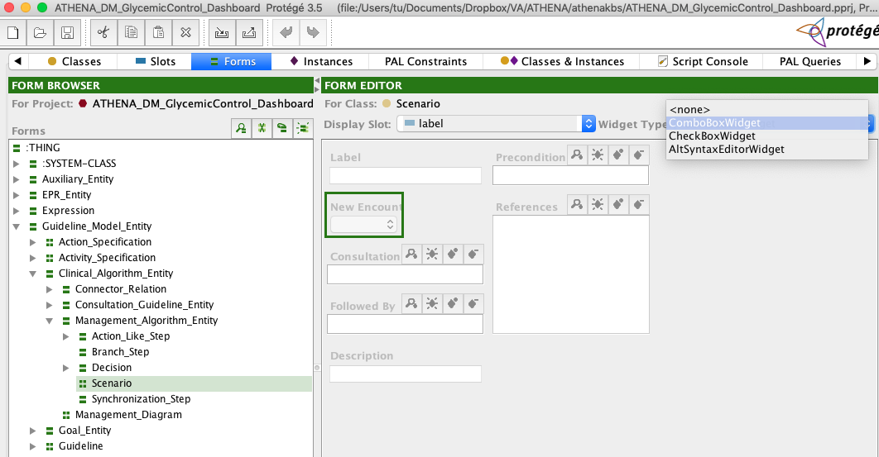

Figure 10 - Changing the slot widget assigned to the new_encounter slot

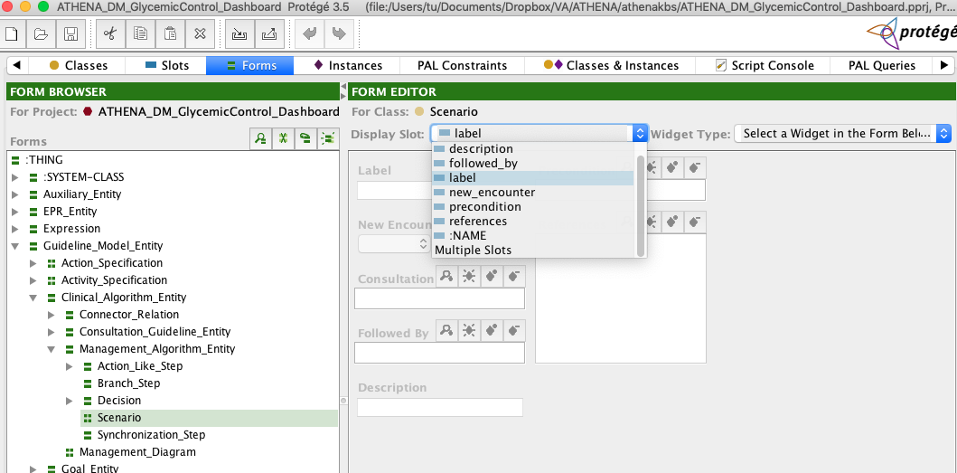

Figure 11 - Selecting the label slot to supply the display name of Scenario instances

### Classes Tab

Quoting the Protégé User Guide:

“The Classes tab provides a single window in which you may view, create, and edit classes, which model concepts in your domain. An example is shown below (Figure 12). The window consists of three panes:

1. The **Class Relationship** pane in the upper left shows classes in a hierarchy and allows you to edit, create, and delete new classes. It also allows you to rearrange the class hierarchy by dragging a class to a replacement superclass.
2. The **Superclasses** pane in the lower left shows the superclasses of the selected class and allows you to add and remove superclasses for a class, as well as jump to a different superclass by clicking on it.  
   Note: If you cannot see the **Superclasses** Pane, your window may be too small. You can see the pane by enlarging your window or by dragging the slider bar at the bottom of the **Class Relationship** Pane. ….
3. When a single class is selected, the **Edit** pane on the right contains the Class Form for the selected class. The Class Form allows you to: name the class, choose its role, define constraints, provide a brief note, and, most importantly, define and edit the template slots. The Class Form can also be displayed as a separate window by clicking the View icon in the Class Relationship pane.”

The Class Form can also be viewed by double clicking on a selected class under the Classes tab.

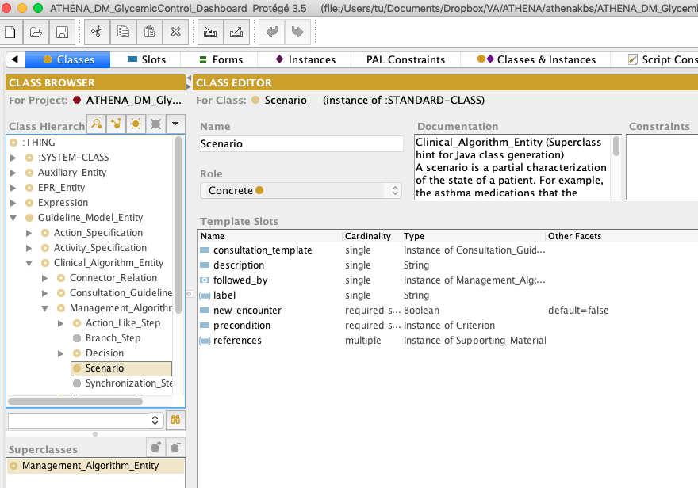

Figure 12 - The Classes tab in Protégé, showing the classes in the ATHENA-CDS Knowledge Base and the Class Form for editing the Scenario class

### Instances Tab

Quoting the Protégé User Guide:

“The Instances tab provides a window in which you may view, create, and edit instances. (Classes model concepts in your domain, slots model properties of classes and any relationships between them, and instances model the actual data.) An example of the Instances Tab is shown below (Figure 13). The window consists of three panes:

1. A **Class pane** at the upper left shows the classes in a superclass/subclass relationship. The Instances Tab lets you view classes, but you cannot edit or rearrange them. …
2. The **Direct Instances pane** in the center shows all the direct instances, if any, for the selected class, and allows you to view, edit, create, and delete direct instances.
3. When a single instance is selected, the Edit pane on the right contains the **Instance Form** for the selected instance. The Instance Form displays all the slots which apply to the instance, and allows you to edit them. The Instance Form can also be displayed as a separate window by clicking the View icon in the Direct Instances pane.”

Double clicking on an instance in the Direct Instance pane under the Instances tab causes the Instance Form of that instance to pop up in a separate window. Elsewhere in this manual, an instance form is also called a “template”.

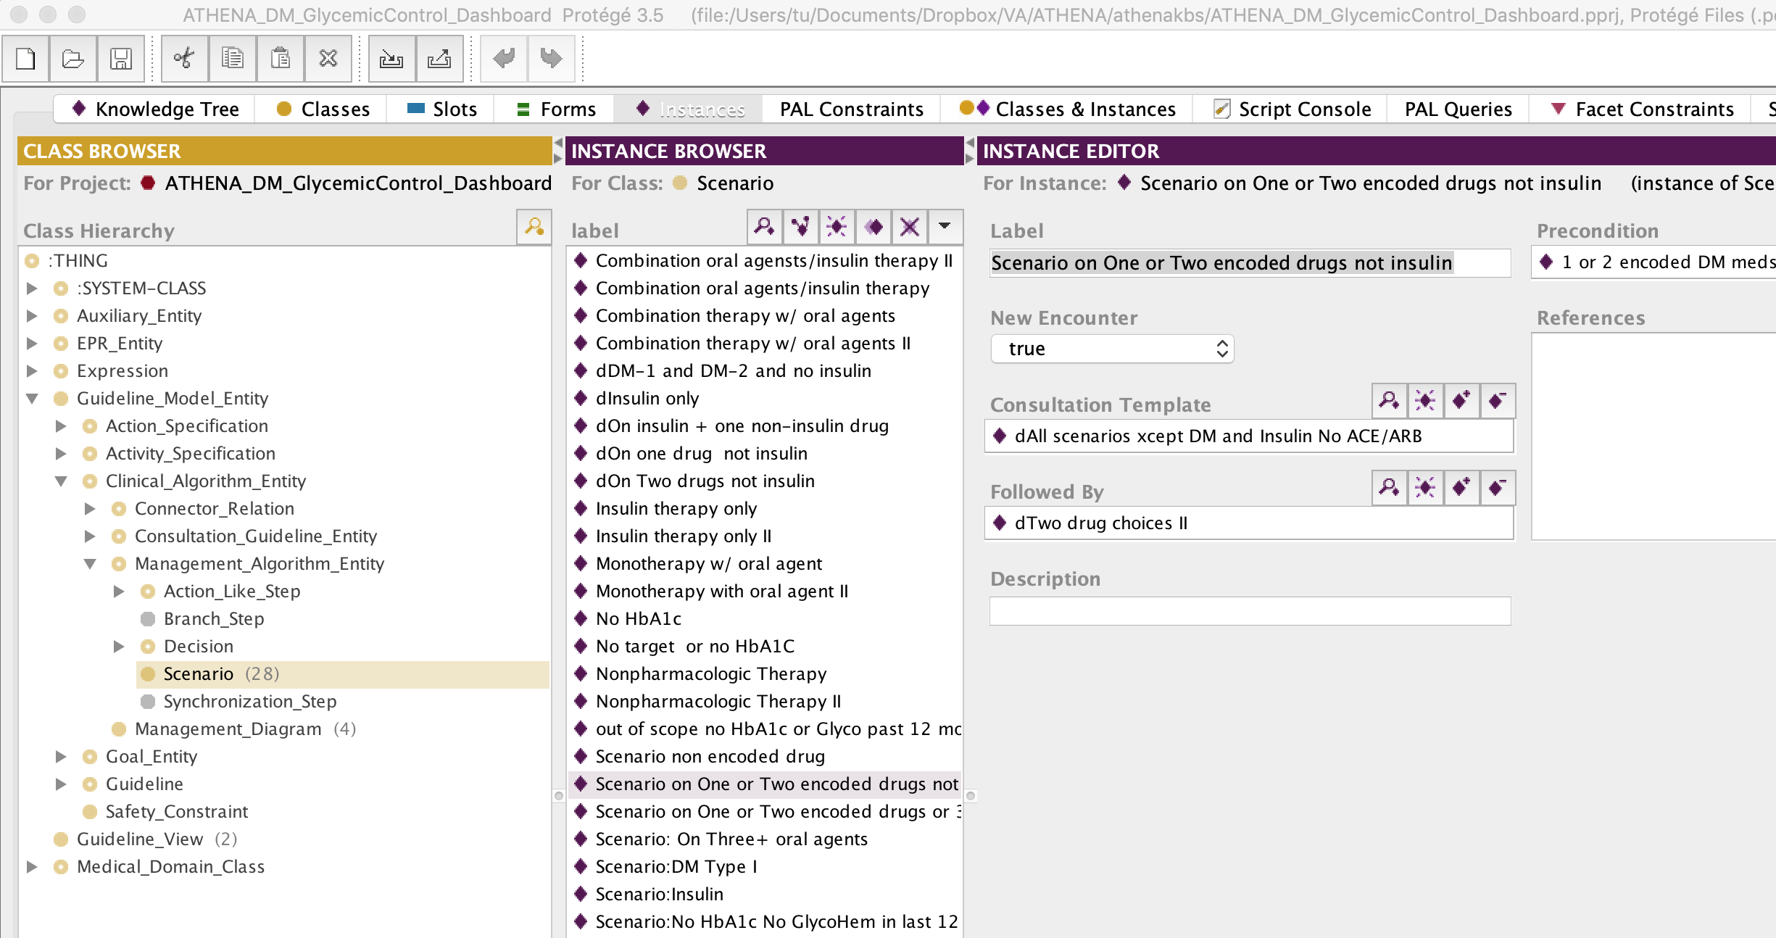

Figure 13 - The Instances tab, showing the Instance Form associated with the “Scenario on One or Two encoded drugs not insulin” instance of Scenario

### Classes & Instances Tab

The Classes & Instances tab combines most of the functionalities of the Classes tab and the Instances tab in a single tab. Like the Instances tab, the Classes & Instances tab has three main panes: Class Relationship pane as it exists in the Class tab, Direct Instances pane, and the form for the selected class or instance. When a class is selected in the Class Relationship pane, but no instance is selected in the Direct Instances pane, then the form pane displays the class form associated with the selected class (Figure 14). When a class is selected in the Class Relationship pane and an instance is selected in the Direct Instances pane, then the form pane displays the Instance Form associated with the selected instance (Figure 15).

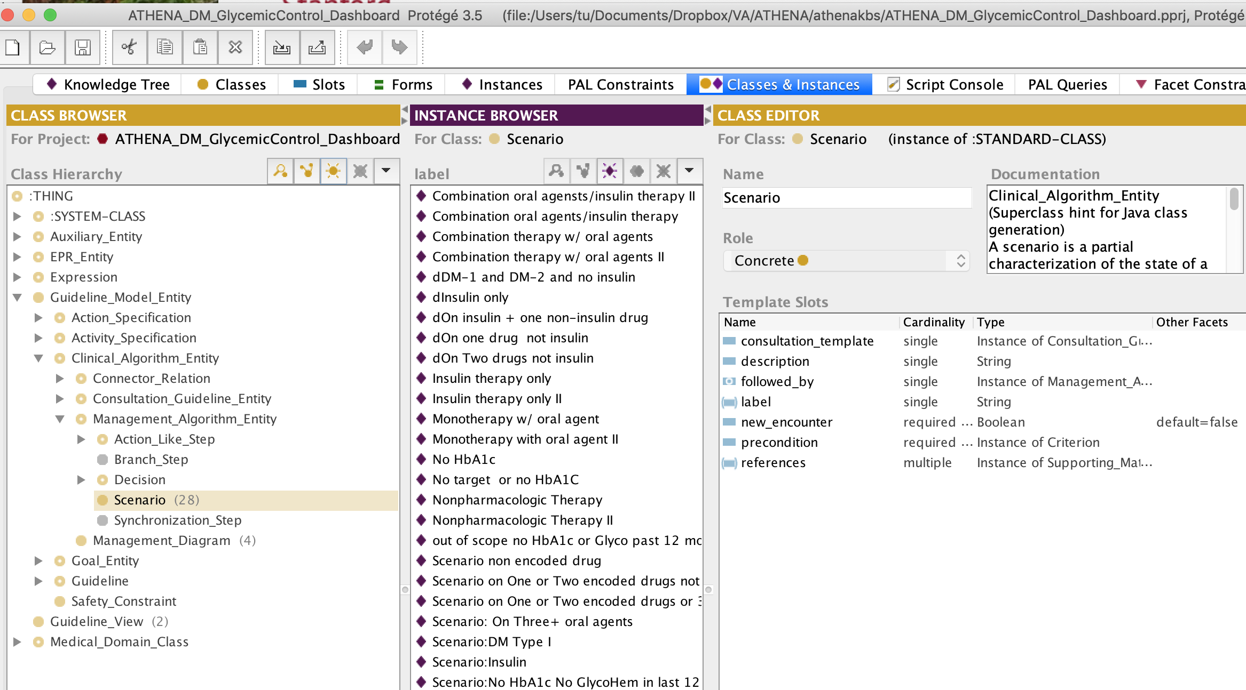

Figure 14 - The Classes & Instances tab. It shows a class hierarchy in the Relationship pane on the left, a Direct Instances pane in the center, and a Class Form for class Scenario on the right.

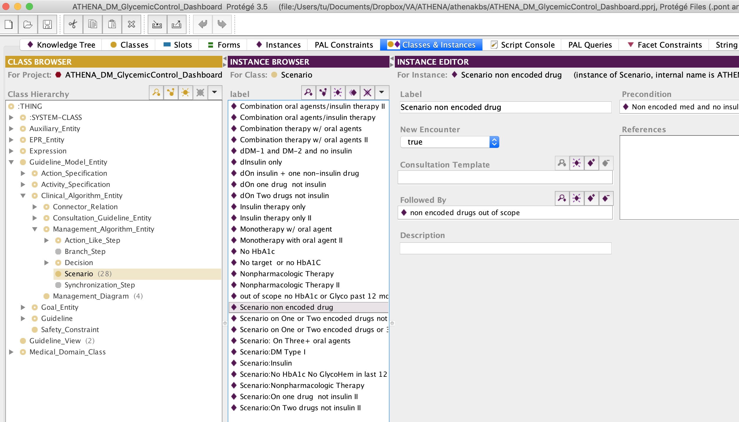

Figure 15 - The Classes & Instances tab, as in Figure 14, except that on the right it is displaying an Instance Form for the “Scenario non encoded drug” instance

### Knowledge Tree Tab

The Knowledge Tree tab is designed to facilitate navigation in a Protégé knowledge base by specifying an instance as the entry point for browsing the knowledge base. For the ATHENA-GlycemicControl_Dashboard Knowledge Base, the ATHENA DM: Glycemic Control Dashboard instance of the Management_Guideline class is the starting point for browsing the ATHENA-GlycemicControl_Dashboard Knowledge Base (Figure 16).

The KnowledgeTree widget allows navigation of frames that are directly and indirectly referenced from the root guideline instance in a tree structure. By clicking on the triangular icon next to a slot (e.g., the clinical_algorithm slot), the user can navigate to instances that are referenced in the guideline recursively in the tree. Figure 17 shows the clinical algorithm associated with the Glycemic Control Dashboard guideline in the Knowledge Tree.

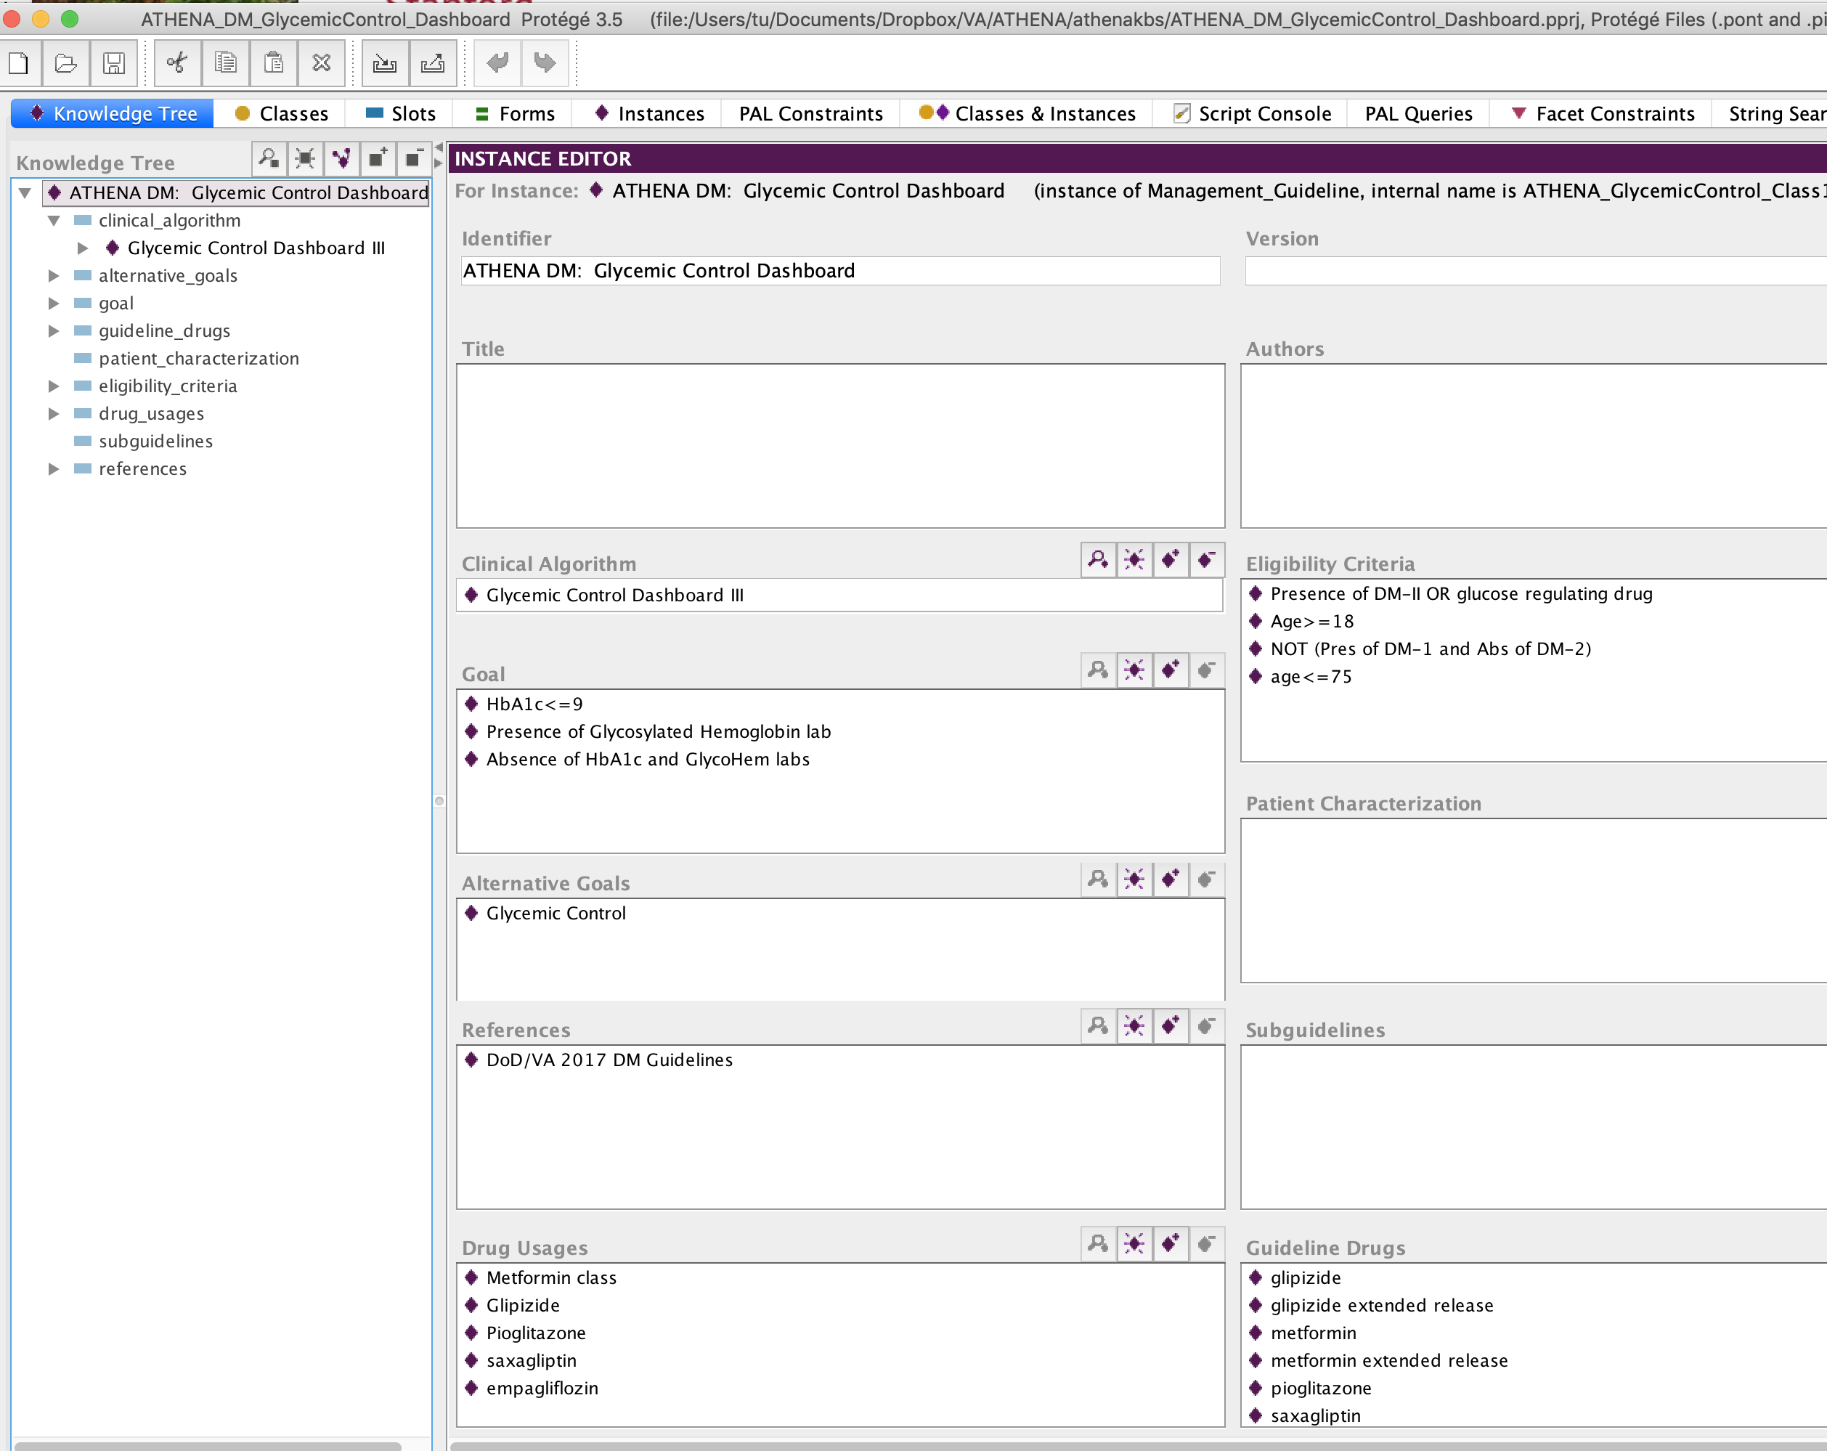

Figure 16 - The Knowledge Tree tab, showing the Instance Form of the ATHENA-GlycemicControl_Dashboard instance of the Management_Guideline

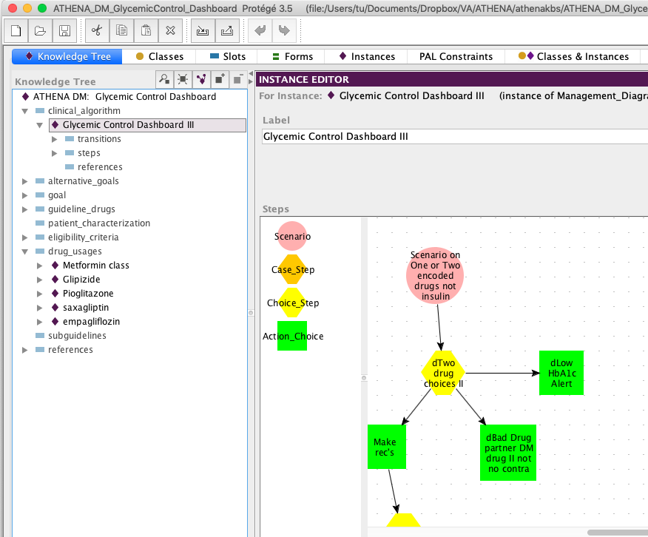

Figure . Navigating to the clinical algorithm from the root guideline node.

The Knowledge Tree was designed to make most important entries in an ATHENA-CDS Knowledge Base visible on a single form.

### Graph Widget

To graphically display and edit the clinical algorithm associated with a guideline, the ATHENA-CDS Knowledge Base uses the graph widget to represent the steps and connections among the steps (Figure 18). For the Management_Diagram class, the Steps slot is configured such that the associated graph widget shows the allowed classes of the slot (Choice_Step, Action_Choice, Scenario, and Case_Step). They are available in the drawing palette of the graph. For example, a user can create an instance of Scenario in the drawing canvas by selecting and dragging a Scenario icon from the drawing palette to the drawing canvas. A connection between two icons (representing instances) can be created by clicking on cursor on the “from” icon and drag it to the “to” icon.

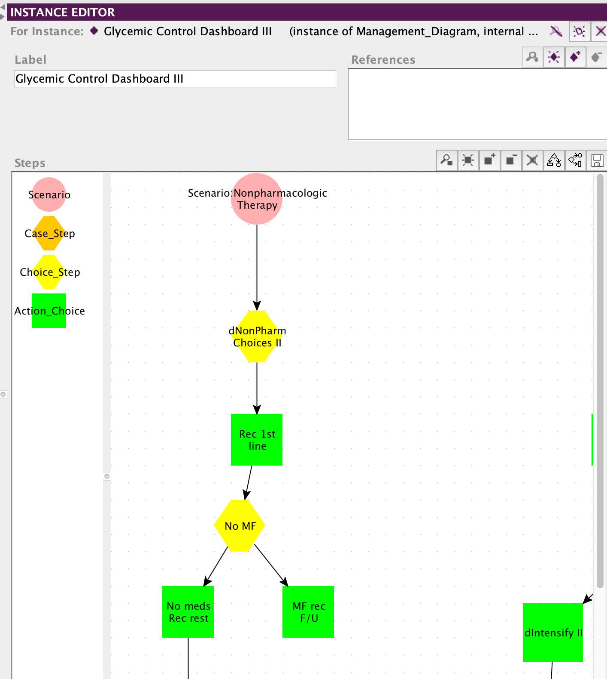

Figure 18 - The graph interface for creating a clinical algorithm. A user creates an object in the graph by selecting and dragging an icon from the drawing palette to the drawing canvas.

## Two Common Tasks

The following subsections describe two tasks that a user will commonly carry out in Protégé. One is using the search function to find existing classes or instances. The other is finding references to classes, slots, or instances in one or more places throughout the ATHENA-CDS Knowledge Base.

### Using the Search Function to Find Classes or Instances

In Protégé, a user can search for existing classes or instances by their display names. This is done using the binocular search pane available in a number of Classes & Instances panes and dialog boxes (Figure 19). The binocular search pane consists of the search-string text field and the binocular search button.

Suppose a user is looking for a class with a name that begins with “anti”. He or she can enter the search string “anti” in the search-string text field and click the binocular button (Figure 19). If there is one match, that class will be highlighted. If there is more than one match, Protégé will show a dialog box containing all matches (Figure 20), and the user will be able to select one. String comparisons in searches are *not* case sensitive.

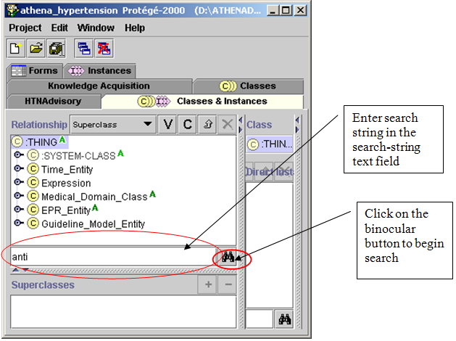

Figure 19 - Using the binocular search pane to look for classes with a name beginning in “anti”

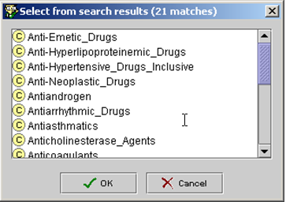

Figure 20 - Results for the search string “anti”

If you want to find classes with names containing “anti” in any position, you can add the wildcard character **\*** at the beginning of the search string. Protégé will return all classes with names containing “anti” (Figure 21).

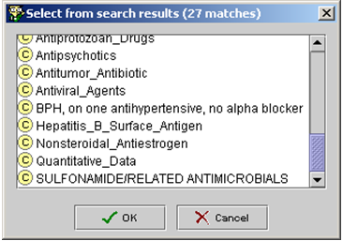

Figure 21 - Search results for the search string “*anti”

### Finding References to Classes, Slots, or Instances throughout the Knowledge Base

A class or an instance may be used in one or more places in the knowledge base. If a user wants to modify or delete a class or an instance, it is essential to know all places this class or instance is used. He or she can use the references buttons, highlighted in Figure 22, to find all references to a particular class or instance.

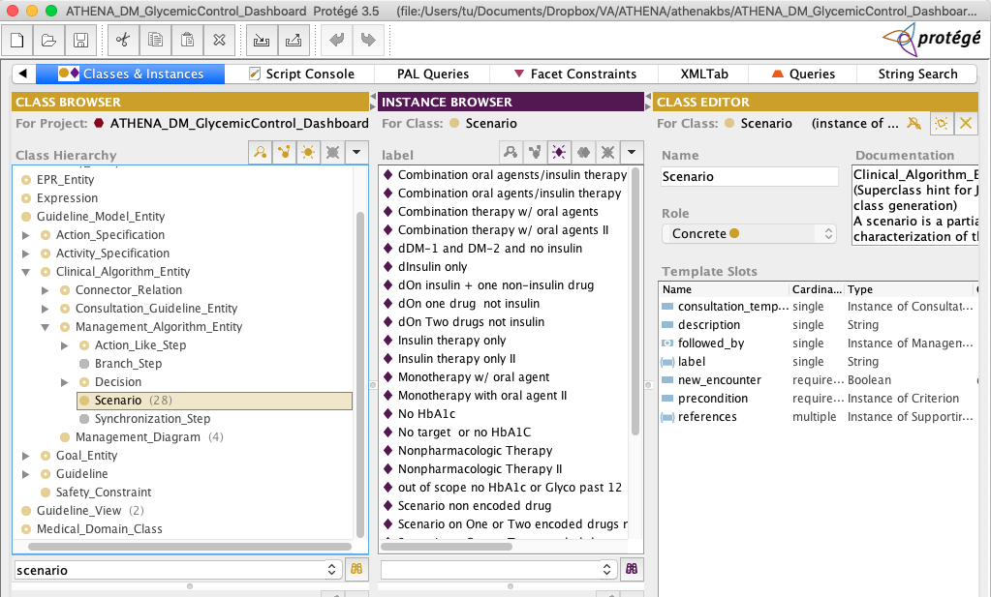

Figure 22 - References buttons (, between  and  buttons) in the Classes & Instances tab

If you select the Scenario class and click on the references button in the class hierarchy pane, for example, a window showing all references to the Scenario class will pop up (Figure 23). The window shows that: the Scenario class is an allowed class of the first_object slot in the Followed_By class; it is the direct instance of the :STANDARD-CLASS metaclass; it is the direct subclass of the Management_Algorithm_Entity class; it is the direct type of a number instances; and it is the slot value type of the previous_scenarios slot.

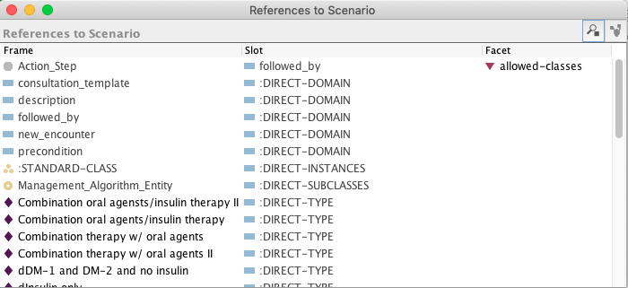

Figure 23 - Window showing all references to the Scenario class

From the window that shows all references to the Scenario class, you can select a class, slot, or instance (e.g., Management_Algorithm_Entity class in Figure 24), and click on the references button on the form to open another window that shows all references to the selected frame (e.g., Figure 25 shows all references to the Management_Algorithm_Entity class in the knowledge base).

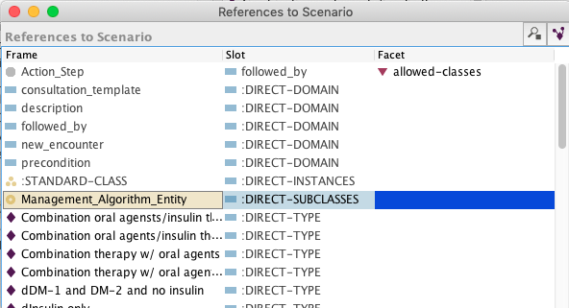

Figure 24 - Selecting a frame (e.g., Management_Algorithm_Entity class) in the References to Scenario window, and clicking on the references button to find all references to the selected frame

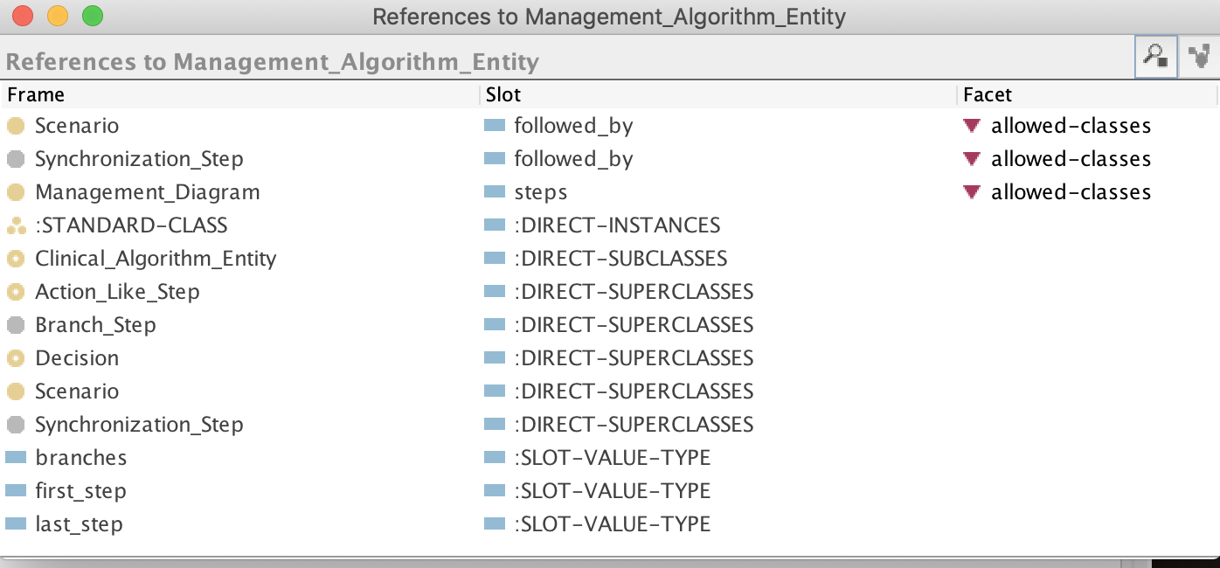

Figure 25 - All references to Management_Algorithm_Entity

# EON Models and the ATHENA-CDS Knowledge Base

The ATHENA-CDS Knowledge Base encodes select, authoritative hypertension knowledge in the format required by EON models. These models, consisting of an extensible set of Protégé projects, structure the knowledge and data so they can be used to encode guidelines and protocols in a form suitable for generating patient-specific recommendations. The EON models include:

1. *Patient Data Model* (EPR_Entity hierarchy) – defines the structure of patient information used by the EON system. It converts the clinical data from the electronic medical record (or other source) into a format the Guideline Interpreter can process.
2. *Medical Concept Model* (Medical_Domain_Class hierarchy) – primarily defines the medical vocabulary used in encoding guidelines. The terms in the medical concept model are mapped to standard terminologies or to the terminology used in the host information system.
3. *EON Guideline Model* (Guideline_Model_Entity and Expression hierarchy) – defines the structure of a computable EON guideline.

As shown in Figure 26, the EON Guideline Model contains:

1. *Eligibility criteria* – define the target population of the guideline. For example, a guideline on Hypertension would have a target population of patients with high blood pressure as an eligibility criterion.
2. *Goals* (e.g., target blood pressures) – specify patient states the guideline aims to help achieve.
3. *Abstractions about patients* (e.g., the risk group to which a patient belongs) – represent interpretations about a patient’s medical condition.
4. *A clinical algorithm* – organizes a collection of patient scenarios, decisions to be made, and possible action choices. Each action choice includes decision criteria for giving preference to the actions specified in the choice. The actions may include sending a message, referring a patient, evaluating activities to recommend, or starting, stopping and modifying activities.
5. *Activity specification* – represents an action that can take place over time (e.g., taking a medication to manage chronic problems). Activity specifications have properties, such as compelling indications, relative indications, relative contraindications, and absolute contraindications, that can be used to determine whether the activity is appropriate. Drug_Usage and Guideline_Drug are the two classes of activities heavily used in the ATHENA-CDS Knowledge Base. Instances of Drug_Usage (e.g., ACE Inhibitors) often contain information on classes of drugs, while instances of Guideline Drug contain specific information about a particular drug in a class (e.g., Captopril).
6. *Computable expressions* (e.g., eligibility criteria) – expressions, written using the expression languages available in the EON Guideline Model. They can be evaluated using coded patient data to infer valid statements about a patient.

Expression

Language

Domain Concepts

**Guideline   
Model**

Decision

Action   
Choice

organizes

Clinical Algorithm

Scenario

Patient Data Model

(EPR Entity)

Standard

Terminologies

Action Specification

Goals

Eligibility Criteria

Activity Specification

Figure 26 - Overview of the relationships among components of EON models

The following subsections describe the EON models and ATHENA-CDS Knowledge Base in more detail. They identify three levels: those features of the knowledge base that have impact on the display of the ATHENA-CDS GUI (as of November 2005), those features that are implemented by the EON Guideline Interpreter (as of November 2005) but are not displayed on the ATHENA-CDS GUI, and those features of the EON Guideline Model that are not fully implemented by the Guideline Interpreter. The subsections cover the patient data model, the guideline concept model, the EON Guideline Model, and the EON expression language.

## Patient Data Model

The EON patient data model defines the structure of the patient data used by the EON system. The Guideline Interpreter, for example, uses the data to determine whether a patient satisfies the eligibility criteria of the guidelines represented in the ATHENA-CDS Knowledge Base. Patient data are modeled as static (i.e., unchanging), as time stamped, or as having a time interval during which the information they represent is valid. For example, laboratory test results may be modeled as instances of Numeric_Entry, which has a code, a numeric value, and a time stamp. The Guideline Interpreter evaluates decision criteria using patient data represented in the format of the patient data model. The EON patient data model, represented by subclasses of the EPR_Entity class (see Figure 27), consists of the following classes[3]:

* *Encounter class* – represents records of the encounters a patient has with health-care providers.
* *Patient class* – represents non-varying demographic information about specific patients (e.g., sex and date of birth).
* *Note_Entry class* – describes time-stamped non-numeric observations made by clinicians.
* *Numeric_Entry class* – represents results of quantitative measurements.
* *Adverse_Event class* – models adverse reactions to specific substances.
* *Condition class* – represents medical conditions that persist over intervals of time (i.e., it has a start time and may have a stop time).
* *Medication class and Procedures class* – two intervention classes, they model drug prescriptions and other medical procedures that have been recommended, authorized, or used.

All entities in the patient data model are assertions about the demographic and clinical conditions of specific patients. The model is not designed to replicate all the contents of an electronic medical record. Rather, it includes only those distinctions relevant to modeling guidelines and protocols.

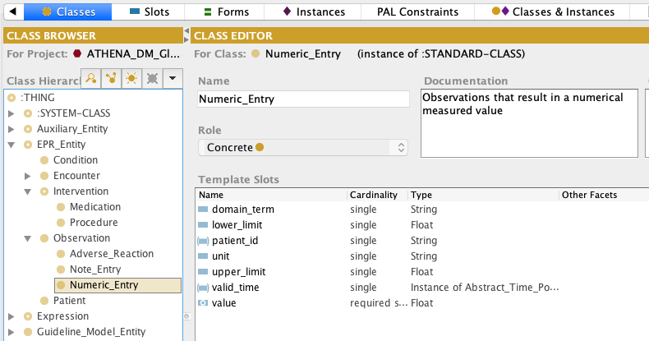

Figure 27 - The classes in the EON patient data model (EPR_Entity). The Patient, Condition, Encounter and Procedure classes are not used in ATHENA CDS KBs.

## Medical Concept Model

The medical concept model contains classes that represent terminological concepts necessary to encode patient information and guideline statements.

These concepts and relationships are organized in a taxonomic hierarchy (see Figure 28). The particular collection of classes represented in the current EON medical concept model is a historical legacy that does not conform to any external standard such as SNOMED Clinical Term.

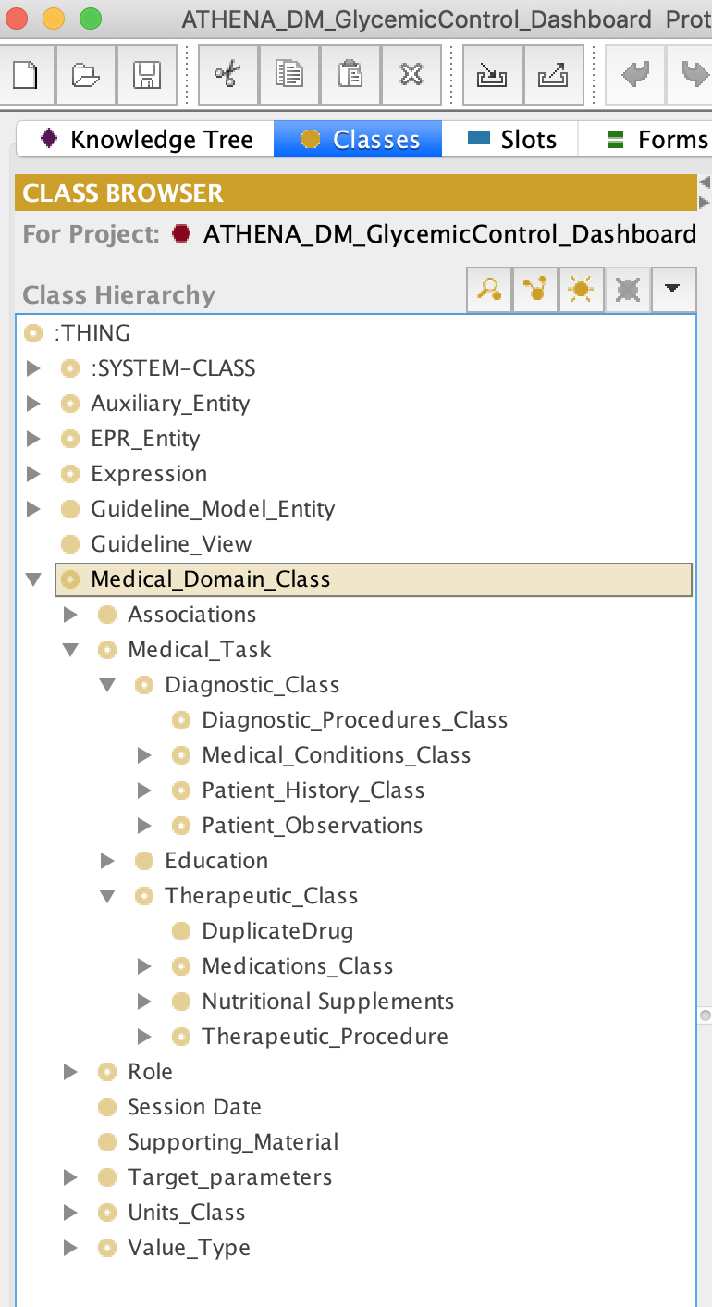

Figure 28 - The top-level classes in the medical concept model (subclasses of Medical_Domain_Class)

### Metaclasses

Classes in the Medical_Domain_Class hierarchy are instances of user-defined metaclasses. The important metaclasses to understand are:

1. *Canonical_Terms_Metaclass* – Canonical_Terms_Metaclass is the root of most metaclasses used in the Medical_Domain_Class hierarchy. (The only exception is Ordered_List_Value, see below). Medical concepts represented in the hierarchy should be instances of this metaclass or its subclasses. The Canonical_Terms_Metaclass provides a PrettyName slot that can be used to provide a more human-understandable name for the class. The Synonyms slot is not used.
2. *Medical_Conditions_Metaclass* – Instances of Medical_Conditions_Metaclass represent findings, diagnosis, and problems. They should be subclasses of the Medical_Conditions_Class in the Medical_Domain_Class hierarchy (Figure 29). A term representing a finding or diagnosis, such as Atrial_Fibrillation, may be mapped to patient data by through external mapping (e.g., the ICD9 codes 427.31 and 427.32). Like the Canonical_Terms_Metaclass, only the PrettyName slot is used in the current system. Note that the current ATHENA-CDS Knowledge Base has PAL criteria (see 2.4.3) whose variables range over instances of Medical_Conditions_Metaclass. (So if a finding is not an instance of Medical_Conditions_Metaclass—e.g., it is an instance of Canonical_Terms_Metaclass—it will not be considered when the system looks for, for instance, the contraindications of a drug.)
3. *Diagnostic_Term_Metaclass* – Diagnostic_Term_Metaclass provides a second way to relate guideline concepts to terms used in data. Instances of Diagnostic_Term_Metaclass have a DiagnosticCriteria slot that takes a Boolean criterion. If, for a patient, the criterion evaluates to *true*, then the EON Guideline Interpreter concludes that the finding is present for the patient. For example, in the ATHENA-CDS Knowledge Base, “hypertension without comorbidities that compellingly indicates thiazides or beta blocker” is represented as an instance of Diagnostic_Term_Metaclass, with DiagnositicCriteria “presence of hypertension and absence of myocardial infarction, diabetes, heart failure, and isolated systolic hypertension”.
4. *Derived_Parameter_Metaclass* – An instance of a Derived_Parameter_Metaclass is used to represent a concept whose value may come from multiple sources. In ATHENA-CDS, Treatment_Systolic_BP and Treatment_Diastolic_BP are instances of the Derived_Parameter_Metaclass where the *definition* slot specifies an ordered list of queries that can be used to obtain values for the two parameters. For example, the value for Treatment_Systolic_BP is derived by querying sequentially for: MD_Typical_Systolic_BP (the blood pressure a clinician uses for the purpose of managing hypertension), MD_Clinical_Systolic_BP (the most recent blood pressure measurement entered by a clinician through the ATHENA-CDS SYSTEM interface), and DB_Systolic_BP (the most recent blood pressure stored into the VistA database). The Guideline Interpreter uses the first data returned by this ordered list of queries. Thus, MD_Typical_Systolic_BP, if present, will be used instead of the DB_Systolic_BP blood pressure data in the database.
5. *Interval-Valued_AtomicTest_Metaclass* – Instances of Interval-Valued_AtomicTest_Metaclass are used to represent test results, such as the level of serum creatinine, that may have upper and lower limits of normal. The Guideline Interpreter also uses the *precision* slot to determine the number of digit to the right of the decimal point in displaying values of the test result.
6. *Medications_Metaclass* – Instances of the Medications_Metaclass are the generic drug names such as terazosin and lisinopril. Only the PrettyName slot is used. Again, because current PAL criteria use variables that range over instances of Medications_Metaclass, a drug that is not an instance of this metaclass will be missed in the evaluation of PAL criteria.
7. *Ordered_List_Value* **–** Instances of the Ordered_List_Value metaclass have pointers to the next and previous instances in a list. This metaclass is used to model the sequence relationship among High_Dose, Medium_Dose, and Low_Dose.

Other metaclasses, such as Drug_Category_Metaclass, play no role in the interpretation of the knowledge base.

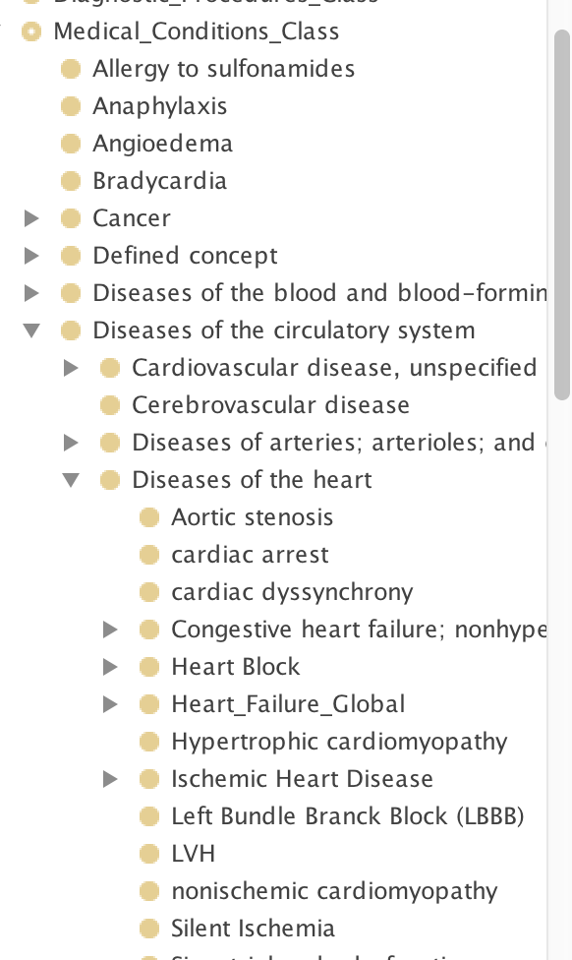

Figure 29 - Part of the ATHENA-CDS Medical Conditions Class hierarchy. Those classes in the hierarchy that have no subclasses should be either mapped to terms used in patient data or defined using Diagnostic_Term_Metaclass.

### Terminology Hierarchies

The Diagnostic_Class, Therapeutic_Class, Medical_Task, Value_Type, and Units_Class hierarchies supply controlled terminologies for the formal encoding of guideline knowledge in the ATHENA-CDS Knowledge Base and for patient data (Figure 30). Units_Class is not used by the Guideline Interpreter, which assumes that the data and knowledge base are using consistent units of measure.

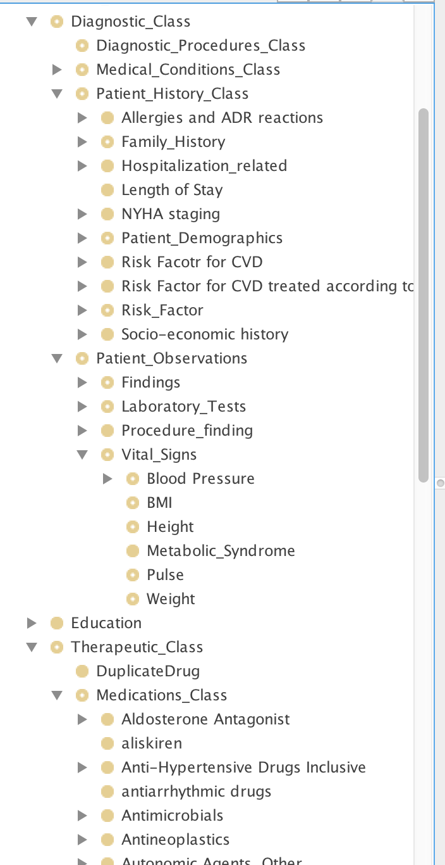

Figure 30 - Terminology classes in the Medical_Domain_Class hierarchy of the ATHENA-CDS Knowledge Base

With the exception of the Value_Type hierarchy, which is explained later in this subsection, the terminological hierarchies can be organized into any form by clinicians and knowledge engineers maintaining the ATHENA-CDS Knowledge Base, as long as a concept (represented by a class):

1. is mapped to a term in the patient data, with the mappings defined in a relational database table (e.g., Creatinine class is mapped to the CREATININE string);[4]
2. is defined as instances of Diagnostic_Term_Metaclass or Derived_Parameter_Metaclass; or
3. has subclasses that are mapped (as in case 1 above) or defined (as in 3).

In addition, the concept should be an instance of an appropriate metaclass (e.g., a generic drug class like *lisinopril* should be an instance of the Medications_Metaclass and a finding such as *fever* should be an instance of Medical_Conditions_Metaclass). The terminology hierarchy may contain additional classes (e.g., Patient_Observation) that are used to group concepts for navigational purposes; they play no role in the decision-support system.

The ATHENA-CDS Knowledge Base organizes medical conditions and drug classes into classification hierarchies as shown in Figure 29 and Figure 30. The medical condition classes either: have mappings (in a relational database) to data in the VA database, or are defined using Diagnostic_Term_Metaclass or Derived_Parameter_Metaclass. The drug class hierarchy has, at the most specific level, generic drug names—such as labetalol in Figure 30—that are mapped to drug terms in VA prescriptions. In addition, the ATHENA-CDS Knowledge Base enumerates the vitals, laboratory test results, and demographic terms used in encoding the hypertension guidelines. These terms are mapped to terms used in the VA patient database.

### Value_Type Hierarchy

The Value_Type hierarchy defines concepts that are used in the EON system as enumerations of mutually exclusive categorical values. A complete hierarchy listing is shown in Figure 31.

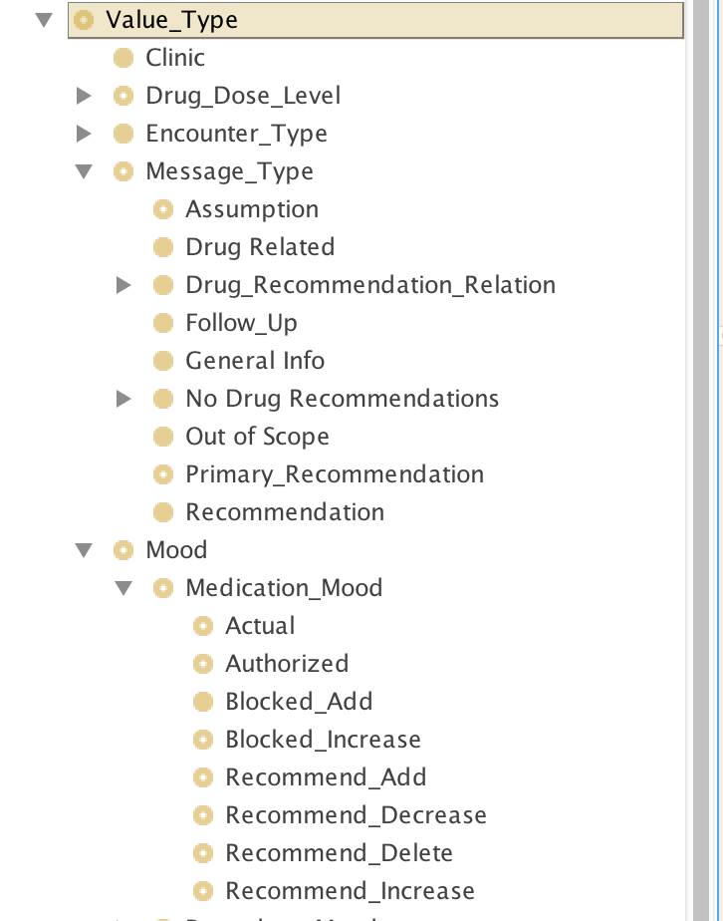

Figure 31 - The set of system-recognized terms, as organized in the Value_Type hierarchy

**Medication_Mood**

As the Guideline Interpreter generates recommendations about drug usage, it needs to perform additional tasks based on these recommendations (or the lack thereof). For example, in order to generate patient-specific messages associated with the recommendation to add a drug,[5] developers of the ATHENA-CDS Knowledge Base must encode messages that are based on the system’s drug recommendations (i.e., the collateral actions associated with an instance of Drug_Usage). In effect, these recommendations must be represented as data upon which additional reasoning can be based. Accordingly, the Guideline Interpreter generates instances of the Medication class to represent its recommendations. To distinguish among system-generated Medication instances from patient data, the Guideline Interpreter uses Medication_Mood values (see Figure 31):

* The Authorized mood value represents the medication that is prescribed.
* The Actual mood value represents the medication that is currently being taken by the patient.
* The Recommend_Decrease, Recommend_Delete, Recommend_Increase, and Recommend_Add, Blocked_Add, Blocked_Increase mood values represent possible recommendations for a drug.

**Drug_Dose_Level**

The possible values of Drug_Dose_Level in ATHENA-CDS are High_Dose, Low_Dose, and Medium_Dose. They are instances of the Ordered_List_Value metaclass that allows the specification of an ordered list (Figure 32). Thus, Low_Dose’s *next* attribute value is Medium_Dose, whose *next* attribute is High_Dose. Similarly, the *previous* attribute of High_Dose is Medium_Dose; and the *previous* attribute of Medium_Dose is Low_Dose. These terms are used in the Guideline_Drug class to specify ordinal levels of drug doses. The actual ranges for the dose levels are defined in the dose_level_ranges slot of Guideline_Drug class. The Guideline Interpreter classifies a patient’s medication dose according to the dose levels specified in instances of the Guideline_Drug class to determine whether the current daily dose is at the maximum level. The values of Drug_Dose_Level can be changed (e.g, Level_1, Level_2, etc. instead of Low_Dose, Medium_Dose and High_Dose), as long as the values are instances of Order_List_Value metaclass and the ranges are defined in instances of Guideline_Drug.

Low_Dose

Medium_Dose

High_Dose

next

next

previous

previous

Figure 32 - Use of Ordered_List_Value metaclass to create a sequence of ordinal drug dose levels

**Message_Type**

Subclasses of this class (Figure 23) define the possible values for the message_type slot of the Message class and its subclasses (see Figure 31 and Subsection 2.3.3). The Guideline Interpreter doesn’t do anything with the message types. The developer of the ATHENA-CDS Knowledge Base can change the values of these message types as long as the client program knows how to interpret the values and display the messages in the end-user graphical user interface appropriately.

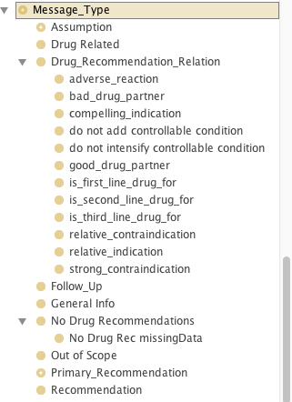

Figure . Message type hierarchy as of 2019-02-10.

## EON Guideline Model

The **EON Guideline Model** consists of a set of classes and attributes that describe concepts and relations with which the content of clinical guidelines are formalized. The content of a particular guideline is encoded as instances and as attribute values of these classes. The EON Guideline Model includes classes and attributes for modeling concepts such as the target population of the guideline, goals, and a clinical algorithm that sequences the decisions and actions of a guideline. Depending on the nature of the guideline knowledge to be modeled, the EON Guideline Model may allow a clinical algorithm to be specified as a collection of scenarios, decisions to be made in these scenarios, and preferred alternatives at these decision points.

This section describes the details of the EON Guideline Model as it is used in the ATHENA-CDS Knowledge Base. It addresses individuals charged with maintaining the ATHENA-CDS Knowledge Base or with creating a guideline knowledge base like the ATHENA-CDS Knowledge Base.

The description of the EON Guideline Model and the ATHENA-CDS Knowledge Base will be divided into four parts:

1. properties of the Management_Guideline class other than the clinical algorithm,
2. the clinical algorithm,
3. the actions (e.g., substituting drugs, raising doses, and sending messages) that the CDS SYSTEM can recommend to the end users
4. the clinical interventions (i.e., Drug_Usage and Guideline_Drug classes) whose properties (e.g., indications and dose range) are used by the Guideline Interpreter to generate recommendations.

The topics covered by these subsections represent the four areas that a developer of a knowledge base has to conceptualize the guideline knowledge in creating a computable guideline knowledge base in the EON format.

### Management Guideline

The *label* attribute is a short name for the guideline. It also serves as the identifier for the Guideline Interpreter to access the correct instance of Management_Guideline (i.e., JNC-VI Hypertension Guideline, in the case of ATHENA-CDS Knowledge Base.

The eligibility_criteria attribute (Eligibility Criteria slot in Figure 7) defines the target population of a guideline encoded in EON. In applying the eligibility criteria, the Guideline Interpreter identifies a patient as *eligible* if none of the eligibility criteria explicitly rule out him or her (i.e., a criterion evaluates to *false*). Thus, the Guideline Interpreter will apply the guideline to the patient even if there is insufficient information to rule out a patient (i.e., if the criteria evaluate to *unknown)*. Section 2.4 describes the formats of criteria.

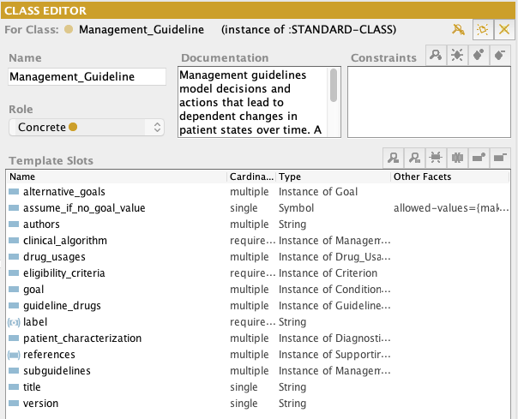

Figure 34 - The definition of the Management_Guideline class

The *goal* attribute is used to specify the goals a guideline establishes for each patient. Values of the attribute should be a list of Conditional_Goal instances. Figure 35 shows an example of a conditional goal. The selection_criterion attribute (Selection Criterion in Figure 35) is a Boolean criterion that, if evaluated to *true* for the patient, determines whether the criterion_to_achieve (Criterion To Achieve) applies to the patient.

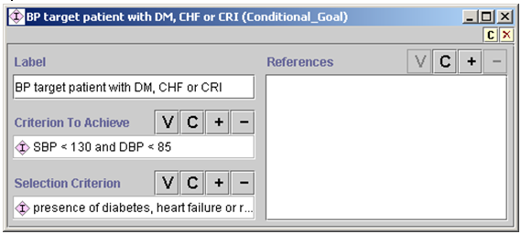

Figure 35 - Conditional_Goal example in the ATHENA-CDS Knowledge Base

Goals in the Guideline Interpreter should be mutually exclusive. That is, only one conditional goal should be applicable to a patient. The criterion to achieve can be a complex conjunction or disjunction (*and* and *or*) of other criteria. In the ATHENA-CDS Knowledge Base, the goals are target systolic and diastolic blood pressures.

The goal criteria can be used in decision-making through instances of the Goal_Criterion class. Figure 36 shows the goal criterion used in ATHENA-CDS. It is simply a reference to an instance of Management_Guideline. The Guideline Interpreter evaluates the conditional goals associated with the guideline, and returns *true*, *false*, or *unknown*. If the goal criterion evaluates to *unknown*, then the Guideline Interpreter generates alternative recommendations based on assumptions it makes about the patient’s status (i.e., the assumption that the patient satisfies the goal or that the patient does not satisfy the goal).

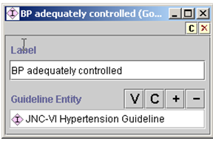

Figure 36 - Goal_Criterion used in the ATHENA-CDS Knowledge Base

The patient_characterization attribute is the place to specify abstractions about a patient case that the developer of the knowledge base wants the Guideline Interpreter to return as part of the recommendation. In the ATHENA-CDS Knowledge Base, the specified abstractions are risk groups used to classify patients (e.g., risk group A being no risk factor and no target organ damage or clinical cardiovascular disease). The values of this attribute are instances of the Diagnostic_Term_Metaclass. Currently, the ATHENA-CDS GUI does not display these patient abstractions that the Guideline Interpreter computes and returned as part of the recommendation.

The drug_usages and guideline_drugs slots specify the classes of drugs (as Drug_Usage instances) whose usage are fully specified in the guideline and the generic drugs (as Guideline Drugs instances) whose dosing properties are specified. (See Section 2.3.4)

The slot alternative_goals is used to encode performance measures. A performance measure would be modeled as instances of the Goal class, with inclusion and exclusion criteria and conditional goals modeling the numerator and denominators of a performance measure.

The *title, version,* and *authors* attributes are not used by the CDS SYSTEM, but should be used to annotate the knowledge base.

### Clinical Algorithm

Individuals charged with creating a guideline knowledge base like the ATHENA-CDS Knowledge Base—the developers of the knowledge base—can specify the flow of the decisions and actions of a guideline in the clinical_algorithm attribute of the Management_Guideline class. The value of this attribute should be an instance of the Management_Diagram class. Protégé provides a graphical tool for viewing and editing the algorithms (Figure 37). A clinical algorithm in the EON system basically functions to organize guideline recommendations into a collection of starting scenarios (pink squares in Figure 37), such that a patient case falls into exactly one of them. Associated with each scenario is a *consultation guideline* where the developer can specify actions that should be performed for all patients classified into the scenario (actions such as showing warning messages about current medications).

Control of flow in an algorithm is achieved by using instances of Case_Step (yellow diamond in Figure 37), by which exactly one path is selected (i.e., deterministic choice); or by using instances of Choice_Step (light yellow ovals), where more than one choice is possible (i.e., non-deterministic choices). Instances of Action_Choice (green ovals) follow a choice step. In action choices, the developer specifies the criteria for ruling out or for preferring the choice; and Action_Specification defines the recommended actions for that choice. Subclasses of Action_Specification fall into two categories: (1) those that perform actions directly (mostly sending messages to the user) and (2) those that do something to an “activity” (e.g., recommending adding or stopping the use of a drug, evaluating the set of drugs to add, and increasing the dose of current medications).

Figure 37 is a partial view of a simple clinical algorithm in the ATHENA-CDS Knowledge Base. It shows two possible starting scenarios. The first one (characterized by SBP>=220 or DBP>=115) leads to an Action_Choice step where an urgent attention message is sent. The second scenario includes cases in which the patient is not taking any antihypertensive medication, as the patient’s blood pressures are not in the range of those in the first scenario. This scenario leads to four possible management choices: adding an antihypertensive drug, recommending lifestyle changes, prescribing an ACE inhibitor, and prescribing a beta-blocker for secondary prevention. If a specific drug should be added but none has been indicated (see branch of the *no indicated drug?* case step), the algorithm makes default choices; otherwise the algorithm continues to a scenario where messages are generated that suggest considering the addition of drugs.

The Guideline Interpreter uses a clinical algorithm by:

1. determining which starting scenario into which the patient case falls,
2. following the paths from that scenario, then
3. stopping when it reaches a terminal node (i.e., a node with no outgoing link) or when it encounters case steps or choice steps for which there is no preferred alternative.

As the Guideline Interpreter traverses the clinical algorithm, it constructs a recommendation that is eventually presented to the end user of the CDS SYSTEM.

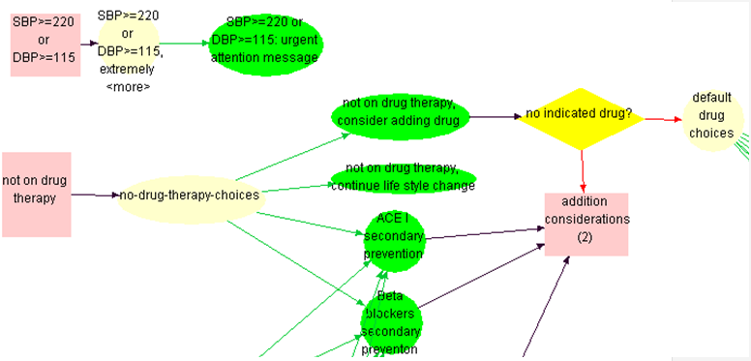

Figure 37 - Part of a clinical algorithm in the ATHENA-CDS Knowledge Base

The components of the clinical algorithm are described in more detail, below.

**Scenario**

Scenarios are mutually exclusive; patients flow through only one "top level" (more on this later) Scenario. Control of flow through particular Scenario(s) are via Preconditions. Each Scenario can have a "Consultation Template", that are diagrams/algorithms in themselves that have their own Consultation_Action_Step and Consultation_Branch_Step (more later). Examples of Scenarios

* No drug therapy
* One drug therapy

Figure 38 shows the details of the *not on drug therapy* scenario of the clinical algorithm. Because new_encounter is true (shown as New Encounter in the figure), the Guideline Interpreter will treat the scenario as a possible starting point in the clinical algorithm. The type of patient for whom a scenario is appropriate is defined by the criterion in the *precondition* slot of the scenario (shown as Precondition). At the start of its operation, the Guideline Interpreter collects all instances of Scenario class whose new_encounter slot is checked, and uses the value of their *precondition* slot to determine which scenario to use for the patient. For example, in Figure 38, the clinical algorithm’s new_encounter slot is checked, so the *not on drug therapy* scenario will be used as a starting point in generating the guideline advisory if its precondition (shown as *no drug therapy and [SBP<220 and DE..* in ) evaluates to *true*. The followed_by slot (shown as Followed By in Figure 38) links the scenario to the next node in the clinical algorithm. The ATHENA-CDS algorithm contains five new_encounter scenarios, which are the potential starting points for a patient case: one based on blood pressure (SBP>=220mmHg or DBP>=115mmHg) and four based on the number of antihypertensive medications prescribed for the patient (0, 1, 2 or 3, and 4. In Figure 37, starting scenarios are the two orange rectangles: SBP>=220 or DBP>=115, and *not on drug therapy*.

In general, anyone creating a guideline knowledge base should ensure that the definitions of scenarios have preconditions that use commonly available data, and the classification of patients into scenarios should be unambiguous. Furthermore, one scenario should lead to management decisions that differ from decisions resulting from other scenarios. However, some overlap is acceptable (e.g., secondary prevention decisions are common to all ATHENA-CDS scenarios).

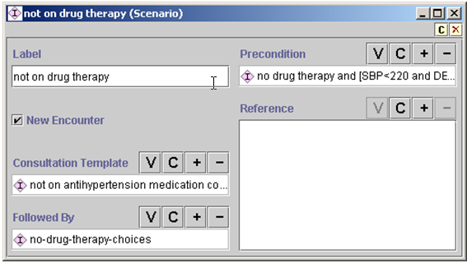

Figure 38 - *Not on drug therapy* scenario example in ATHENA-CDS

In addition to determining the starting point for generating a guideline advisory, the second function of a scenario is to specify actions that should be performed for patients who have been classified to meet the preconditions of the scenario (Figure 38 and Figure 39). The Consultation_Guideline has a *steps* slot where these scenario-based actions are specified. The steps of a Consultation_Guideline consist of instances of Consultation_Branch_Step (Figure 40) and Consultation_Action_Step (Figure 41).

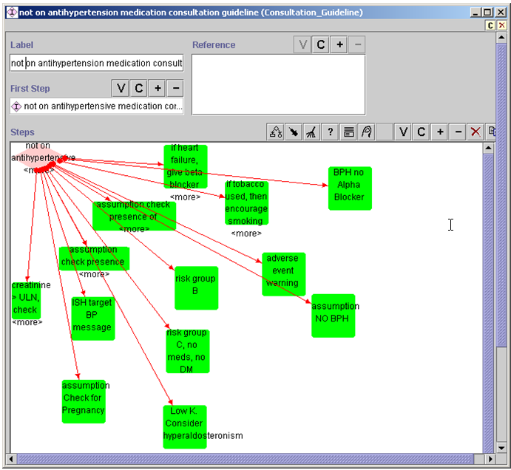

Figure 39 - Consultation_Action_Step generating messages within Consultation_Guideline. For instance, it encourages smoking cessation when the patient is a smoker.

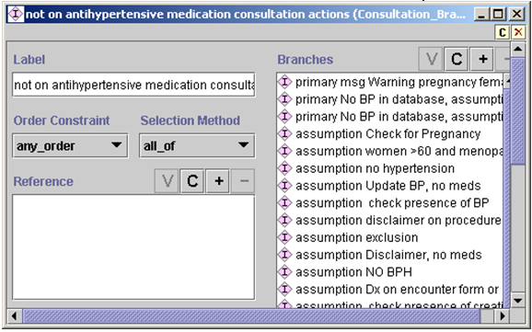

Figure 40 - Consultation_Branch_Step example

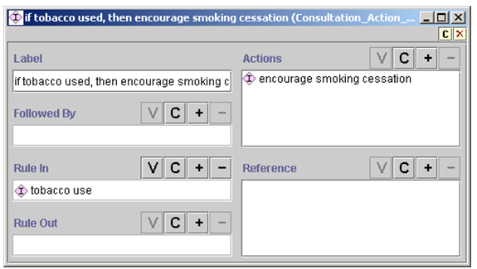

Figure 41 - Consultation_Action_Step example showing the “encourage smoking cessation” action if the “tobacco use” rule_in condition (shown as Rule In) is true

The Consultation_Guideline class was designed to allow interactive presentation of and requests for information. Each instance of Consultation_Branch_Step represents a potential decision point for determining what information to present or to request. In the current implementation of the Guideline Interpreter, however, the Consultation_Guideline allows presentation only of textual messages. An instance of Consultation_Guideline should start with an instance of Consultation_Branch_Step (specified in the first_step slot). Possible values of the *branches* slot (shown as Branches) are other instances of Consultation_Branch_Step and Consultation_Action_Step. An instance of Consultation_Action_Step has a rule-in and a rule-out condition, where an action step is marked as preferred if it is not ruled out and is ruled in. ATHENA-CDS GUI presents to the user only messages that are preferred. The *actions* slot (shown as Actions) in Consultation_Action_Step should contain instances of On_Screen_Messages or its subclasses. In the ATHENA-CDS Knowledge Base, these messages give warnings about specific conditions a patient may have and assumptions the system makes.

**Case_Step**

A decision represents a choice from a set of competing alternatives. The EON Guideline Model supports various ways of describing alternatives, and also the corresponding selection mechanism. In the current model are two subclasses of decisions: Case_Step models decisions that are resolved by evaluating an expression and using the result to select one alternative; and Choice_Step models decisions for which one or more alternatives may be preferred, leaving the choice to the end user. Thus, ATHENA-CDS SYSTEM may recommend that, according to the guidelines, both Beta Blocker and ACE Inhibitor are good choices for a patient, leaving the actual decision for a clinician to make.

Figure 42 shows an instance of Case_Step that contains an expression (with label *no indicated drug and cannot increase dose?)*. The expression, in this case, evaluates to true, false, or unknown. If the expression evaluates to true, then the system steps to the choice step to consider default drug recommendations. If the expression evaluates to false, then the system goes to a scenario where, through the use of a consultation guideline, messages are generated. If the expression evaluates to unknown, because no branch for the unknown value is specified, the Guideline Interpreter will not continue on this path.

The system determines which branch to take based on the value specified in the link between the case step (yellow diamond in Figure 42) and its branches (the red arrows). The link is an instance of the Case_Selection class (Figure 43), which has slots for the source and target of the link (first_object/First Object and second_object/Second Object, respectively) and the *value*/Value slot.[6] If the expression in the first_object slot evaluates to the value in the Value slot, the object in the second_object slot should be activated.

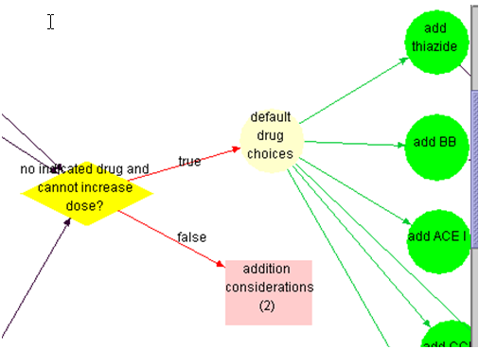

Figure 42 - Illustration of the use of Case_Step (yellow diamond). If an expression in Case Step evaluates to true (i.e., no drug has been recommended based on indications), the Guideline Interpreter evaluates the alternatives in the *default drug choices* step (yellow oval). If the expression evaluates to false, a scenario *(addition considerations (2)*) is used to generate appropriate messages. The red arrows branching from the case step (labeled *true* and *false* in the graph) are instances of the Case_Selection class shown inFigure 43 - Case_Selection instance. It specifies that if the expression in the source (First Object) evaluates to the value in the Value slot, then take the step in the target (Second Object). Figure 43.

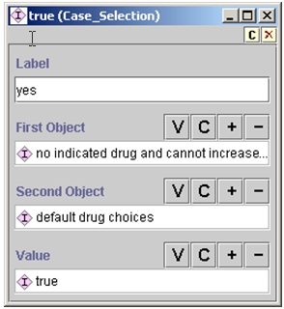

Figure 43 - Case_Selection instance. It specifies that if the expression in the source (First Object) evaluates to the value in the Value slot, then take the step in the target (Second Object).

**Choice_Step and Action_Choice**

Choice_Step and the associated Action_Choice are instances that model non-deterministic choices (i.e., more than one choice can be presented to the end user). An instance of the Choice_Step class (Figure 44) contains only links to the previous step and to the alternatives in the choice (*branches* slot, displayed as Branches). An Action_Choice instance (Figure 45) contains decision criteria (strict rule-in and strict rule-out conditions) for determining a preference for actions specified in the *actions* slot (shown as Actions). If a strict rule-out condition evaluates to true, then an alternative is rejected. If the strict rule-out condition is false or unknown and a strict rule-in condition evaluates to true, then the alternative is marked as preferred. If neither evaluates to true, then the preference for the choice can be determined by a default preference associated with the action choice. The current Guideline Interpreter is configured so that, if there is no default preference when neither strict_rule_in nor strict_rule_out conditions evaluate to true, the action choice and subsequent steps are not further pursued.

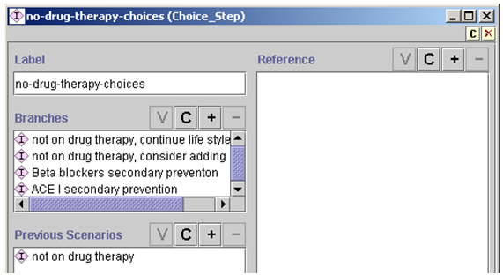

Figure 44 - An instance of Choice_Step. It contains only links to the previous step and alternatives in the choice (Branches slot).

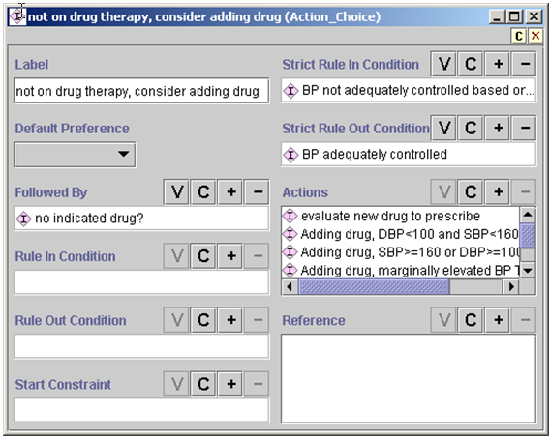

Figure 45 - Example of Action_Choice. Decision criteria (strict rule-in and strict rule-out conditions) determine preferences for actions specified in the Actions slot.

Action_Choice includes actions that are instances of the Action_Specification class, that include, Message, Order_TestProcedure, Referral, etc.

An Action_Choice -must- be preceded by a Choice_Step or a Case_Step.

### Action Specification

Figure 46 shows the list of possible action specifications (Action_Specification) with instances that individuals building the ATHENA-CDS Knowledge Base can add to the *actions* slot of Action_Choice instances (shown as Actions in Figure 45). The action specifications can be placed into two broad categories: those generating textual output (shown as messages in the ATHENA-CDS Client) and those involving adding, deleting, or substituting activities (drug recommendations).

**Messages**

In the first category of Action_Specification are those action specifications in the EON Guideline Model that essentially send textual messages to the user. They include On_Screen_Message and its subclasses, and also—because of the lack of complete implementation in the current ATHENA-CDS version of the Guideline Interpreter—Procedure, Collect_Patient_Data (and its subclasses), Present_Data, Schedule, Referral, Acute_Prescription, Modify_Activity, Step_Down_Activity, Step_Up_Activity, Stop_Activity, and Evaluate_Current_Activity classes. If instances of these classes are used (e.g., Schedule and Referral), the current Guideline Interpreter simply inserts the *label* and *description* slot values of these instances into the recommendation. In order to issue a scheduling recommendation, an instance of the Schedule class should be created. This should be done in case the Guideline Interpreter changes in the future, and also because the ATHENA-CDS GUI may be able to use the information that the scheduling recommendation is an instance of Schedule class.

Instances of On_Screen_Message class (Figure 47) contain the text of any message that will be part of a patient advisory displayed by an ATHENA-CDS Client. The class also has a message_type slot (shown as Message Type) whose possible values are specified as classes in the Value_Type hierarchy (Section 2.2.2). The message types are used by the ATHENA-CDS Client to determine the display location of the messages. If the criterion in the rule-in condition slot evaluates to “true,” the message is added to the advisory; otherwise the On_Screen_Message has no effect.[7]

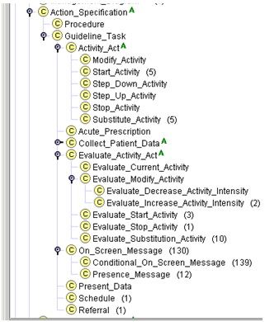

Figure 46 - Different types of Action_Specification in the EON Guideline Model

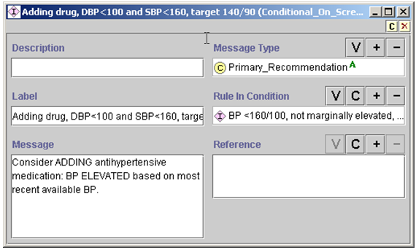

Figure 47 - Example of On_Screen_Message

The Parameterized_Message class of messages… <To Do>

**Drug Recommendations**

In the second category of Action_Specification are recommendations to add, delete, substitute, or modify prescribed drugs (Figure 50). Subsection 2.3.4 describes the properties of drug classes and generic drugs that are used in generating drug-related recommendations. Below, the action specifications of this category are described.

**Activity_Act**

**Start_Activity**

**Substitute_Activity**

**Evaluate_Activity_Act**

**Evaluate_Modify_Activity**

**Evaluate_Decrease_Activity_Intensity  
Evaluate_Increase_Activity_Intensity**

**Evaluate_Start_Activity**

**Evaluate_Stop_Activity**

**Evaluate_Substitution_Activity**

Figure 50 - List of actions that modify drug prescriptions

The difference between Activity_Act and Evaluate_Activity_Act is that, for both Start_Activity (Figure 51) and Substitute_Activity (Figure 52), the drug class or generic drug to add or substitute is always marked as preferred in the recommendation, regardless of whether the drug class or generic drug has a specific indication or not. Thus, ACE Inhibitor may have no specific indication (i.e., Diabetes and Proteinuria/Renal Manifestations or Heart Failure), but the Guideline Interpreter may nevertheless recommend it to be added in some circumstances (e.g., when using it as the default drug to add). In subclasses of Evaluate_Activity_Act, on the other hand, the Guideline Interpreter evaluates the indications, contraindications, drug partners, and complications of the selected drug classes, but it does not mark any of the evaluated drug classes as preferred. Instead, the results of evaluating these properties of selected drug classes are made available as part of an advisory.

For example, an instance of Start_Activity to start a Cardioselective Beta Blocker may, when applied to a particular patient, result in the following recommendation:

**Add evaluation**

activity_to_start: Cardioselective Beta Blocker

relative_contraindications: Obstructive_Pulmonary_Disease(492.8, 496.)

preference: preferred

messages:

name: add beta blocker, obstructive pulmonary disease

text: Cardiovascular benefits of beta blocker therapy may outweigh the increased risk of bronchospasm in this patient

action_spec_class: On_Screen_Message

An Evaluate_Activity_Act to start Cardioselective Beta Blocker, when applied to the same patient case, will result in the same recommendation, except that the *preference* attribute will not have a value. (The current ATHENA-CDS GUI does not display this preference information.)

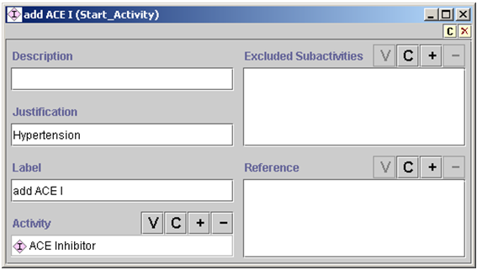

Figure 51 - An example of Start_Activity. The excluded_subactivities/Excluded Subactivities slot is not used.

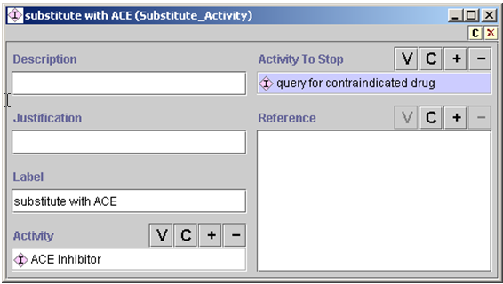

Figure 52 - An example of Substitute_Activity

In Substitute_Activity, the drug to be deleted is specified using a PAL_Query (see 2.4.3 for details about PAL query). Figure 53 shows an instance of PAL_Query that references a PAL query expression (not shown). The query expression, upon evaluation, returns an instance of Medication for verapamil, if verapamil is one of the active prescriptions of the patient. Then, based on the value of key_slot (shown as Key Slot), returns the drug_name of that instance (i.e., the string *verapamil*).

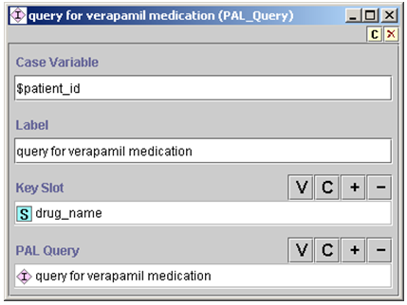

Figure 53 - PAL_Query that returns the drug_name of the query for verapamil medication

Among the subclasses of Evaluate_Activity_Act is Evaluate_Start_Activity (see Figure 54). For each instance of Drug_Usage enumerated in the alternatives slot, the Guideline Interpreter will evaluate its indications, contraindications, drug partners, drug partner to avoid, complication factor, formulary preferred drug,[8] and collateral actions and make them available in the advisory.

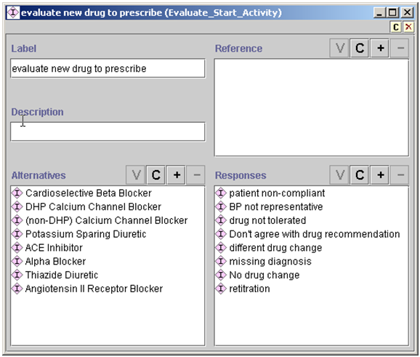

Figure 54 - Example of Evaluate_Start_Activity

Figure 55 shows an example of Evaluate_Stop_Activity, which is another subclass of Evaluate_Activity_Act. Given the example, the Guideline Interpreter will:

1. Find all instances of Medication (activity_class/Activity Class slot) whose domain term (domain_term/Domain Term) is subsumed by the Antihypertensive_Agents slot.
2. For these Medication instances, find instances of Drug_Usage (activity_spec/Activity Spec slot) whose Drug_Class_Name slot value subsumes the drug names of the Medication instance.
3. Evaluate the indications, contraindications, drug partners, drug partners to avoid, complication factor, formulary preferred drug, and collateral actions of the drug usage as part of the recommendation to discontinue this medication.

Using a PAL query is the alternative to this complicated sequence of operations.

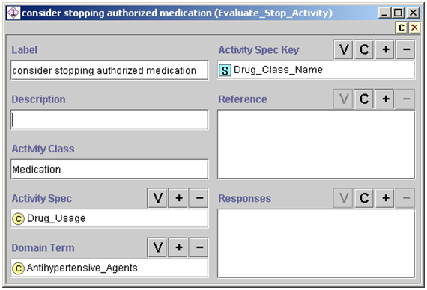

Figure 55 - An instance of Evaluate_Stop_Activity

Figure 56 shows a use of Evaluate_Substitute_Activity that does not use a PAL query to specify which drug is to be deleted in the substitution. The usage is exactly like Evaluate_Stop_Activity (Figure 55), except that—in addition to finding the Drug_Usage instance for the medication to be deleted (e.g., furosemide) and evaluating its properties—the Guideline Interpreter evaluates, for the drug class to be added (e.g., thiazide diuretics), the indications, contraindications, drug partners, drug partners to avoid, complication factor, formulary preferred drug, and collateral actions.

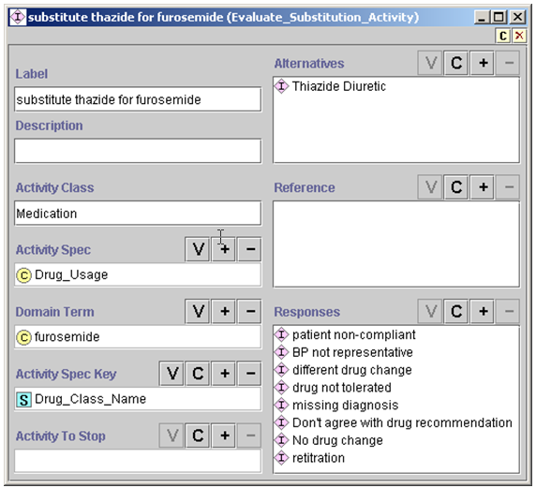

Figure 56 - Example of Evaluate_Substitute_Activity usage, without employing a PAL query

Figure 57 shows an example of using a PAL query to find the drug to delete in the substitution evaluation. The PAL query (not shown)[9] finds antihypertensive medications that are to be discontinued. Then the Guideline Interpreter finds the Drug_Usage instances associated with the drugs to be discontinued[10] and evaluates their properties. Finally, the Guideline Interpreter evaluates the properties of the drug classes to be added in potential substitution. The Evaluate_Substitution_Activity results in recommendations to discontinue some medications and start others.

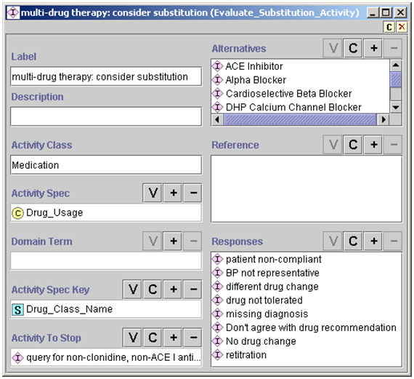

Figure 57 - Example of Evaluate_Substitution_Activity usage, employing a PAL query to determine which drugs should be substituted

Evaluate_Increase_Activity_Intensity (Figure 58) illustrates how to specify the evaluation of a drug dose for possible increase. The PAL query in the activities_to_modify/Activities To Modify slot returns the names of drugs that have a daily dose below the maximum level and do not have any contraindications or bad drug partners. The Guideline Interpreter then finds the Guideline_Drug instances (activity_spec/Activity Spec slot) whose generic_drug slot values match those of the medications. From the dose-level table in these Guideline Drug instances, the Guideline Interpreter determines the level to which the medications’ daily doses should be increased. The current ATHENA-CDS GUI does not make use of this dose-level information.

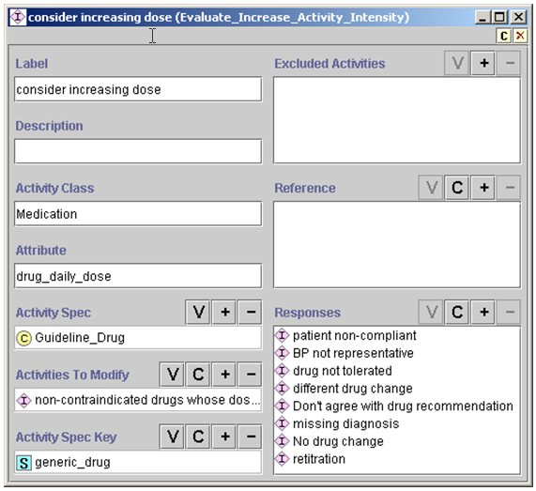

Figure 58 - Example of Evaluate_Increase_Activity_Intensity

### Drug Usage and Guideline Drug Activities

**Drug_Usage**

The Drug_Usage class contains declarative information about properties of a drug class, such as Cardioselective Beta Blocker (Figure 59). The drug_class_name slot links this drug-usage instance to the corresponding drug class in the medical concept model’s medication hierarchy. The formulary_preferred_drug_in_class slot (shown as Formulary Preferred Drug in Class in the figure) links this drug-usage instance to the generic drugs that can be prescribed for this drug class.

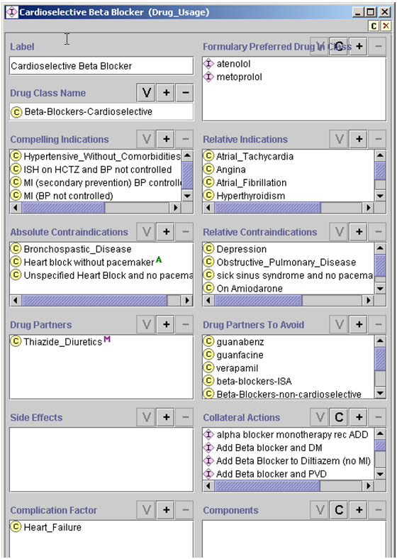

Figure 59 - Details of a Drug_Usage instance, showing the declarative properties of a drug class that can be used in the ATHENA-CDS SYSTEM

*Algorithm for evaluating a drug class*

In evaluating a drug class to add or delete:

1. The Guideline Interpreter determines whether the patient has any of the compelling and relative indications, absolute and relative contraindications, drug partners to avoid, or complication factors that are specified in the drug-usage instance of the drug class.
2. If the patient has at least one complication factor, the Guideline Interpreter will not generate any recommendation concerning the specified drug.
3. If the drug class is not absolutely contraindicated and there is at least one compelling or relative indication, then—unless the patient is already taking a drug of this class—the Guideline Interpreter will include the drug class among the ones it recommends adding.
4. If the recommendation includes adding a drug class, the Guideline Interpreter checks the formulary_preferred_drug_in_classslot (shown as Formulary Preferred Drug in Class) to see whether there is a more specific formulary preferred drug. These drugs are instances of Guideline_Drug class (Figure 62). If there is only one guideline drug specified in the Formulary Preferred Drug in Class slot and it is not ruled out as a result of evaluating the rule-out condition, then that drug is used as the formulary preferred drug. If there is more than one formulary preferred drug that is not ruled out, then the system evaluates the rule-in criteria. If at least one guideline drug is ruled in, then the ruled-in drugs are considered to be preferred. If no drug is ruled in, then the system returns all drugs that are not ruled out as possibilities that a clinician can select.
5. After determining whether a drug should be added or deleted or have its dose increased, the system—as part of the evaluation of a drug class—assesses the Collateral_Action instances in the collateral_actions slot of a Drug_Usage.

Figure 60 shows an instance of Collateral_Action class. It contains a mood/Mood slot that specifies the context (Recommend_Add, Recommend_Delete, or Recommend_Increase_Dose) where the actions specified in the actions/Actions slot are applicable. The *actions* slot should contain instances of Action_Specification that generate messages (e.g., Figure 61).

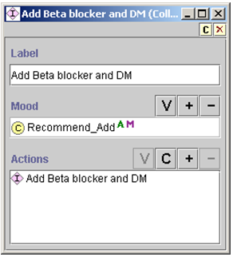

Figure 60 - An example of Collateral_Action associated with a drug class

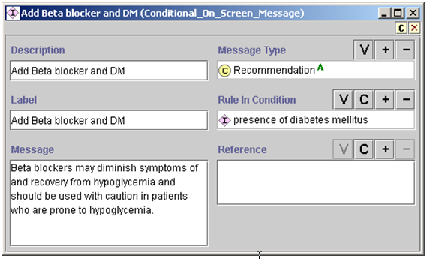

Figure 61 - An example of Message associated with a drug recommendation

**Guideline_Drug Activities**

As described earlier in this subsection, instances of the Guideline_Drug class make it possible to specify preferred drugs in the formulary. The second role of Guideline_Drug is to encode dose information, such that the system can determine when to recommend increasing the dose of a drug. Figure 62 shows an instance of the Guideline_Drug class. It contains: a reference to the generic drug metoprolol in the medication hierarchy, a table of dose-level ranges *(*dose_level_ranges/Dose Level Ranges slot), and the specification of the maximum recommended dose level (max_recommended_dose_level/Max Recommended Dose Level slot). The dose-level range table is a set of Range_Mapping_Entry instances that specifies the lower and upper dose limits for a nominal dose level (Figure 63). The system would recommend increasing the dose of a drug only if the current daily dose is in a range below the maximum recommended dose level.

Currently, the Guideline Interpreter ignores the starting_dose, dose_strength_unit, drug_usage, duration_constraint, prescribable_items, and collateral_actions slots of the Guideline_Drug class.

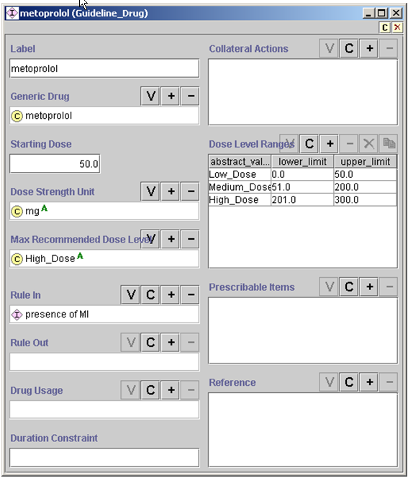

Figure 62 - An instance of Guideline_Drug class

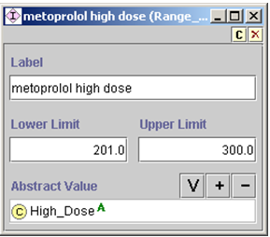

Figure 63 - An instance of Range_Mapping_Entry, showing the lower and upper limits of “high dose” for metoprolol.

## Expressions

The primary mechanism through which the EON Guideline Model interacts with the patient data model and medical concept model involves decision criteria and other expressions written in the EON’s expression languages. These decision criteria and expressions are what make encoded guideline knowledge bases, like that of ATHENA-CDS, “computable” (i.e., they can be used to automatically match patient data to conditions in a guideline).

Guideline authors and developers can write expressions and decision criteria in the EON Guideline Model in one of three languages. Expressions and decision criteria in these two languages are represented as Protégé classes and instances (Figure 64).

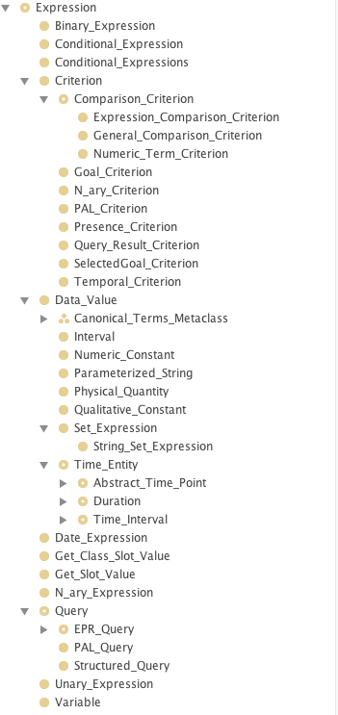

Figure 64 - Classes that make up expression languages in EON

### Template-based Expression Language

The first expression language consists of a set of object templates, allowing a guideline author to encode common but relatively simple criteria by filling in forms generated by Protégé. Expressions in this language are instances of those subclasses of the Expression class that are not Numeric_PAL_Criterion, PAL_Criterion, Query_Result_Criterion, Structued_Query, and PAL_Query.

Consider the example: “(Presence of diabetes mellitus) and (Minimum creatinine within last two months is greater than upper limit of normal)”. This example can be encoded using a nested series of object templates described below.

Criteria encoded in this template-based language evaluate to *true*, *false*, or *unknown*. For example, in the absence of any serum creatinine result, the criterion that compares the serum creatinine value to its upper limit may evaluate to *unknown*. However, if a patient does not have a medical problem, this fact is usually not explicitly recorded. When checking for the presence or absence of medical problems specified in the medical concept model, the Guideline Interpreter assumes that, if a problem is not explicitly recorded, the patient does not have that problem. Accordingly, these criteria evaluate to *false* when there is no record of a medical condition specified in these criteria.

In most of the EON Guideline Model, a criterion makes a difference when it evaluates to *true*. For example, strict rule-out and strict rule-in conditions apply only when the conditions evaluate to *true*. Thus, in most cases, the *unknown* truth value[11] has the same effect as the *false* truth value. In three places, however, *unknown* makes a difference:

1. In checking eligibility for guidelines, *unknown* has the same effect as *true*. In other words, a patient is not eligible for a guideline only if at least one eligibility criterion evaluates to *false* (see Section 2.3.1).
2. If a goal criterion evaluates to *unknown*, then the Guideline Interpreter generates alternative recommendations based on assumptions that the goal is first satisfied and then unsatisfied (see Section 2.3.1).
3. In a Case_Step, flow of control is based on the value of the expression specified in the step. If the value of the expression is *unknown*, and if there is a branch that matches the *unknown* value, then that branch will be taken. Otherwise, the Guideline Interpreter will stop following the path.

Below, selected classes in the template-based language are described in detail. The construction and usage of the classes other than those described are similar.

**Presence_Criterion**

Consider: *(Presence of diabetes mellitus).* This expression can be encoded using an instance of the Presence_Criterion class Figure 65. Presence_Criterion allows the specification of the presence or absence of patient data model instances (e.g., Note_Entry instances) that correspond to domain terms from the medical concept model (e.g., diabetes mellitus).

The *period* (shown as Period) attribute specifies how far back to look for the record. In the absence of a value for the *period* attribute, the Guideline Interpreter looks at all past data available to it. The *mood* (shown as Mood) attribute is used only with Medication records, and is explained in Subsection 2.2.3.

The evaluation of a Presence_Criterion instance returns *true* or *false*. For a criterion with the *presence* (shown as Presence) flag checked, the criterion is true if and only if there exists an entry of the entry_type (Entry Type) that satisfies the *mood* and *period* constraints specified in the Presence_Criterion instance.

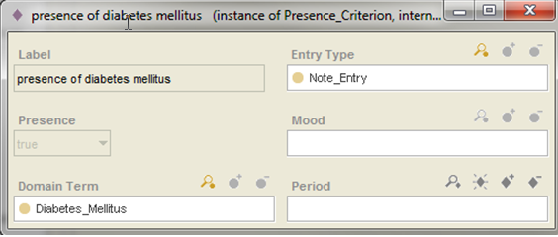

Figure 65 - An instance of Presence_Criterion that is checking whether there has ever been a note entry of diabetes mellitus diagnosis

**General_Comparison_Criterion and Numeric_Comparison_Criterion**

Next consider the condition: *Minimum serum creatinine within last two months is greater than upper limit of normal.* An individual maintaining the ATHENA-CDS Knowledge Base can encode this condition as an instance of the General_Comparison_Criterion. Figure 66 shows the entry_type, domain_term, and valid_window attributes, whose values are used by the Guideline Interpreter to get all numeric entry instances whose domain term is Creatinine and whose timestamp is *within last 2 months*. The aggregation operator, *minimum,* is used to identify the minimum among the queried values. The *value* (Value) attribute specifies that the minimum value has to be greater than the upper limit of normal of Creatinine. Following are explanations of each attribute:

* *Entry_type (Entry Type)* – The attribute can be Numeric_Entry or Note_Entry.
* *Domain_term (Domain Term)* – This is a class from the domain concept model.
* *Aggregation_operator (Aggregation Operator)* – Possible values are minimum, maximum, most recent, average, and count (the number of returned values).
* *Valid_window (Valid Window)* – The valid_window attribute specifies how far back to look for the value being queried. It is an instance of Relative_Time_Interval_Definite (Figure 67).[12]
* *Operator* – Possible values are >,>=, <. <=, =, eq, and neq; eq and neq are used to compare non-numeric values.
* *Assume_if_no_value (Assume If No Value)* – Possible values are no_assumption, assume_satisfied, assume_unsatisfied, and use_default. If this slot is not filled in, or if no_assumption is specified, evaluation of the criterion makes no assumption and the result may be *true, false,* or *unknown*. Assume_satisfied or assume_unsatisfied mean the criterion is assumed to be true or false, respectively, if there is no value for the domain term. Use_default means the default value specified in the default_value (Default Value) slot should be used. If no assumption is specified and there are no data for evaluating the criterion, *unknown* is the result of evaluating the criterion.

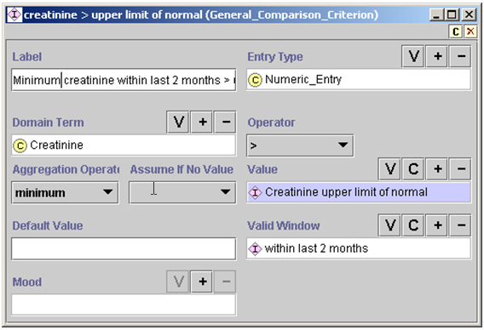

Figure 66 - An instance of General_Comparison_Criterion, stating that the minimum creatinine value within the last two months is greater than the upper limit of normal

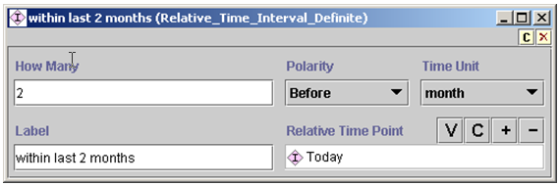

Figure 67 - An instance of Relative_Time_Internal_Definite, specifying the time interval “two months before today”

The *value* (Value) slot of a General_Comparison_Criterion should be an instance of Expression, whose subclasses are:

* *Binary_Expression* – subtraction or division
* *N_ary_Expression –* multiplication or addition of multiple arguments
* *Controlled_Term –* reference to controlled terminology; e.g., the Male class from the medical concept model
* *Numeric_Constant –* an instance with a number in its *value/*Value slot
* *Qualitative_Constant –* an instance with an arbitrary string in its *value/*Value slot
* *Get_Class_Slot_Value and Get_Slot_Value –* classes with instances specifying queries in Protégé to get a slot value either from a class or from an instance
* *EPR_Query –* Queries for patient data in the formats of the EPR_Entities (see Subsection )

The definitions of most Expression classes are straightforward. Here, only Get_Class_Slot_Value and the types of EPR_Query are illustrated. Both Get_Class_Slot_Value and Get_Slot_Value are designed to query values from the Protégé classes and instances so they can be compared with patient data. Figure 68 shows an instance of Get_Class_Slot_Value that queries for the value of the UpperLimitOfNormal slot from the Creatinine class. (Recall that Interval-Valued_AtomicTest_Metaclass metaclass, described in Subsection 2.2.2, allows class instances of this metaclass to specify upper and lower limits of normal.)

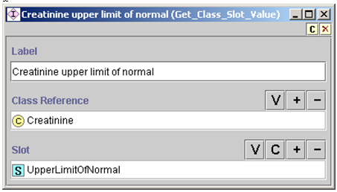

Figure 68 - An instance of Get_Class_Slot_Value. It obtains the value of the UpperLimitOfNormal slot from the Creatinine class.

Among the subclasses of the EPR_Query class, Numeric_Term_Query and Qualitative_Term_Query may be useful. An instance of Numeric_Term_Query is shown in Figure 69. It specifies a query for the most recent value of the MD_Typical_Systolic_BP. MD_Typical_Systolic_BP is the systolic blood pressure a clinician enters into ATHENA-CDS to update an advisory. The query returns a numeric result.

An instance of Qualitative_Term_Query analogously has the same format but returns a string as its result.

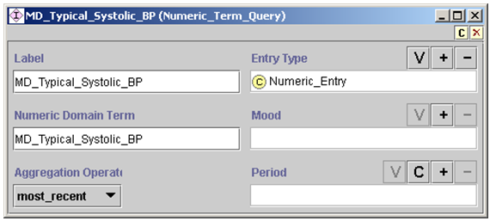

Figure 69 - A Numeric_Term_Query that asks for the most recent value of the MD_Typical_Systolic_BP

**N_ary_Criterion**

Instances of N_ary_Criterion[13] allow other criteria to be specified in Boolean combinations (*and, or,* and *not*). Figure 70 illustrates how to combine Presence_Criterion and General_Comparison_Criterion, discussed above, to form a conjunctive n-ary criterion using the *and* operator.

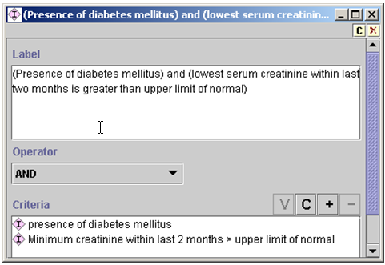

Figure 70 - An instance of N_ary_Criterion that requires both of its constituent criteria to be true, as indicated by the AND operator

Recall that criteria expressed in the template-based expression language can evaluate to *true*, *false*, or *unknown*. Accordingly, the truth tables used to derive the truth values of N_ary_Criterion take the *unknown* truth value into account. The following truth tables are used:

|  |  |  |  |
| --- | --- | --- | --- |
| AND | true | false | unknown |
| true | true | false | unknown |
| false | false | false | false |
| unknown | unknown | false | unknown |

|  |  |  |  |
| --- | --- | --- | --- |
| OR | true | false | unknown |
| true | true | true | true |
| false | true | false | unknown |
| unknown | true | unknown | unknown |

|  |  |  |  |
| --- | --- | --- | --- |
| NOT | true | false | unknown |
|  | false | true | unknown |

Other criteria templates in the EON Guideline Model:

* support simplified numerical value comparisons (Numeric_Term_Criterion, as illustrated in Figure 71), where the value slot can only be a number, instead of an instance; and
* allow a statement expressing that the goals associated with a guideline are being reached (Goal_Criterion as explained in Subsection 2.3.1 and illustrated in Figure 36).

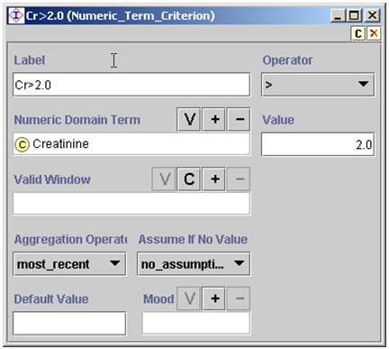

Figure 71 - An instance of Numeric_Term_Criterion. It is a simplified version of General_Comparison_Criterion.

### Structured Query in the EON Guideline Model

#### Introduction

“Structured Query” is a new addition to the EON Guideline Model. It allows the construction of relatively complex queries that hitherto had to be formulated as PAL queries. This document tries to give a user some idea about what can be expressed as “structured queries” and examples of how to construct such queries.

#### Basic Operations

A Structured Query is patterned after SQL queries of the form

Select (aggregation operator) (column) from table where …

It has the form

Select (*aggregation operator*)(*attribute*) from *type* where (*Filter*)*

where the mandatory *type* is a Protégé class, the optional *attribute* is a slot of the class, the optional *aggregation operator* is one of {*average, count, maximum, minimum, most_recent*}, and (*Filter*)* is zero or more instances of the **Filter** class. In Figure 72, **Adverse_Reaction** is the type and the where restrictions are ‘domain term is a subclass of Angioedema’ and ‘substance is subclass of ARB.’

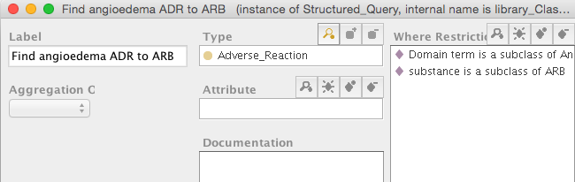

Figure 72. An example of "Structured Query"

The execution engine resolves a “Structured Query” by

1. Finding all instances of *type*
2. Evaluating the instances against the *where restrictions*
3. If the aggregation operator is *most_recent*, finding the most recent instance of the instances that satisfy the *where* *restrictions*
   1. if *attribute* is not null, returning the attribute value of most recent instance
   2. if *attribute* is null, returning the most recent instance
4. If the aggregation operator is one of {*average, maximum, minimum*}, the *attribute* must not empty and must have numeric values. In this case the execution engine applies the aggregation operator to the numeric attribute values and returns the result.
5. If the aggregation operator is *count*, returning the count of instances that satisfy the *where restrictions* (in case there is no attribute) or the count of attribute values of the instances that satisfy the *where restrictions*
6. If there is no aggregation operator, returning the set of instances that satisfy the *where restrictions* (if there is no attribute) or the set of attribute values of the instances that satisfy the *where restrictions*.

#### Filter

A filter associated with a query is evaluated against an instance of the type in the query (e.g., Medication). If the evaluation results in *true* then the instance is passed to the next filter. If an instance passes all filters of a query, then the instance either becomes the part of the query result or it is further processed according to the *attribute* and *aggregation operator* properties of the query. There are four types of filters.

##### Comparison_Filter

Comparison filters have the form:

attribute operator value-expression

For example, when querying for instances of Note_Entry or Numeric_Entry, the comparison filters may be:

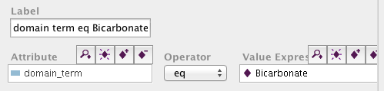

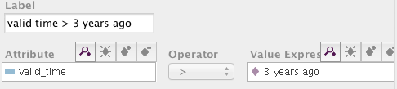

The *value expression* slot can be filled by any instance of the Expression class. In particular, it may be another Structured Query instance. So, if we want to find all instances of Drug Usage whose drug class name includes one that has a bad drug partner among current medications, we can construct a Structured Query with type = Drug_Usage and whose where restriction is a Comparison Filter

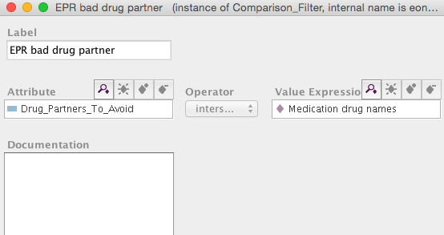

where the *operator* is ‘intersection’ and the *value expression* is a the result of another Structured Query that get all drug names of current medications:

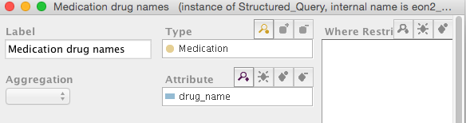

The comparison filter checks that a Drug Usage instance whose ‘Drug_Partners_To_Avoid’ intersect the names current medications. The execution engine expands ‘Drug_Partners_To_Avoid’ to all of its children when it performs the ‘intersection’ calculation.

##### N_aryFilter

An instance of N_aryFilter is a Boolean combination of other Filters.

##### Predicate_Filter

An instance of *Predicate_Filter* has three slots: *attribute*, *predicate* (always “derivable” for now) and *quantifier* (always “exists” for now). Currently the filter can check to see whether there exists a value of the *attribute* that satisfies the *predicate*. The use case for this filter is the need to check, for example, that one of the absolute contraindications of Drug Usage can be “derived” from patient data. ACE inhibitor has ‘Angioedema due to ADR to ACEi’ as an absolute contraindication. When the following filter is placed on instances of Drug Usage, and if the patient has angioedema due to ADR to ACEi, then the ACE inhibitor instance of Drug Usage will pass the filter.

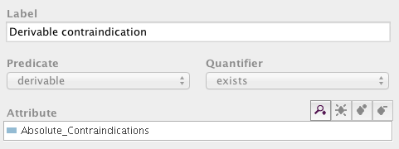

##### Join_Filter

A *Join_Filter* is designed to do a SQL-like join of two sets of instances. It implements a query of the form:

Select (*aggregation operator*)(*attribute*) from *type* t where [Query q and (t.attribute operator q.attribute_to_compare)*]

A *Join_Filter* implements

[Query q and (t.attribute operator q.attribute_to_compare)*]

It has two slots *query* and *attribute comparisons*, that correspond to Query q an the set of join comparisons.

For example, to query for medications not at maximum dose, construct a query

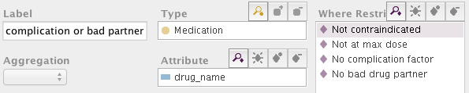

where ‘Not at max dose’ is a join filter:

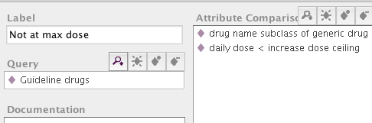

The filter get all instances of Guideline drugs and compare the attribute values of Medication instances with attribute values of Guideline drugs. For instance, ‘daily dose’ of Medication should be less than the ‘increase dose ceiling’ of a Guideline drug:

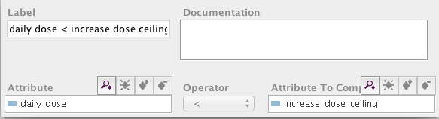

#### Grammar

The Structured Query uses Protégé to implement the following query grammar:

Notation:

Word_In_Regular_Font represents a non-terminal node defined by a production

*Italic_Word* represents a symbol

“|” represents “or” (i.e., possible alternative)

(..) represents 0 or 1 occurrence (i.e., optional)

(..)* represents 0 or more occurrences (i.e., optional, may have multiple entries)

[..] represents 1 occurrence (required, and only one entry is allowed)

[..]* represents 1 or more occurrences (i.e., required, multiple entries are allowed)

Structured_Query :

**Select** (*most_recent*) (attribute) **from** [type] (where_restriction)* |

**Select** *count* (attribute) **from** [type] (where_restriction)* |

**Select** [numeric_aggregator_operator] [attribute] **from** [type] (where_restriction)*

type: a Protégé class that is a subclass of Guideline_Model_Entity, EPR_Entity, or

Canonical_Term_Metaclass

numeric_aggregator_operator:

*average* | *maximum* | *minimum*

attribute: a Protégé slot that is a template slot of the class *type*

where_restriction:

Comparison_Filter | N_aryFilter | Predicate_Filter | Join_Filter

Comparison_Filter:

(attribute) [comparison_operator] [value_expression]

comparison_operator:

*> | < | <= | >= | = | eq | neq | member_of | subclass_of | superclass_of | intersection*

N_aryFilter:

[logical_operator] [where_restriction]+

logical_operator:

*AND* | *OR* | NOT

Predicate_Filter:

(attribute) quantifier predicate

quantifier: *exists* | *forall*

predicate: *derivable*

value_expression: an instance of a subclass of Expression

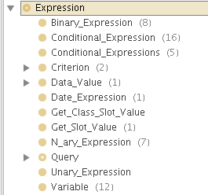

Join_Filter: [Query] [attribute_comparison]*

Query: Structured_Query | PAL_Query

attribute_comparison : [attribute] [operator][attribute_to_compare]

See 2.4.2.3.4

operator :

> | < | <= | >= | = | eq | neq | member_of | subclass_of | superclass_of | intersection | not_subclass_of | not_member_of

#### Patterns

This section describes some common patterns of making structured queries.

##### Basic Queries

**Pattern:**

**Select** * **from** [type] (attribute comparison_operator value_expression)

**Examples:**

1. select * from Medication (daily_dose > 20)
2. select drug_name from Medication (daily_dose >20)(drug_name subclass_of ACE_Inhibitors)

Comments:

“attribute” should be a template slot of the class that’s the focus of the query. In Example 2, both “drug_name” and “daily_dose” are slots of the Medication class.

Multiple “where_restriction” in the selection frame are ANDed together. Therefore, in Example 2, it’s not necessary to use n-ary filter to AND together the two comparison filters (one involving daily_dose and the second involving drug_name)

### PAL-based Expression Language

A guideline author can use the templates described so far to write most common decision criteria with little training. The criteria that can be written in this way, however, are not sufficiently expressive. Take the expression, “Presence of an authorized medication that is contraindicated by some medical condition”. It requires that, for each authorized medication, the Guideline Interpreter finds its contraindications from the ATHENA-CDS Knowledge Base and checks to see if there is any patient-data instance that suggests the presence of these contraindications.

Instead of trying to resolve such complex criteria procedurally, the Protégé Axiom Language (PAL)—a constraint language—is used to write them. The PAL constraint language implements a subset of first-order predicate logic written in Knowledge Interchange Format (KIF) syntax (Genesereth, 1991)(Genesereth, 1991). It makes full use of Protégé’s frame-based knowledge model. For example, variables can range over instances of Protégé classes (e.g., in Figure 73, the variable ?current_med ranges over instances of Medication class). Attributes of classes (e.g., Absolute_Contraindications in Figure 73) can be used as a binary predicate to check that a constant or the value of a variable (e.g., ?contraindication) is a value of the slot. An attribute (e.g., domain_term in Figure 73) can also be used as a function of one argument that returns the value of the slot for an instance. It is not expected that domain experts untrained in logic will formulate these complex logical criteria. Full documentation of the PAL constraint language is available at the URL: http://protege.stanford.edu/plugins/paltabs/pal-documentation/index.htm.

(defrange ?current_med :FRAME Medication)

(defrange ?problem :FRAME Note_Entry)

. . .

(exists ?current_med

(and (patient_id ?current_med $patient_id)

(exists ?med_class

(and (subclass-of

(drug_name ?current_med) ?med_class)

(exists ?contraindication

(and (Absolute_Contraindications

?med_class ?contraindication)

(exists ?problem   
 (and (patient_id ?problem $patient_id)

(subclass-of

(domain_term ?problem)

?contraindication)))))))

Figure 73 - Example of a PAL expression

The PAL language was originally designed for writing constraints on concepts and relationships in a Protégé knowledge base. In adapting it for writing decision criteria that involve patient data, it is necessary to introduce a variable ($patient_id in Figure 73) that stands for the patient ID that, at run time, the Guideline Interpreter will use to replace the variable before evaluating a PAL criterion. Thus, an instance of PAL_Criterion (Figure 74), aside from a label, has two parts: (1) the case_variable slot (shown as Case Variable) that tells the Guideline Interpreter which string in the PAL expression stands for the patient ID, and (2) the slot that holds the PAL expression itself (such as the one in Figure 73).

The PAL constraint language has a query form that, instead of evaluating to *true* or *false*, returns instances that satisfy constraints written in PAL. Instances of PAL_Query, which has exactly the same format as PAL_Criterion, contain a PAL query (instead of a PAL constraint). PAL query is used in a number of places. For example, PAL query can be used to find all current medications, such that each of them is contraindicated by a problem a patient is experiencing. Furthermore, in Substitute_Activity, the drug to be deleted is specified using a PAL query. PAL query is also used to obtain the names of drugs whose doses need to be increased.

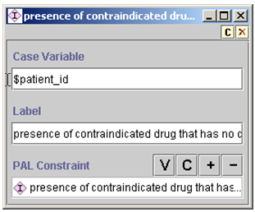

Figure 74 - An instance of PAL_Criterion

### Summary

Criteria languages in the EON Guideline Model are all informed by the same patient data model and serve complementary requirements. The template-based language provides form-based templates that domain experts can easily use to write the common decision criteria. The logic-based PAL language adds additional expressiveness for writing specific types of complex criteria. Structured queries and criteria represent an alternative, form-based, way to encode complex expressions. All three types of expression languages use the taxonomic hierarchies in the medical concept model to infer generalization/specialization relationships and to make abstractions based on definitions embedded in the hierarchies (e.g., the definition of *hyonatremia*).

A common evaluation-result interface unifies the usage of the template-based, structured-query–based and PAL criteria. For criteria written in each language, the guideline execution engine invokes the appropriate criteria-evaluation engine. Each criteria-evaluation engine returns the result consisting of the criterion being evaluated, the truth value of the criterion as applied to available patient data, and annotations that can be used for explanation purposes.

# Updating Knowledge Sources in ATHENA-CDS SYSTEM

## Update the Rules Document

The Rules Book is maintained and updated by the VA ATHENA-CDS Project Team. The Rules Book is a description of the content of the Knowledge Base, with explicit mention of portions of the Knowledge Base that deviate from JNC 6. The VA ATHENA-CDS Project Team maintains two versions of the ATHENA-CDS SYSTEM: the production version (installed in the ATHENADSS directory) and the development version (installed in the DEVATHENADSS directory). The Rules Book and appendices that correlate to the Knowledge Base being used in clinics are kept in the folder ATHENADSS/doc, and the files that contain the Knowledge Base are in the folder ATHENADSS/domain_model.

The DEVATHENADSS/doc folder (developmental version of ATHENA-CDS SYSTEM) contains the most current version of the Knowledge Base and the Rules Book, with updates as determined by the VA ATHENA-CDS Project Team and consultants. These updates are the responsibility of the VA ATHENA-CDS Project Team. Each update is tested when entered into the Knowledge Base, then the update is made to the rules document. Transferring the developmental version of the Knowledge Base and rules to the live system requires extensive testing (see testing procedure for transfer of updated Knowledge Base. At this point, further, extensive testing is required when transferring updates from the developmental version to the live system (see Subsection **Error! Reference source not found.**). The Rules Book and appendices are archived at the VA, and their filenames have a suffix reflecting the date of change.

## Update the Knowledge Base in Protégé

### Add a New Drug

Each drug used in the CDS SYSTEM reasoning needs to be added to the appropriate drug class of the Medications_Class in the Knowledge Base class hierarchy (see Figure 75). A drug is added by following the steps described below:

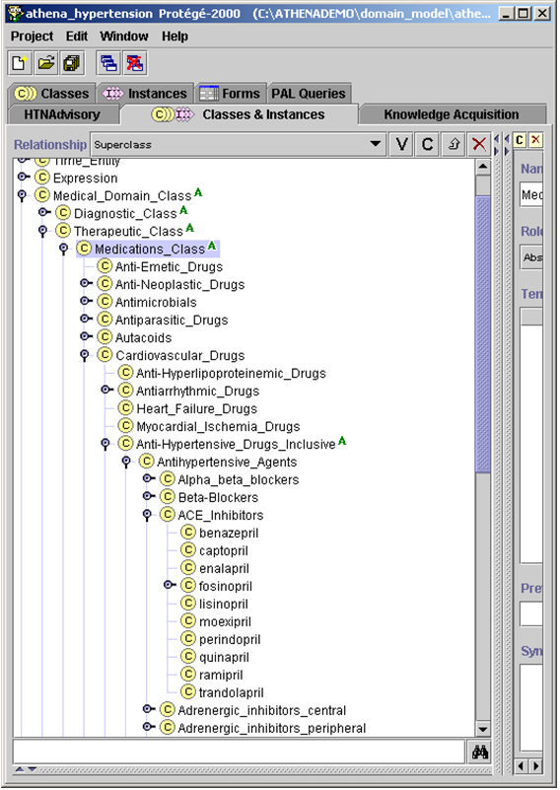

Figure 75 - Medications_Class in Medical_Domain_Class, within the class hierarchy

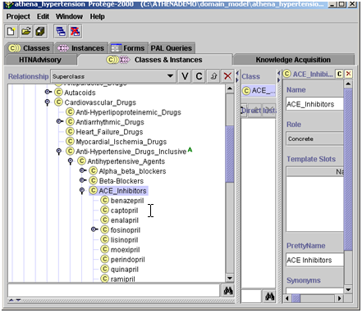

Figure 76 - Selecting the appropriate drug class

1. Select *Create subclass using metaclass…* Figure 111 shows selection of a drug class: ACE Inhibitors. Figure 77 shows addition of a new drug to the drug class. (In Figure 79, test_drug is added to the ACE_Inhibitors class.)

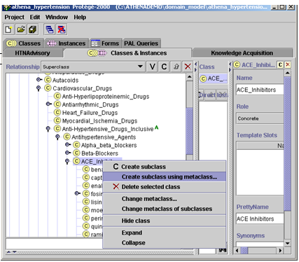

Figure 77 - Adding a new drug to the Medications_Class category, ACE_Inhibitors

1. Select Medications_Metaclass and click OK (Figure 78).

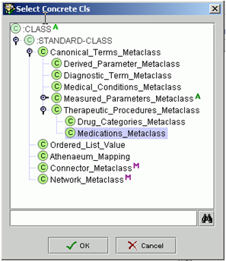

Figure 78 - Selecting Medications_Metaclass in order to add a new instance of a drug within Medications_Class

1. Add the drug name to the Name slot (Figure 79). Note that, for this drug to be identified and considered in the algorithm of the Knowledge Base, letter case and spelling must be identical to those in the drug mapping table (‘DRUGS’) in the SQL database (ATHENA and ATHENEON). Ignore the other slots.

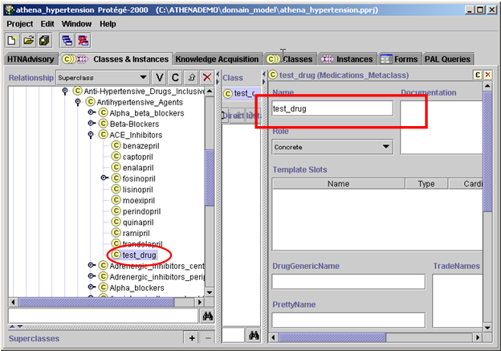

Figure 79 - Adding the new drug, test_drug, to the ACE_Inhibitors drug class

In specific situations, the drug update may require updating other areas of the Knowledge Base. For instance, it may be necessary to make changes so that a drug will be displayed as preferred or so that it is possible to recommend an increased dosage of a drug. These two procedures are outlined in the following subsections.

### Displaying a Drug as Preferred in the Advisory

An ATHENA-CDS advisory recommends a drug class if there are compelling or relative indications for it. For example, it will recommend ACE Inhibitors for patients who have suffered heart failure. Within the drug class, a formulary preferred drug is displayed in parentheses beside the drug class being recommended. In Figure 80, lisinopril is indicated as a preferred drug: *Add ACE Inhibitor (lisinopril).*

Several drugs can be designated as preferred within a drug class for specific scenarios, based on rule-in criteria. Multiple preferred drugs matching rule-in/-out criteria can be displayed.

**Considerations for adding drug:**

* ACE Inhibitors
  + specific drug(s): lisinopril
  + Is second-line drug for: HTN and no CKD([VA HTN no CKDGFR(80.0@06/30/2013)])
  + Relative indications: DM without CKD([VA HTN no CKDGFR(80.0@06/30/2013)])
  + Adverse reaction: lisinopril(rash)
  + Recommendation basis: is second-line drug for
  + Do not add controllable conditions: Absence of K in past month()
  + preference: blocked
  + fine-grained priority: 0
    - [do_not_add_controllable_condition; fine-grain-priority=0] old K 4.1 (6/30/2011).
    - [General_Info; fine-grain-priority=300] Beware of 20% increase in creatinine (or 15% decreaes in eGFR) after initiation or change in dose of ACE/ARB.
    - [General_Info; fine-grain-priority=300] ACE Inhibitors or ARBs in pt with DM and proteinuria significantly reduces risk of MI, stroke, overt nephropathy and cardiovascular death.

Figure 80 - Preferred drugs for the ACE Inhibitor

To make test_drug a preferred drug in the ACE Inhibitors drug class:

1. Go to the Knowledge Tree tab and select the ACE Inhibitor class under Drug Classes (Figure 81).

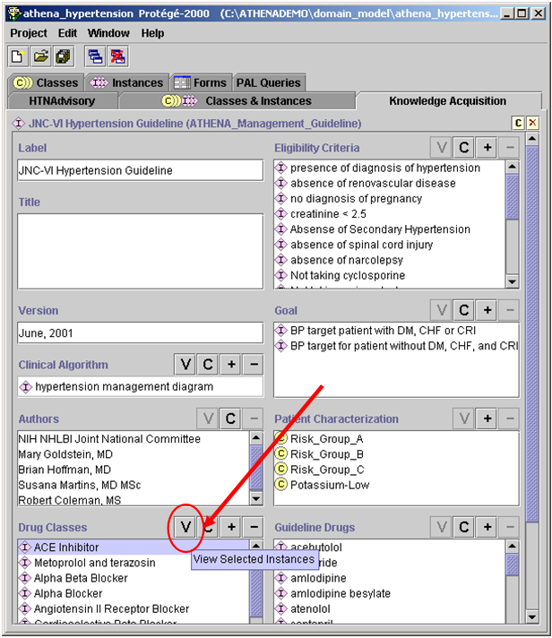

Figure 81 - View ACE Inhibitor drug class

1. Click on **V** to view the ACE Inhibitor form shown in Figure 81.
2. Go to the slot, Formulary Preferred Drug in Class (Figure 83), and add the preferred drug by clicking on the **C** button to create a guideline drug instance or on **+** to add an existing one. When creating a new guideline drug instance, the Guideline_Drug template will appear (Figure 83). Fill in the following fields:

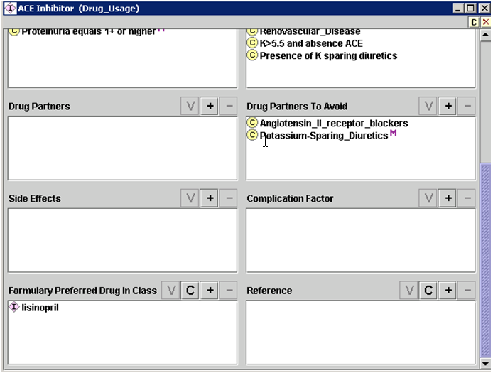

Figure 82 Partial view of Drug Usage ACE Inhibitor class

* **Label** – Identify the drug.
* **Starting Dose** – Type in a starting dose
* **Generic Drug** – Add from the class hierarchy.
* **Max Recommended Dose Level** – The Guideline Interpreter will use the lower limit of this dose range when recommending a dose increase.
* **Dose Level Ranges** – Supply these as appropriate. This field is currently used only for dose increase. If the dose is below the lower limit of the recommended dose range for High_Dose, then ATHENA-CDS will recommend a dose increase. For example, one can create dose ranges for low dose, medium dose, and high dose. If the Max Recommended Dose Level is defined as the high range, and if the current dose is less than the lower limit of high dose range, ATHENA-CDS will recommend a dose increase.

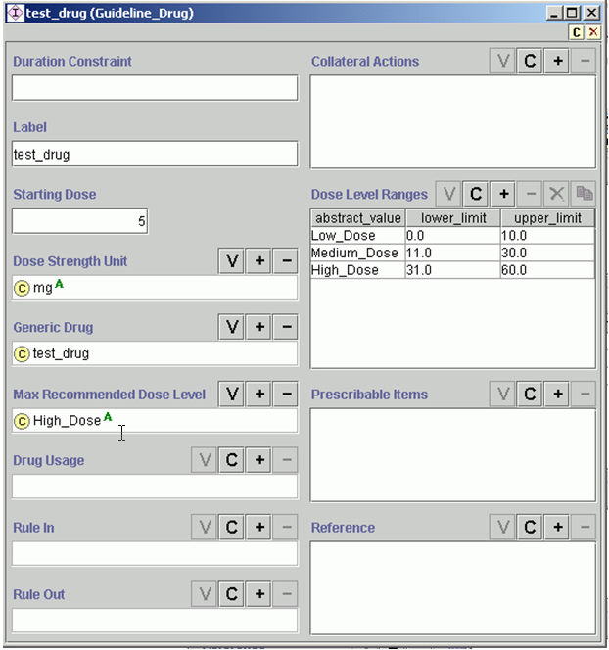

Figure 83 - Guideline_Drug template

The label of test_drug can now be seen in the Formulary Preferred Drug in Class slot (Figure 84).

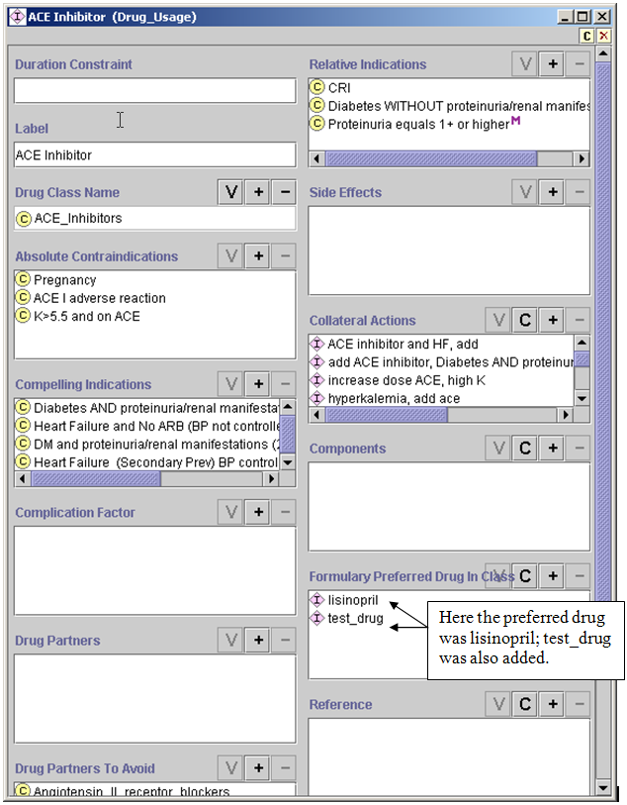

Figure 84 - Adding a new preferred drug to the drug class ACE Inhibitor

### Enabling Dose Increase Recommendations for a New Drug

For ATHENA-CDS to recommend drug dose increases, it is necessary first to create an instance of Guideline_Drug for the specific drug and define the dose ranges for low, medium, and high doses:

Go to the Knowledge Tree tab and find the Guideline Drugs slot (see Figure 85).

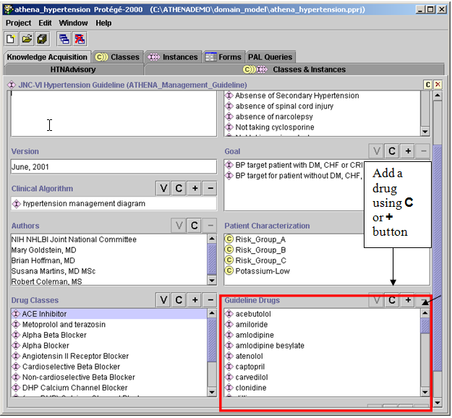

Figure 85 - Knowledge Tree tab: Guideline Drugs

1. Click on the **C** button in the Guideline Drugs slot to create a new Guideline Drugs instance (described in Subsection 3.2.2, #3), or click on **+** to add an existing one.

In Figure 86, test_drug has been introduced to the Guideline Drugs slot of the Knowledge Tree tab.

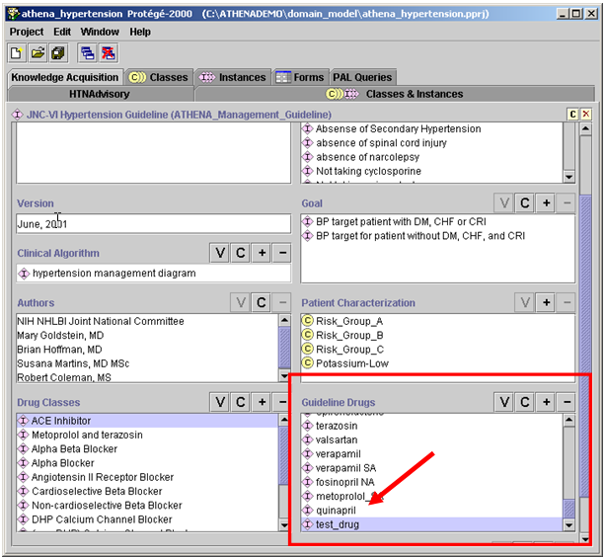

Figure 86 - Test_drug added to Guideline Drugs slot in the Knowledge Tree tab

### Adding a Compelling Indication to a Drug Class

The JNC6 guideline refers to “compelling indications”, that is, medical conditions that are a strong indication for use of particular drugs. To model JNC6, it is necessary to enter the diseases or medical conditions, if any, that are the compelling indications for using the drug class. The steps for adding a compelling indication are similar for adding a strong (or absolute) contraindication, relative contraindication, or relative indication. They are:

* + - 1. Go to the Knowledge Tree tab in Protégé.

1. Select from Drug Classes and click on **V** to view.

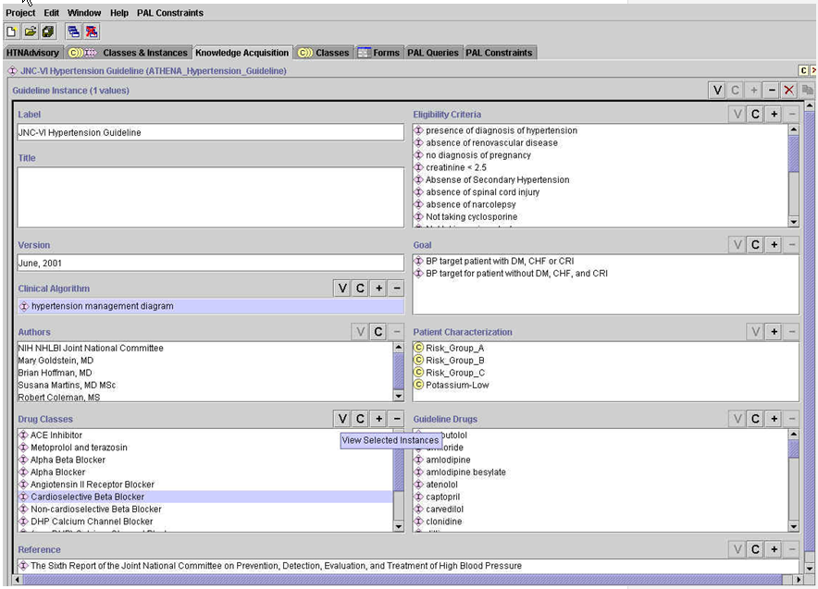

Figure 87 - Knowledge Tree tab

The Drug_Usage template will pop up (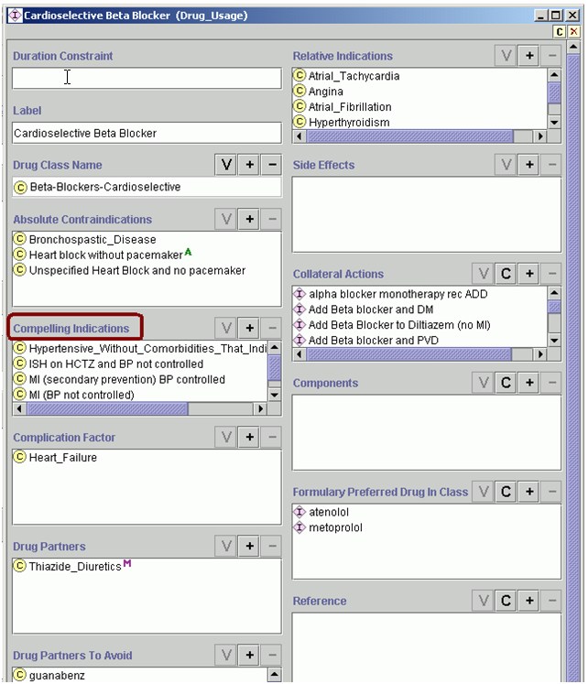

**Figure 88**). It contains slots for characteristics of the selected drug. Locate the Compelling Indications slot (or the Absolute, Relative Contraindications, or Relative Indications slot).



**Figure 88 - Drug_Usage template, with Compelling Indications highlighted**

1. Click on the **+** to add a compelling indication.
2. Select a medical condition from the class hierarchy, and click OK (Figure 89).

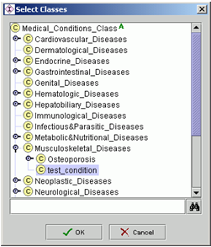

Figure 89 - Selecting the medical condition for a compelling indication

The new compelling indication will be displayed at the bottom of the list for Compelling Indications (see Figure 90).

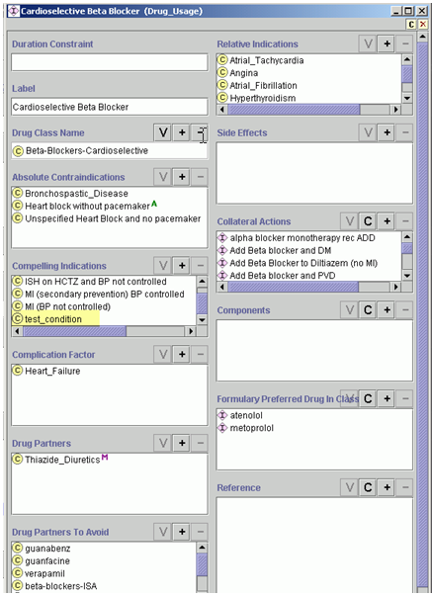

Figure 90 - Test_condition added as a compelling indication for Beta-Blockers-Cardioselective

1. Test the display. Go to the HTNAdvisory tab to create a scenario that will display the just-added condition.
2. Click on the **+** box in the Related Comorbidities section to add test_condition to this patient’s comorbidities (see Figure 91 and Figure 92). A window will pop up (Figure 92). In this window click on ‘Select’ to choose from the class hierarchy (Figure 92).

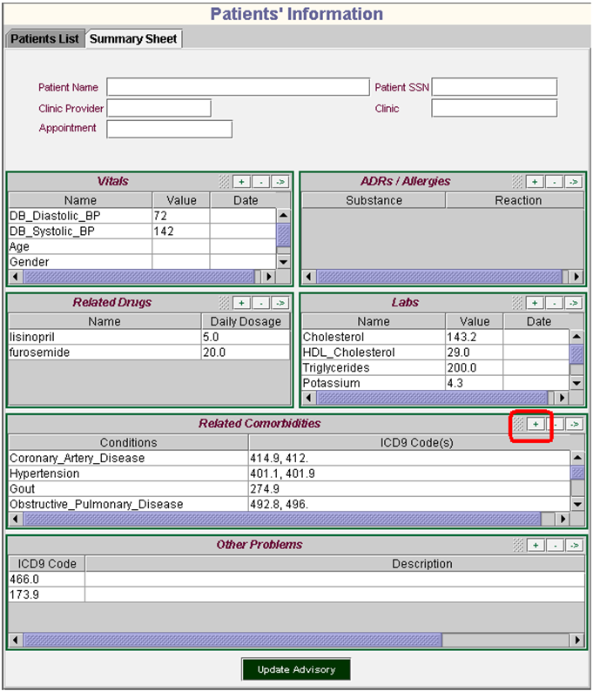

Figure 91 – Patients’ Information Summary Sheet, adding a new medical condition to the patient state

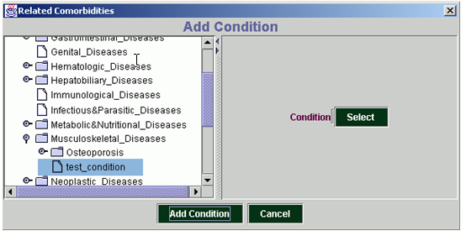

Figure 92 - Selecting test_condition

1. Click Update Advisory on the Patients’ Information Summary Sheet to register changes (Figure 93).

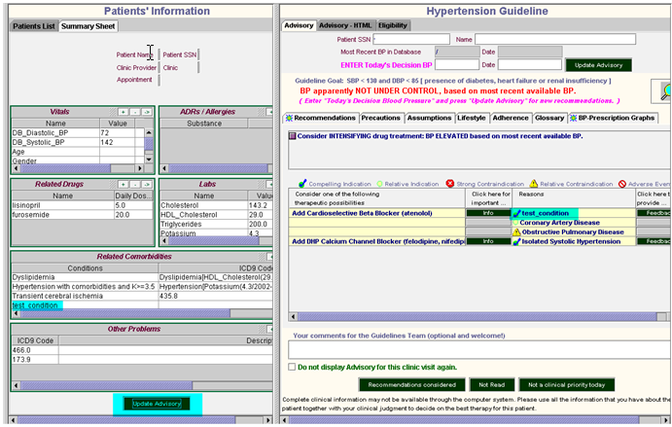

Figure 93 - Updated advisory showing test_condition added to Related Comorbidities and as a compelling indication for beta blockers

1. Confirm that the desired changes have been made to the Advisory.

In Figure 93, test_condition has been added to the list of Related Comorbidities. The Advisory has been updated, and this patient has test_condition as a compelling indication for adding a Cardioselective Beta Blocker.

### Removing Instances by Clicking the - Button

One may enter an instance by mistake in or may want to update it. By clicking the **-** button (see Figure 94), it is possible to remove criteria from rule-in/-out slots and from drug classes.

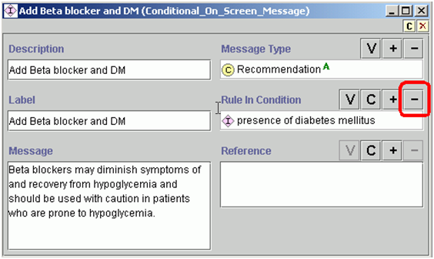

Figure 94 - Removing a rule-in condition from a slot

Do NOT delete criteria from the Protégé knowledge base, as these are the original criteria and may be used in different sections of the Knowledge Base. For example, do NOT select an instance of a criterion class in the Classes & Instances tab and click on the delete icon (X) without first checking whether the criterion is used elsewhere.

To check where specific criteria are used:

1. In the Classes & Instances tab, use the search function to find the criteria. A search can be conducted for instances or classes, depending on which pane is used. Add **\***—the wildcard symbol—before and after a term to find all criteria that contain that term. For example, typing *ace* in the class panel will find classes labeled ACE inhibitor, race, pacemaker, etc.
2. Click on the upward arrow button (highlighted in Figure 95) to bring up a new pop-up window for showing where criteria are used.
3. Click on the upward button again to display where the criteria are used. Repeat as many times as necessary to see the full extent of the use of the criteria.

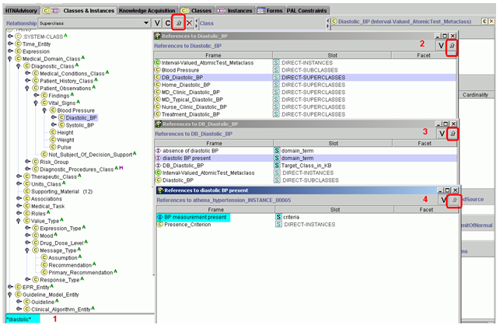

Figure 95 - Searching for where specific criteria are being used in the Knowledge Base

### Adding a New Medical Condition

In this section we will explain how to enter medical conditions defined by ICD9 codes or by other criteria.

#### Creating a New Disease or Condition Defined by ICD9 Code

1. Select the class in which to insert the new disease or condition. Right click on the selected class, and choose *Create subclass using metaclass…* (see Figure 96).

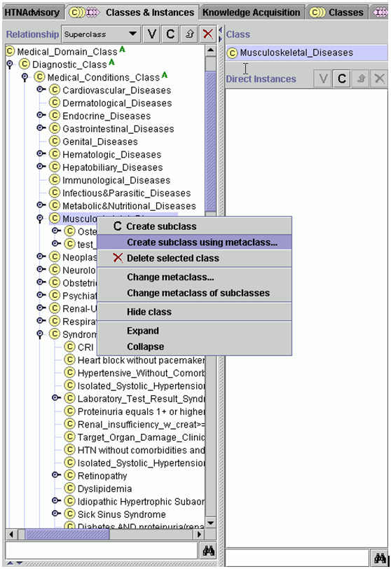

Figure 96 – Creating a subclass using a metaclass

1. Select Medical_Conditions_Metaclass (see Figure 97).

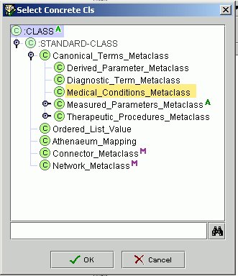

Figure 97 - Selecting the type of metaclass

1. Add the disease or condition to the Name slot. In the example in Figure 98, test_condition is being created in the subclass Musculoskeletal_Diseases.

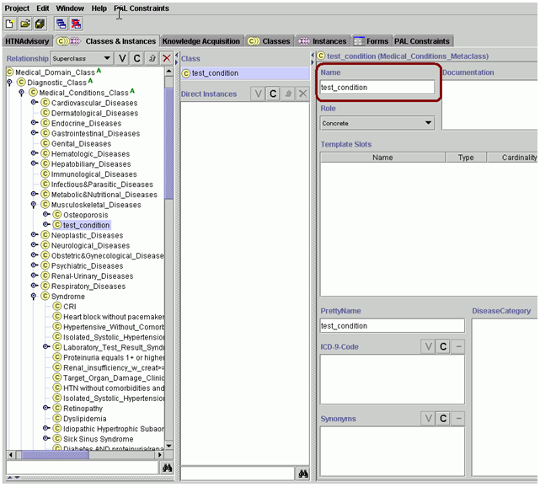

Figure 98 - Adding a new disease or condition to the class hierarchy

To add the ICD9[14] code, right click on the selected class and choose *Create subclass using metaclass…*. Select Medical_Conditions_Metaclass. Add the ICD9 code to the Name slot. In Figure 99, the ICD9 code supplied for test_condition is XXXXX.

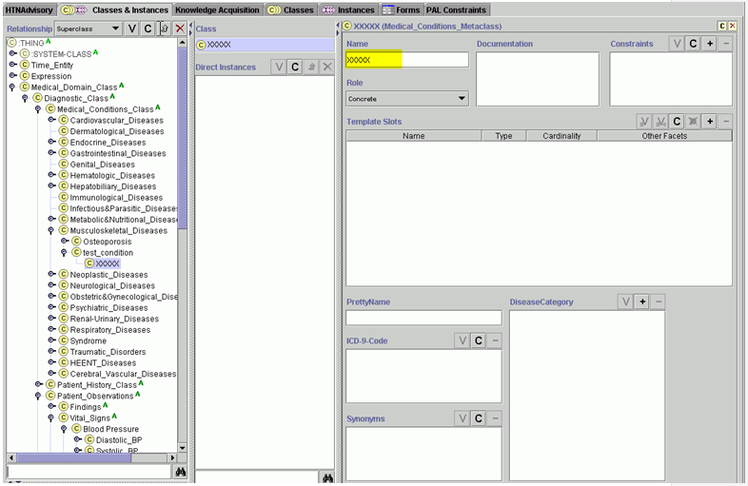

Figure 99 - Creating a condition using Medical_Conditions_Metaclass

#### Adding a Condition Defined by Criteria

Some conditions can only be defined in Protégé using diagnostic terms metaclasses, for example conditions defined by laboratory values sucha as renal insufficiency or conditions that have multiple criteria such as heart block and absence of pacemaker. Conditions defined by criteria are located under Syndrome in Medical_Domain_Class. To create a new condition, right click on the “syndrome” classand choose *Create subclass using metaclass…*. Select Diagnostic_Term_Metaclass (Figure 100).

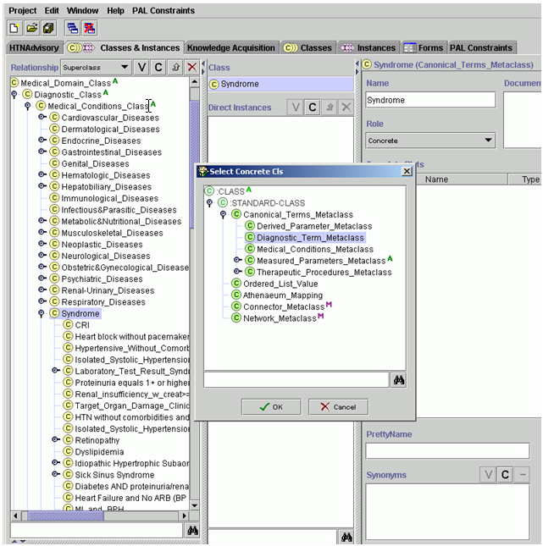

Figure 100 - Select Diagnostic_Term_Metaclass

There is a slot to select or create the diagnostic criteria for the new condition. In Figure 101, the new condition is called test_condition1, for which existing criteria were selected by clicking on the **+** button and scrolling through the options (Figure 102). New criteria can be created by clicking on **C** in the DiagnosticCriteria slot.

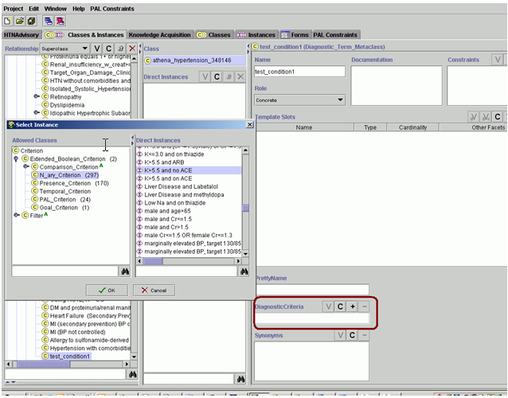

Figure 101 - Selecting rule-in criteria for test_condition1

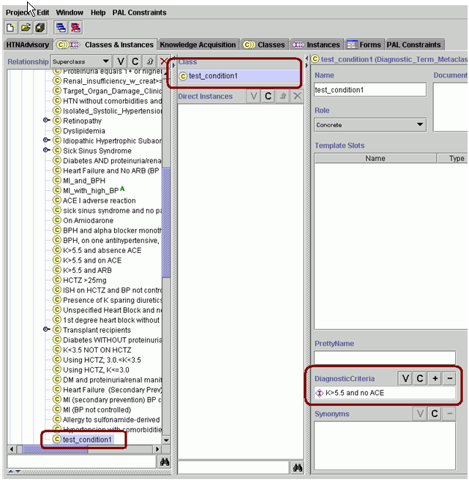

Figure 102 - Test_condition1 created

### Adding Messages to Display in the ATHENA-CDS Hypertension Advisory

Messages provide a way to alert and inform the ATHENA-CDS user about issues specific to the patient. In the test environment, messages can be displayed in two places in an advisory:

1. Action Choices
2. Considerations for adding or changing attributes of drugs

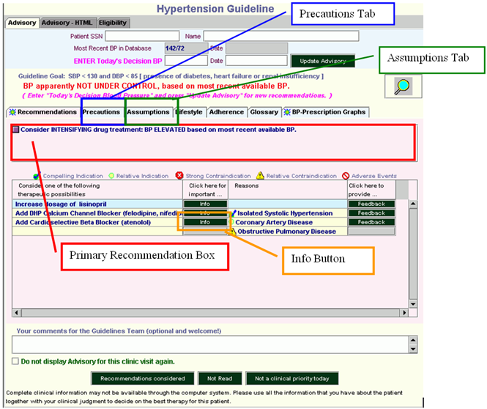

Figure 103 - ATHENA-CDS hypertension advisory

It is possible to add messages to the Knowledge Base in three distinct places:

1. *Scenario* – (pink boxes in the hypertension management diagram from the Knowledge Tree tab; see Figure 104 and Figure 105) primary recommendation box, Precautions tab, or Assumptions tab
2. *Action_Choice* – (green bubbles in the hypertension management diagram from the Knowledge Tree tab; see Figure 104 and Figure 105) primary recommendation box, Precautions tab, or Assumptions tab
3. *Drug Usages* – (Knowledge Tree tab) Info button

The message types and the rule-in/-out criteria of a message control when and where a message will be displayed in the advisory. The message types are covered in greater depth in the following three subsections.

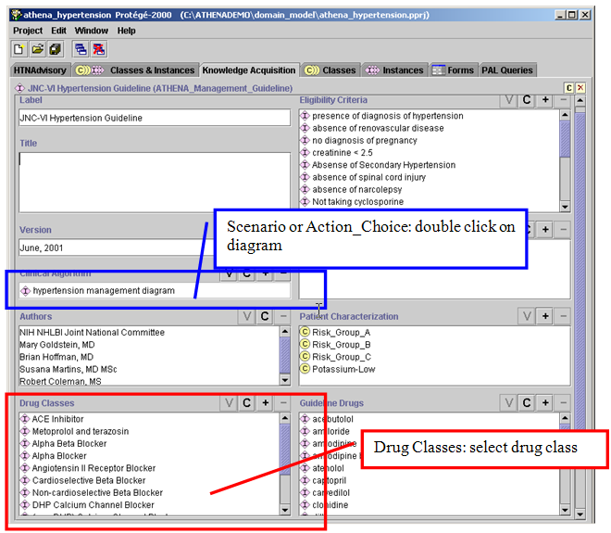

Figure 104 - Knowledge Tree tab

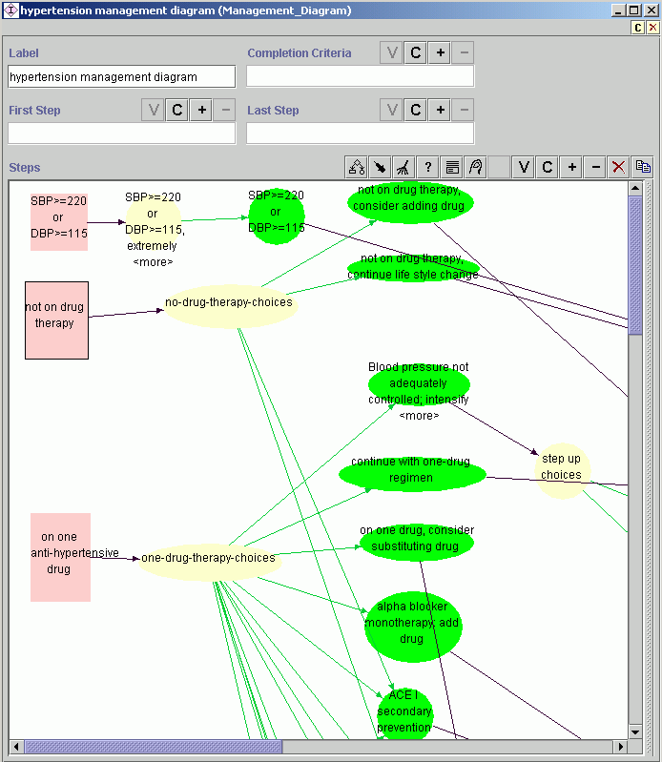

Scenario

Action_choice

Figure 105 - Hypertension management diagram (Management_Diagram)

#### Scenario-related Message

A scenario-related message is associated with the scenarios (pink boxes) in the hypertension management diagram (see Figure 105) and are stored in the Consultation Template slot (Figure 106). Examples of scenarios are: “on one antihypertensive drug” or “on 2 or 3 antihypertensive drugs”.

To view the hypertension management diagram, go to the Knowledge Tree tab in Protégé; select the *hypertension management diagram* in the *clinical algorithm* slot; and click on **V** (Figure 104). In the diagram, pink boxes are instances of the Scenario class. These scenarios are mutually exclusive. It is necessary to add an identical message to each scenario in order to ensure that the message will display in all the desired scenarios.

For example, double click on the *not on drug therapy* scenario in the hypertension management diagram (Figure 105). In the form ‘not on drug therapy (scenario) that pops up there is a slot for the Consultation Template (Figure 106). Click on **V** to view the consultation template (see Figure 107).

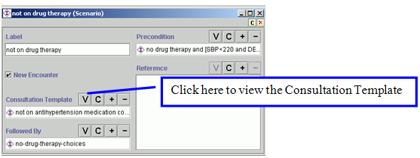

Figure 106 - "Not on drug therapy” scenario

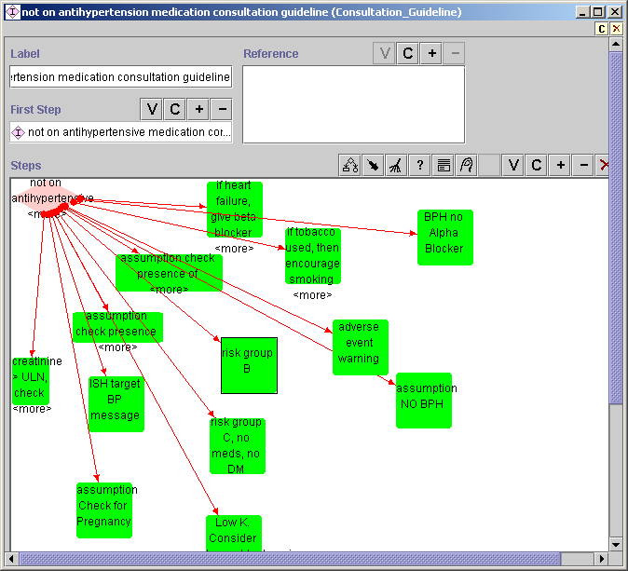

Figure 107 - Scenario *not on drug therapy* consultation template

To add a message to this scenario:

1. Create the Consultation_Action by clicking on **C (**Figure 108, then select Consultation_Action_Step (Figure 109).



Figure 108 - Creating a new Consultation_Action_Step

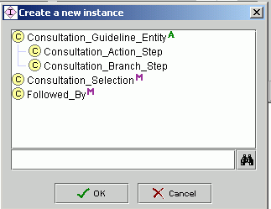

Figure 109 - Selecting Consultation_Action_Step

A new green square will appear in the diagram view of the Consultation_Guideline, with a default name. Double click on the new green square to view the template. Define the Label and the criteria for Rule In and Rule Out. In Figure 110, a rule-in criterion is being created specifying that serum creatinine >2.

1. Add a descriptive label to the consultation action step, and add or create the rule-in and rule-out criteria for the consultation action step (see Figure 110). At the ‘Actions’ slot, create a new message by clicking on **C** and selecting the type of message; or add a message that already exists by clicking on **+**. Filling in the ‘Followed By’ slot is not required in order to display messages.

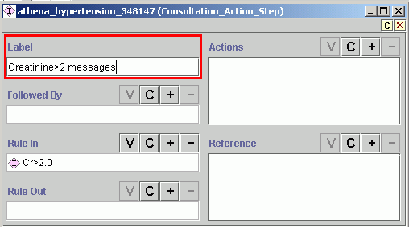

Figure 110 - Adding a label to Consultation_Action_Step; rule-in criterion Cr>2.0 established

When creating a new message, you will select from two types (see Figure 111):

* + **On_Screen_Message**.
  + **Parameterized_Message** .

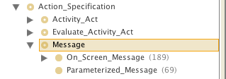

Figure 111 - Choice of message type, dialog box

1. Once you have selected the message type—for example, On_Screen_Message—the specific template will come up (Figure 112). Fill the Description and Label slots with descriptive content; enter the message to be displayed into the Message slot; and select the message type, according to where it is to be displayed in the Advisory (Primary_Recommendation in a primary recommendation box, Recommendation in the Precautions tab, and Assumption in the Assumptions tab). If you have a reference—that is, documentation supporting the advice delivered by the message—add that reference in the message’s Reference slot.

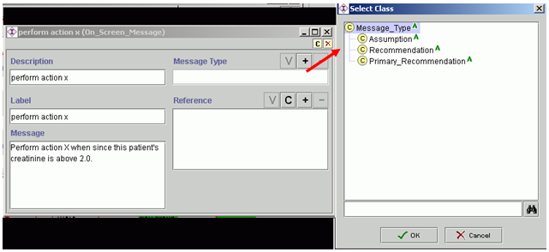

Figure 112 - On_Screen_Message

In Figure 112, the On_Screen_Message labeled *perform action X* has been created. It has the rule-in criteria: *Creatinine>2.0* and *not on drug therapy*. Accordingly, the message will be presented to the user only if creatinine is greater than 2.0 (because of the rule-in criterion in the consultation action step in Figure 112), and the patient is not on drug therapy (because of the precondition of the scenario in Figure 107). You can add numerous messages to the Actions slot, which will be constrained by the precondition criteria of the chosen scenario and the rule-in criteria of the consultation action step. If you need to constrain the criteria further, you can choose Conditional_On_Screen_Message (see Figure 111).

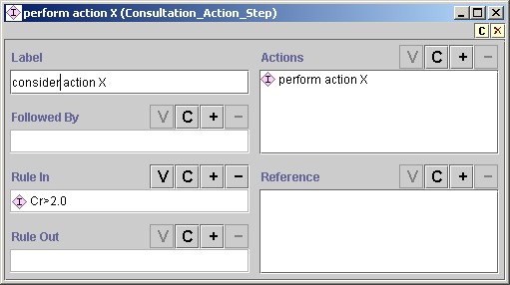

Figure 113 – Perform action X, with rule-in criterion Cr>2.0 that was inherited from scenario *not on drug therapy*

1. Create a link between the Consultation_Branch_Step (diamond) and the Consultation_Action you have just created using the *followed by* arrow in the menu on the right hand side. (Figure 114)

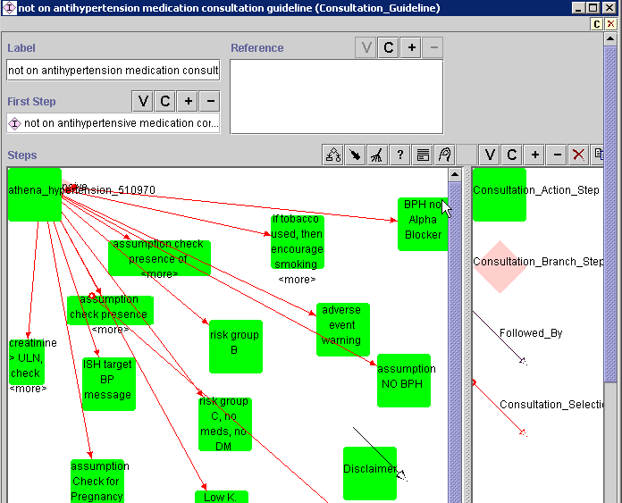

Figure 114: Consultation Guideline template: ‘Followed By’ arrow highlighted

1. Test the new message, as described on page **Error! Bookmark not defined.**.

#### Action_Choice-related Message

Action_Choice-related messages are those associated with alternative choices in a decision. They are represented as green bubbles in the hypertension management diagram (Figure 115).

Go to the Knowledge Tree tab of Protégé and view the hypertension management diagram. In the diagram, the action choices—green bubbles—may not be mutually exclusive alternatives. Note that you may need to add an identical message in various action choices in order to ensure that the message will display in all the desired scenarios.

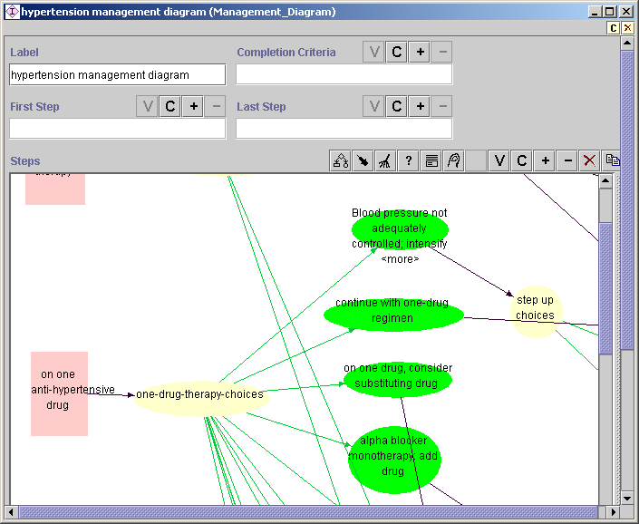

Figure 115 - Clinical algorithm diagram

To add a new Action_Choice-related message to the action choice, *continue with one-drug regimen,,* carry out the following steps:

1. Add a message to the Advisory for patients on thiazide monotherapy when BP is controlled about a K (Potassium) test. From the action choices following the scenario—*on one anti-hypertensive drug* (pink square), *one-drug-therapy-choices* (yellow oval), etc.—select the *continue with one-drug regimen* action choice (green bubble) by clicking on it. This will call up the *continue with one-drug regimen* Action_Choice (Figure 116). The actions (messages) will be activated only if the ‘Strict Rule In Condition’(s) is/are true and the ‘Strict Rule Out Condition’(s) is/are not true for the Action_Choice as well as any criteria specific to the message ( if a conditional message, additional ‘rule in’ criteria may be added). ATHENA-CDS is not currently using the ‘Rule In Condition’ and the ‘Rule Out Condition’ slots.

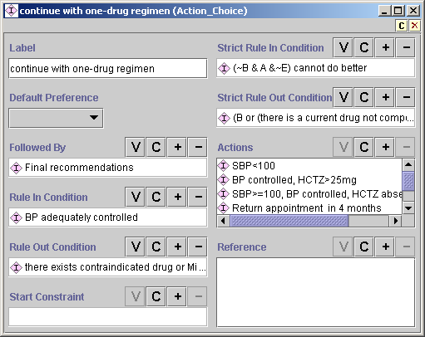

Figure 116 - Action_Choice, *continue with one-drug regimen*

1. Create a new message by clicking on the **C** button in the Actions slot (Figure 116). The following dialog box will appear (Figure 117). For a message specifying thiazide monotherapy, there are rule-in criteria other than the one determined by ‘*continue with one-drug regime’n,* so select Conditional_On_Screen_Message. The template in Figure 118will appear.

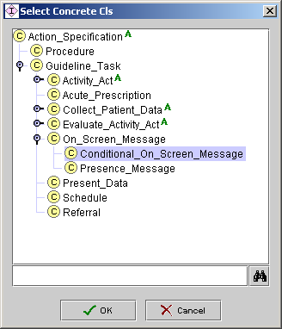

Figure 117 - Dialog box for selecting message type

1. In the template (Figure 118), add a descriptive label to the Label slot; type the message in the Message slot, as it is to appear in the Advisory; select from Message Type according to where the message is to be located in the Advisory; and add/create the rule-in condition in the Rule In Condition slot.

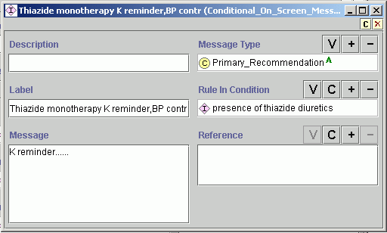

Figure 118 - Conditional_On_Screen_Message, K reminder

The new message should appear in the list in the Actions slot for Action_Choice (**Figure 119**).

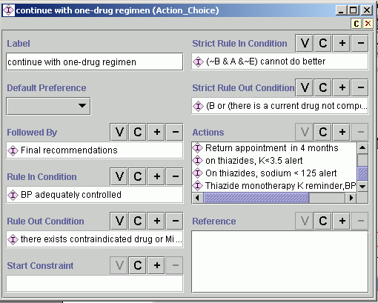

**Figure 119 - Message added to the Action_Choice for *continue with one-drug regimen***

1. To add messages that have been previously created, click on the + button in the Actions slot (**Figure 119**), select the appropriate message type, highlight the message, and click OK ( Figure 120).

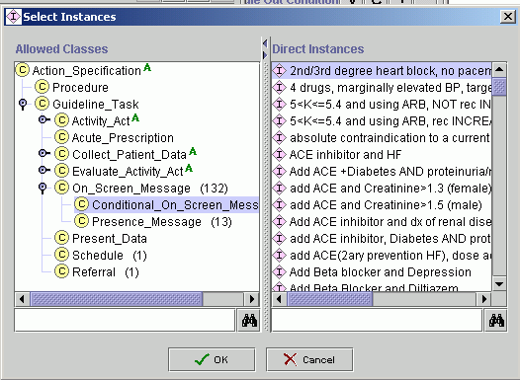

Figure 120 - Adding an already created message

1. Test the new message, as described in **Error! Bookmark not defined.**

#### Drug Classes-related Message

Drug class-related messages are messages that display when a clinician clicks on the Info button next to a specific drug recommendation.

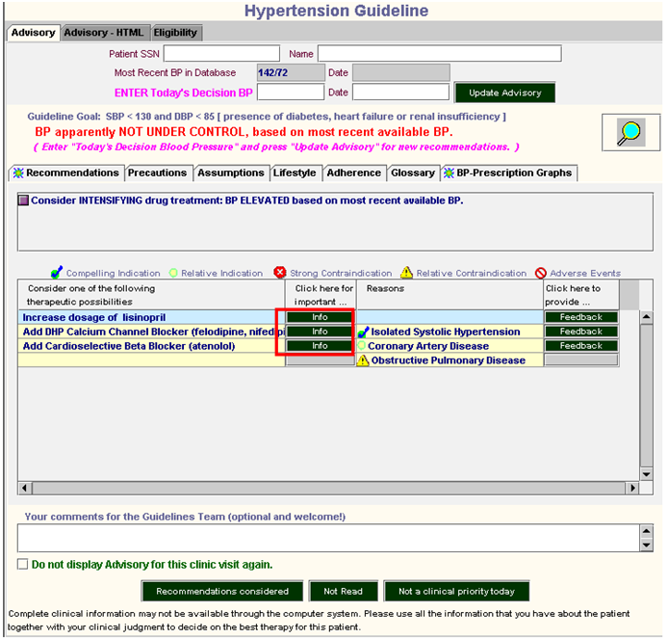

Figure 121 - ATHENA-CDS hypertension advisory

Steps to create a drug classes-related message:

1. In the Knowledge Tree tab, double click on the drug class of interest, for example, ACE Inhibitor VA 2014. The template in Figure 122 will appear.

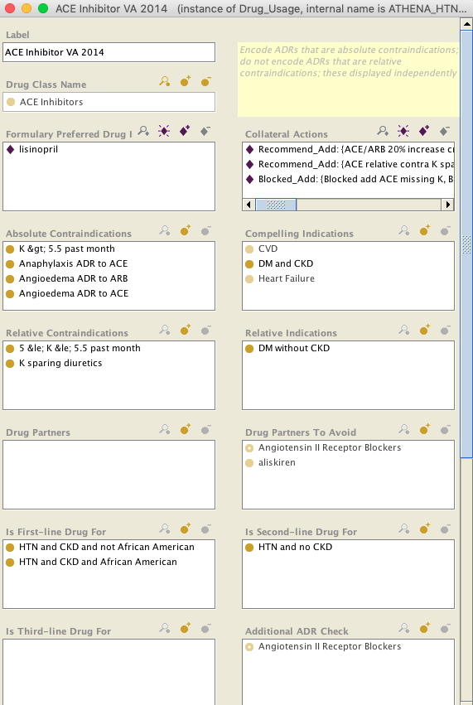

Figure 122 - Drug_Usage template

1. Go to the Collateral Actions slot, and add a previously created message by clicking on the  button, or create a new message by clicking on the  button (Figure 122). When creating a new message, the template in Figure 123 will appear.

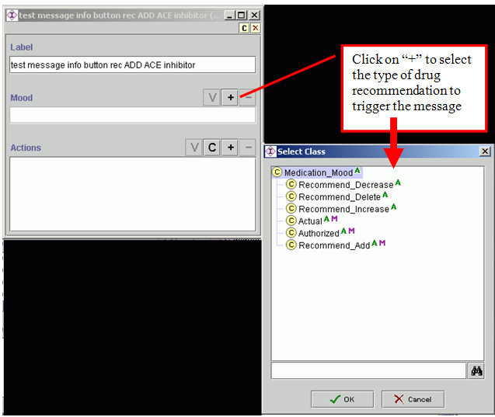

Figure 123 - Creating a drug classes-related message

1. Add a descriptive label to the message, then click on the **+** button in the Mood slot to select the type of drug recommendation to trigger the message (Figure 123):

* *Recommend_Decrease* – when ATHENA-CDS is recommending a decrease in the dose of a specific drug class (in this example, ACE inhibitor)
* *Recommend_Delete* – when ATHENA-CDS is recommending deleting a drug of a specific drug class (e.g., ACE inhibitor), for instance, in a substitution
* *Recommend_Increase* – when ATHENA-CDS is recommending the increased dose of a specific drug class (e.g., ACE inhibitor)
* *Actual* **–** for the inpatient setting; not used in ATHENA-CDS
* *Authorized* – when a patient has an active prescription for a drug
* *Recommend_Add* – when ATHENA-CDS is recommending adding a drug of a specific drug class (e.g., ACE inhibitor)

In the Actions slot, click on **+** to add an already-created message or click on the **C** button to create a new one. When creating a new message, if there are any additional rule-in criteria, select conditional_on_screen_message type from the dialog box. If no additional rule-in criteria are required, select the On_Screen_Message type. Add a descriptive label and the message content in the Message slot, as they are to be displayed in the GUI (Figure 124). It is not necessary to select a message type, as this message is linked to a drug recommendation. If you have a reference, you can add it or create a new one, using the **+** button and **C** button, respectively (Figure 124).

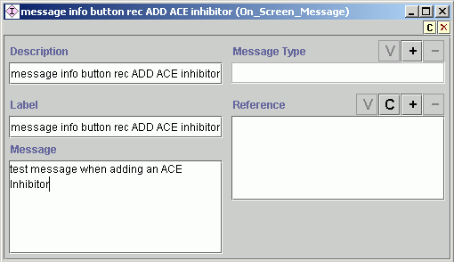

Figure 124 - On_Screen_Message for a drug class-related message

1. In the collateral action” slot of the Drug_Usage template for ACE Inhibitor, scroll down and see the new message labeled “Test message info button rec ADD ACE Inhibitor” (Figure 125)

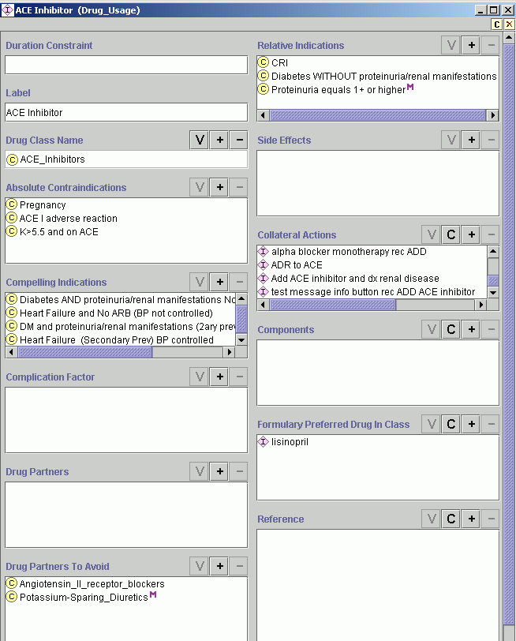

Figure 125 - Drug_Usage template with a new message in the Collateral Actions slot

1. Test the new message, as described in page **Error! Bookmark not defined.**.

#### Creating a New Primary Message Using the Classes & Instances Tab

This subsection will walk through an example of how to add a message that has some rule-in criteria.

1. Go to the Classes & Instances tab.
2. Enter *message* into the search field (see Figure 126).
3. Select On_screen_message[15].
4. Click on **C** in Direct Instances, highlighted in Figure 126, to create a new message.

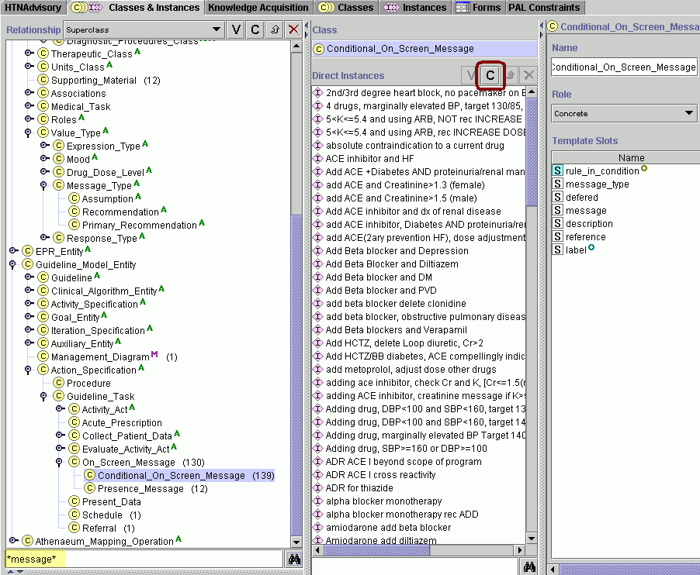

Figure 126 - Creating an on-screen message

1. Fill in the slots highlighted in red in Figure 127:
   * *Description* – Add detail to the message description.
   * *Message Type* – Click on **+** to add the type of message. This will determine where it will display:

*a) Primary* – displays in a box above drug recommendations.

*b) …*. <ToDo: update>

* + *Label* – Enter what is to be displayed in the Protégé user interface.
  + *Rule In Condition –* Select the criteria to the display message. If criteria already exist, use **+** to find them and add them. If there need to be new criteria, then click on **C** to create them.
  + *Message –* Enter the message as it is to be displayed.
  + *Reference –* Insert a reference for the message (optional). Use **C** to create a new reference or **+** to find a reference that already exists in Protégé.

Create a test patient to evaluate if the message is displayed (see page **Error! Bookmark not defined.**).

#### Parameterized Message

Two Use Cases:

1. The queried data elements are directly embedded in the parameterized string (e.g., “Patient's most recent creatinine value is ?creatinine. His/her potassium (date ?date) was >5. Evaluate clinical significance.”). Each embedded data element (?creatinine and ?date) are derived from a separate query.
2. The queried data element (e.g., a medication record) has attributes (e.g., drug name and drug dose) whose values are embedded in the parameterized string (e.g., “?drugName has daily dose of ?dose mg.”)

In both use cases, create an instance of Parameterized_Message. Populate appropriate Label and Rule In Condition, and add an instance of Parameterized_String to the “Parameterized Message” slot.

For use case 1, populate the Parameterized Message slot <ToDo>

# Appendix 1: Questions and Answers

***Question 7/16/2012 - encoding time***

*How to encode a time from an event*

*specific example (gt 12 hours and le 24 hours) or gt 8 weeks) of acute hospitalization*

*taken from*

*(Recommendation) F3. Lipid profiles should not be obtained within 8 weeks of acute hospitalization, surgery, trauma, or infection unless they are obtained within 12-24 hours of the event to ensure accuracy.*

**Answer (ST)**

If you want specify the time (8 to 12 hours after acute hospitalization) when a lipid profile should be ordered, then you want to specify in the "when" property of Order_TestOrProcedure an instance of relative time interval. Similarly, if you want to check whether a test was ordered 8-12 hours after acute hospitalization, you  want to specify the "period" slot of the Presence_Criterion. The 'relative time interval' structure used in both slots allows you to specify an interval in terms of one time point and a duration before or after the time point. So you have to say (4 hours after, [8 hours after [time of acute hospitalization]). "Time of acute hospitalization" has to be written as a PAL query (the patient may have multiple hospitalizations, you need to write the criteria for the one you mean).

I noticed that the current "Relative Time Point" only allows "(past) days from current time". It's a simplification for the ease of implementation. The Relative Time Point is meant to specify the time before or after another time point. I've added the necessary structure in the standalone version of the ontology. You'll see that after you or Susana restart the Protege server.

……………...

***Question 7/13/2012 - encoding criteria***

*I thought there may be criteria created in different disease_kbs that could be re-used, for example age, lab values, presence of drugs, etc. This would avoid duplication of criteria in different projects, akin to the library and concepts. Makes me wonder if criteria should also be part of library.*

**Answer (ST)**

Criteria that are in library project are available to any disease KB. Except when one disease KB includes another (e.g., heart failure including HTN & Lipid), criteria that are in one disease KB is not accessible from another. So there is no point in seeing them in the recommendation project if they not accessible in the KB projects.

There are pros and cons in reusing criteria across guideline KBs. It will be a lot of work to re-organize them.

………………

***Question 7/11/2012 - active meds***

*I need to clarify the criteria for meds in the KB and the connection to patient data. Dan says EON only pulls active prescriptions. I thought that in the medication criterion if you did not add the mood ‘authorized’ it meant ever on the drug. If the mood slot is empty what is the default behavior? But if EON only knows about active prescriptions then my assumptions about ‘ever’ on the drug is incorrect.*

**Answer (ST)**

EON assumes that only active meds are queried and available to the system. "Authorized" means currently active. No mood default to "Authorized." The current distinctions are between "Authorized" and "Recommended."

It is possible to add "Past" medications, but the KB and the execution engine need to be updated.

***Question 7/10/2012 - encoding Forms tab, Slots***

*In recommendations_Lipid.pprj for the slot, Recommendation Text, of the Guideline_Recommendation class, is there a way to have a larger text box?  The recommendation text string can be quite long and a short single line is a bit small.*

**Answer (ST and CO)**

Unfortunately, the form configuration can only be done in Protege's standalone mode.

Are you familiar with Protege's form configuration (use the Forms tab to change the GUI widgets associated with the slots)? We can shut down the Protege server and you can make the necessary configuration changes to the classes that you are editing.

To change size of the slot, "Recommendation Text" in the Guideline_Recommendation class,

* In Classes tab, select Guideline _Recommendation
* Click on Forms tab
* On the right hand side, the Form Editor, click on Recommendation Text
* In "Selected Widget Types" pull down menu, select TextAreaWidget, rather than TextFieldWidget

**Answer (ST) 7/6/2012 - Medical Condition Class - icd9**

The attached HTML file

\\vhapalathenaot\autopm\Protege\Protege_KB_encoding\RelatedFiles\MissingICDChildrenAugmented.html

shows the hierarchy of the "Medical Condition Class" once HTN, HF, CKD, DM, and Lipid KBs are loaded together. Highlighted in BOLD are those ICD 9 CM codes that are subcodes of codes in the hierarchy, but are not in the hierarchy themselves. For example, 585 is a subclass of 'Chronic Kidney Disease', but its subcodes (585.1, 585.2,...) are not in the hierarchy (actually, I check that the subcodes are not among the sibling classes of 585). Therefore the subcodes are highlighted in bold.

Interestingly, I couldn't find a number of codes in the hierarchy in the UMLS 2012AA version of ICD 9 CM. (Search for "No such ICD code" in the HTML page).

Note that this check doesn't uncover the problem of missing systolic heart failure (428.2), because the more general code 428 is not in the hierarchy. Instead, 428.0 (Congestive heart failure, unspecified) is in the hierarchy. One possibility is to extend the search by including the code NNN whenever NNN.0 is in the hierarchy.

The hierarchy needs pruning (e.g., duplicate concepts) and re-organization.

***Question 7/2/2012 - encoding slots***

*We created a slot called “Uses_criterion’ akin to ‘Uses_concepts’ in Guideline_recommendations. The only part we could not emulate was to add the inverse slot ‘is_used_in’. This slot does not show in the list of existing slots.*

**Answer (ST)**

You need to define a new property (e.g., criterion_is_used_in). "is_used_in" is a relationship between Concept and Guideline_Recommendation. (Probably should rename "is_used_in" to "concept_is_used_in").

***Question 7/2/2012 - encoding slots***

*We want to add a slot ‘createdby’ in so Connie can identify the recommendations, criteria and concepts she creates. This gives her the ability to search for things she created. If I remember correctly you mentioned that we were NOT able to create a top level annotation project that would be inherited by all Recommendations_XXXX projects. I just wanted to confirm this. I know how to create the slot, just wanted to make sure where to do it.*

**Answer (ST)**

Don't create "createdby" slot. For the Concept, Criterion_Description, Guideline_Recommendation classes, add the :CREATOR and :MODIFIER system slots to their template slots. Next, go to Project/Configure... menu item and check "Update modification slots" option in the Options tab. Protege will automatically keep track of who create and modify instances of these classes.

***Question 5/14/2012 - encoding (do not) create class as value of property***

*In the Knowledge Tree tab -> Instance Editor -> Patient*

*Characterization, I tried to create another class called “ACS <6mo”.*

*Somehow , I got into a state where there was in red, a <deleted*

*frame> in the box under Patient Characterization. I can go to the Classes&Instances tab, delete the class :THING -> temp1 and the <deleted frame> disappears, BUT when I try to add a new class under Patient Characterization, I end up in the same place; i.e., <deleted frame> reappears.*

**Answer (ST)**

The problem is that when you create a new class as the value of a property, the dialog box asks for the metaclass of the class, but not the parent of the class. By default, :THING is the parent when no parent is specified for a class.

The workaround is to create a class in the Class Hierarchy and place the new class at an appropriate place in the class hierarchy, and then select the class (using the +diamond> as the value of Patient Characterization.

The moral: Don't create a class as the value of a property. Create it in the Class Hierarchy first, and then select it for the propoerty.

***Question (implied) 11/28/2012 - truth tables***

*What are the truth tables for combining Boolean combinations of proposition statements that may evaluate to truth, false, or unknown.*

**Answer (ST)**

You can see them in the wikipedia page:

<http://en.wikipedia.org/wiki/Three-valued_logic>

The version of the logic used in the the EON system is the same as the "Kleene logic" described in the article.

|  |  |  |  |  |  |  |  |  |  |  |  |  |  |  |  |  |  |  |  |  |  |  |  |  |  |  |  |  |  |  |  |  |  |  |  |  |  |  |  |  |  |  |  |
| --- | --- | --- | --- | --- | --- | --- | --- | --- | --- | --- | --- | --- | --- | --- | --- | --- | --- | --- | --- | --- | --- | --- | --- | --- | --- | --- | --- | --- | --- | --- | --- | --- | --- | --- | --- | --- | --- | --- | --- | --- | --- | --- | --- |
| |  |  |  |  | | --- | --- | --- | --- | | ***A AND B*** | **TRUE** | **Unknown** | **FALSE** | | **TRUE** | TRUE | Unknown | FALSE | | **Unknown** | Unknown | Unknown | FALSE | | **FALSE** | FALSE | FALSE | FALSE |      |  |  |  |  | | --- | --- | --- | --- | | ***A OR B*** | **TRUE** | **Unknown** | **FALSE** | | **TRUE** | TRUE | TRUE | TRUE | | **Unknown** | TRUE | Unknown | Unknown | | **FALSE** | TRUE | Unknown | FALSE |      |  |  | | --- | --- | | ***A*** | **NOT *A*** | | **TRUE** | FALSE | | **Unknown** | Unknown | | **FALSE** | TRUE | |  |  |  |

Pasted from <<http://en.wikipedia.org/wiki/Three-valued_logic>>

# Appendix 2: Installing ATHENA Test Environment on a Local Machine

Athena Test Environment used to test and debug KBs is installed on the CMD1 server at

C:\ATHENA_TestEnvironment\

Note: I use the word "directory" and "folder" interchangeably.

To install on your own machine, rather than running on CMD1:

1. Copy over test environment directory to your machine and note of path to this directory;
2. Note where you are keeping the KBs, map that folder to a drive on your machine and note letter of that drive.
3. Edit the EONHOME and KBHOME variables in the batch\GenericATHENA.bat and GenericBatchTest.bat files to paths on your machine

For example,

1. Copy over entire directory to your y: drive
2. You will now have the directory: y:\ATHENA_TestEnvironment
3. Suppose you map the ATHENA KB folder to the z: drive on your machine, you have Z:\ATHENAKB
4. Edit EONHOME and KBHOME variables in the batch\GenericATHENA.bat and GenericBatchTest.bat files to the new paths.

For example, using the drives y: and z: Specifically,

In batch directory, edit GenericAthena.bat, and change the line

set EONHOME=C:\ATHENA_TestEnvironment

to

Set EONHOME=Y:\ATHENA_TestEnvironment

In the batch directory, edit GenericAthena.bat

Change the line

Set KBHOME=C:\ATHENAKB

to

Set KBHOME=Z:\ATHENAKB

Note when running protégé, be sure that "test environment" tab is showing. If it is not, then go to Project -> Configure -> click on "test environment". Save the project to keep the new configuration in the pprj file.

# References

Genesereth, M. R. (1991). *Knowledge Interchange Format.* Paper presented at the Proceedings of the Second International Conference on Principles of Knowledge Representation and Reasoning, San Francisco, CA, USA.

Gennari, J. H., Musen, M. A., Fergerson, R. W., Grosso, W. E., Crubezy, M., Eriksson, H., . . . Tu, S. W. (2003). The Evolution of Protégé: An Environment for Knowledge-Based Systems Development. *Int J Hum Comput Stud, 58*(1), 89-123.

Musen, M. A. (1999). Scalable Software Architectures for Decision Support. *Methods of information in medicine, 38*, 229-238.

Noy, N. F., Fergerson, R. W., & Musen, M. A. (2000). *The Knowledge Model of Protege-2000: Combining Interoperability and Flexibility.* Paper presented at the 2th International Conference on Knowledge Engineering and Knowledge Management (EKAW 2000), Juan-les-Pins, France.

1. For each slot name displayed on the instance form, Protégé automatically replaces the underscore with a blank and capitalizes the first letter of each word. Thus, the slot *eligibility_criteria* is displayed as “Eligibility Criteria” on the instance form of the Management_Guideline class.
2. In the rest of the document, we may use *attribute* synonymously with *slot*. They both represent properties or characteristics of an entity.
3. The *Patient*, *Condition*, *Encounter* and *Procedure* classes are not used in ATHENA CDS and thus greyed out.
4. The mappings of drug names are maintained in the SQL database without reference to mappings in the ATHENA Knowledge Base.
5. These patient-specific messages associated with a drug recommendation are displayed in the ATHENA GUI as the Info button messages next to a drug recommendation. See Section **Error! Reference source not found.**.
6. The description of the attributes of the Case_Selection class applies only to the Protégé 1.7 version of the system. In Protégé 2.0 and later, the attributes of the Case_Selection class differ.
7. The “Conditional_On_Screem_Message is deprecated.
8. A formulary is a list of prescription drugs that a health-care institution or health plan has approved for use by doctors.
9. The PAL query should have “drug_name” in the *key_slot* so that the query will return a list of drug names to delete.
10. These Drug_Usage instances are those whose Drug_Class_Name slot values (e.g., ACE Inhibitor) subsume the names of the drug to be discontinued (e.g., lisinopril).
11. In logic, a truth value is a value indicating to what extent a statement is true. In classical logic, a proposition can only be *true* or *false*. This guide is departing from the requirements of classical logic.
12. There are other types of time intervals and time points that can be specified using the classes in the Time_Entity hierarchy in the EON Guideline Model, but Relative_Time_Interval_Definite is the only one necessary for the ATHENA system. Other classes will not be documented in this manual.
13. By analogy with unary, binary, etc., “n-ary” means “any number of”. Here it refers to the fact that the *and* and *or* operators can take any number of arguments.
14. International Classification of Diseases, 9th Edition
15. Conditional_On_Screen_Message is deprecated.